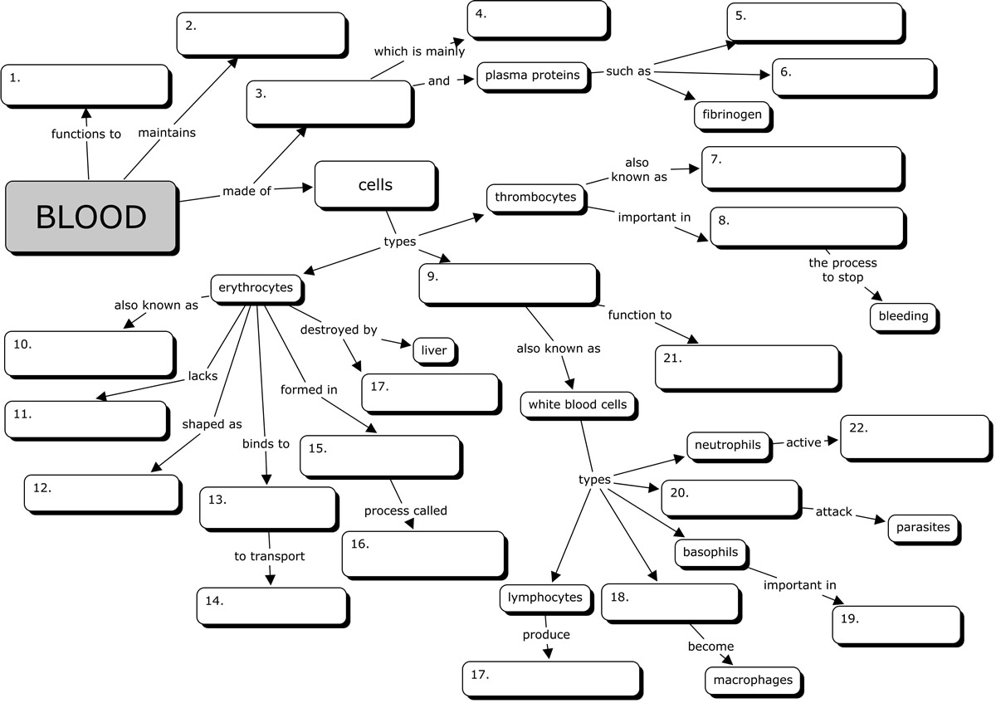

WORD BANK
red blood cells | homeostasis | albumins |biconcave disc
bone marrow | transport nutrients| hemoglobin | monocytes
defend against diseases | plasma | leukocytes | spleen | phagocytes
inflammatory reaction | water | platelets | hematopoeisis
eosinophils | oxygen | nucleus | hemostasis | globulins | antibodies

