Cardiovascular System
Introduction
- The cardiovascular system consists of:
  - ___________________
  - ___________________
    - ___________________
    - ___________________
    - ___________________
Functions
- Heart - __________________________________________________________________________
- Blood vessels - ____________________________________________________________________
_________________________________________________________________________________
  - Systemic Circuit – connects the ____________ to the ________________
    - Delivers ________________ and __________________ to all __________________
    - Removes _________________ from all _________________________
  - Pulmonary Circuit – connects the _________________ to the ____________________
    - _______________________________ occurs
      - Carbon dioxide out
      - Oxygen in

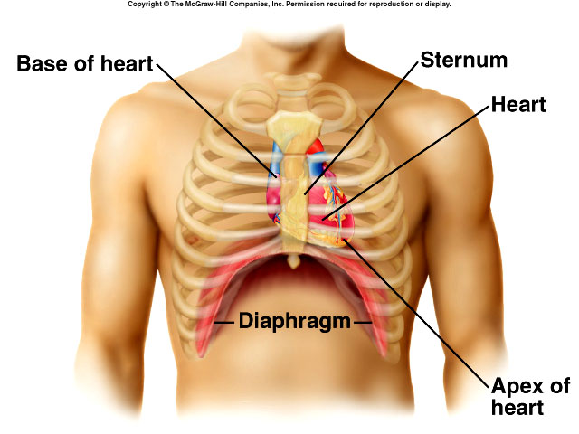
Location of Heart
- _______________ to sternum
- _______________ to lungs
- ______________ to vertebral column
- Lies upon diaphragm

Coverings of Heart
- The ______________________ encloses the heart.
- Two layers:
  - ________________________________ - Outer, tough connective tissue
  - ________________________________ - Covers the heart’s surface
    - Parietal layer – lines the inside of the fibrous pericardium
    - Visceral layer – covers the heart’s surface
- __________________ Cavity
  - Between parietal & visceral layer of the serous pericardium
  - Contains ______________
    - ________________________ as heart moves.
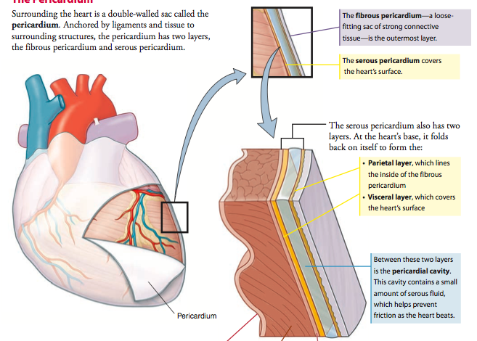
Wall of the Heart
- Three Layers
  - __________________
    - Forms ________________ protective covering, secretes serous fluid.
  - __________________
    - Cardiac muscle, contracts to pump blood from the heart chambers.
  - __________________
    - Forms protective inner lining of the chambers and vessels.
Heart Structures
Structure | Location | Characteristics | Receives blood from: | Function
Atria
Ventricles
Septum |  |  | N/A

Heart Chambers

- _________________
  - receives blood from inferior & superior vena cava
- _________________
  - receives blood from right atrium
- _________________
  - receives blood from pulmonary veins
- _________________
  - receives blood from left atrium

Heart Valves
Valve |  | Location | Structure | Function
Atrioventricular (A-V) Valves | Tricuspid valve
 | Bicuspid valve
Semilunar Valves | Pulmonary valve
 | Aortic valve

Pathway of Blood Through the Heart

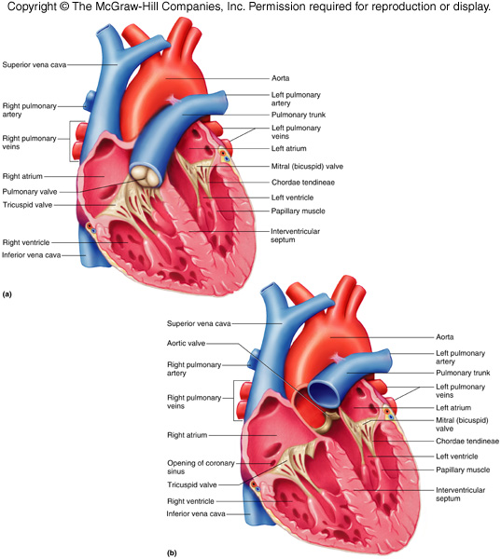

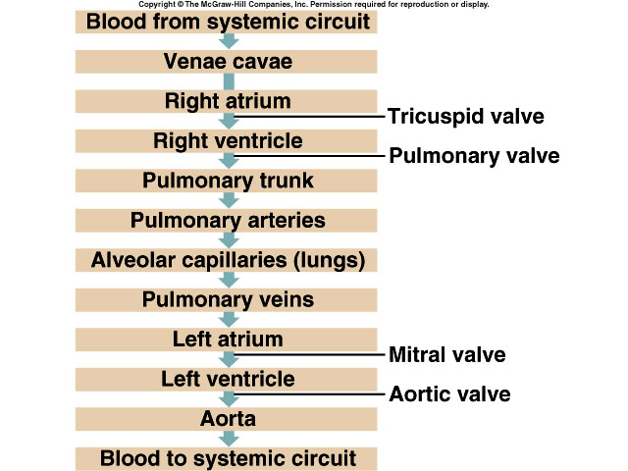
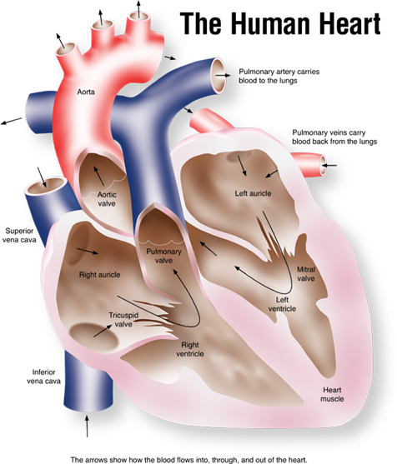
The Cardiac Cycle
The Cardiac Cycle
- _____________________ - the events associated with _________________________
- One cardiac cycle lasts 0.8 seconds
- Described as the __________________ and __________________ of the 4 heart chambers
  - During _________________ ( __________________ ), chambers fill with blood
  - During _________________ ( __________________ ), chambers expel blood
- Both atriums will contract at same time while the ventricles relax then vice versa.

Cardiac Cycle
- Atrial Systole/Ventricular Diastole
  - ________________________
  - ________ of blood flows _____________ from atriums into ventricles
  - Atrium _______________ forcing remaining _________ of blood into ventricles
  - Ventricular pressure _______________
- Ventricular Systole/Atrial diastole
  - A-V valves ________
  - Atria ____________ & blood begins to flow into ___________
  - Ventricular pressure ______________
  - _________________ & ____________ valves open
  - Ventricles contract forcing blood into ___________________ and _________
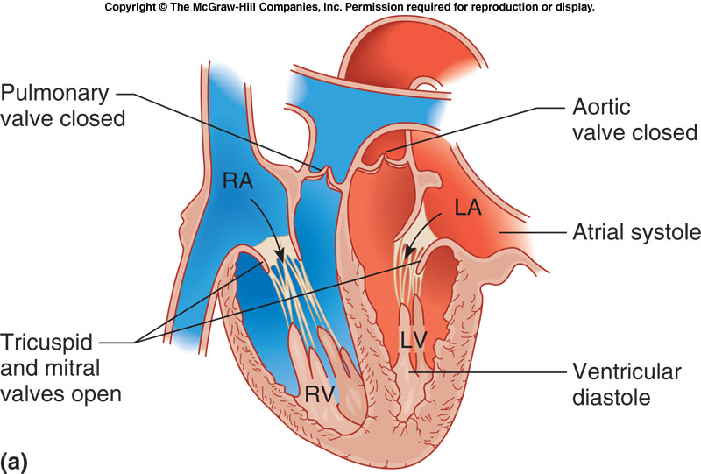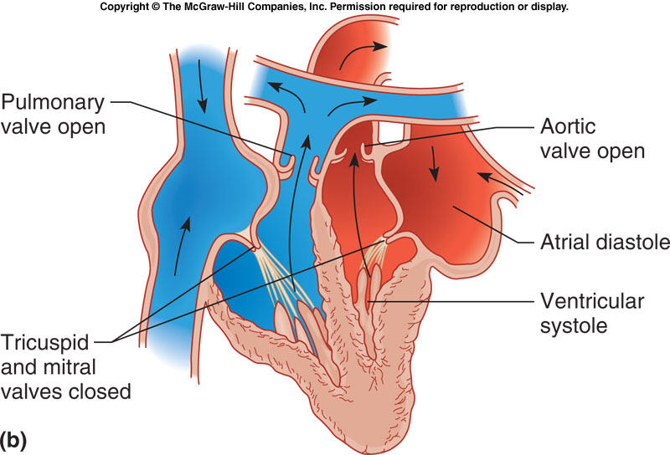
Heart Sounds
- ________
  - First heart sound
  - Occurs during ventricular _____________ (contraction)
  - A-V valves ____________
- ________
  - Second heart sound
  - Occurs during ventricular ____________ (relaxation)
  - ______________ and __________ valves closing
- _____________
  - Abnormal heart sound due to valve damage
  - Some blood leaks back through the valve when it closes
Cardiac Conduction System
- The heart does not require stimulation from the ________________________ to initiate a _________________________________________________
- Three crucial parts:
  - Sinoatrial (SA) Node
    - Small bundle of cells in the __________________
    - Capable of ___________________________________ the will cause the ______________________________________.
    - AKA: ___________________________
  - Atrioventricular (AV) Node
    - Small bundles of cells that can ___________________________________________
    - Continue the electrical signal down into the _____________________
  - His-Purkinje System
    - Group of fibers that carry the electrical impulse through the ____________, causing them to ________________________.
Pathway of Electrical Impulse

- ___________ - stimulates contraction of the ___________
- ___________ - impulse slows to allow atria to contract
- _________________ - branches into left and right
- ________________________ - stimulate contraction of the ________________

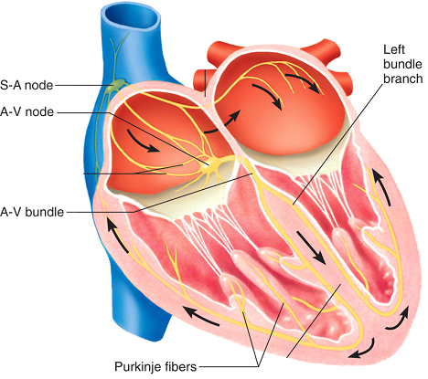

Electrocardiogram
- Measurement of the ____________________________________________ created by the heart
- Used to assess heart’s ability to conduct impulses
  - __________ – atrial depolarization and contraction
  - __________ – ventricular depolarization and contraction
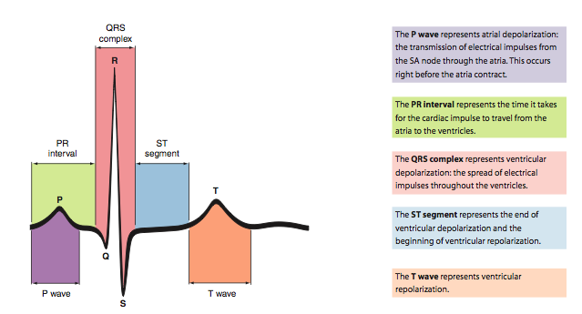
  - __________ – ventricular repolarization and relaxation

Blood Vessels & Paths of Circulation
Blood Vessels

Blood Vessel | Branches into | Function
Arteries
Veins
Capillaries | N/A
Path of Circulation: ---- Arteries ---- Arterioles ---- Capillaries ---- Venules ---- Veins ----
Highway Analogy: ---- 4-lanes ----- 2 lanes ---- 1 lane ---- 2 lanes --- 4 lanes ---
Arteries and Arterioles
 | Structure | Extra Info
Arteries
Arterioles

*NOTE: All arteries carry ________________ blood except for the _________________ that carries _______________________ to the _______________.
Pulse
- Only felt in __________________
- Spurt of high pressure blood passing along the arteries when the left ventricle contracts
- Can be felt at superficial arteries
- Also known as ________________________
Pulse Rate/Heart Rate
- Measured in ________________________ ( ______ )
- Average resting adult: __________________
- Well-trained athletes: __________________
  - _________________ - exceeds normal range
  - _________________ - below normal range
Blood Pressure
- _______________________ - force the blood exerts against the inner walls of the _____________
- Blood Pressure
  - _____________ when ventricles ________________
  - _____________ when ventricles ________________
  - _________________________ - maximum pressure (ventricle contracts)
  - _________________________ - minimum pressure (ventricle relaxes)
- Normal BP
  - _______________
  - _________________ - _________blood pressure (>120/80)
  - _________________ - _________ blood pressure (<90/25)
Factors That Influence Blood Pressure
- Heart Action
  - ___________________ - volume of blood discharge from left ventricle each heartbeat
  - ___________________ - volume of blood discharged per minute (mL/bpm)
  - Cardiac output = __________________________________
    - Cardiac output increases = BP ______________________
    - Cardiac output decreases = BP ______________________
- Blood Volume
  - Consists of formed elements and plasma
  - Blood volume decreases = BP ___________________
    - Due to _________________ or _____________________
Veins and Venules
 | Structure | Extra Info
Veins
Venules

*NOTE: All arteries carry ________________ blood except for the _________________ that carries _______________________ to the _______________.
Venous Valves
- Allows blood to flow to the heart, but prevents backflow of blood to capillaries.
Venous Blood Flow
- Not a direct result of _____________________
- Dependent on:
  - ________________________ - muscles surrounding leg veins aid in venous return
  - ________________________ - change in pressure in the thoracic cavity as a result of the diaphragm contracting for inhalation aids in moving blood
  - ________________________

Capillaries
 | Structure | Extra Info
Capillaries

