Chicken Wing Dissection
Introduction
An uncooked chicken wing is ideal for studying tissues histology and is remarkably similar to the human arm. Review the diagrams below before answering the pre-lab questions.

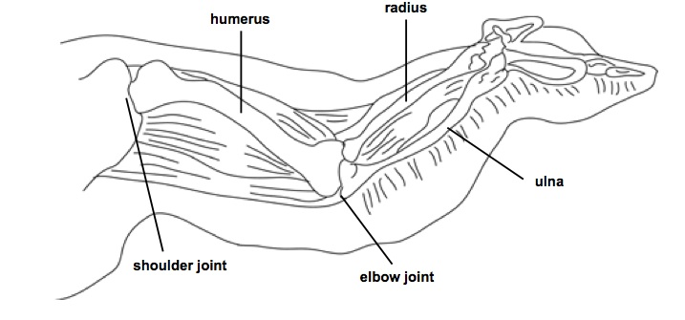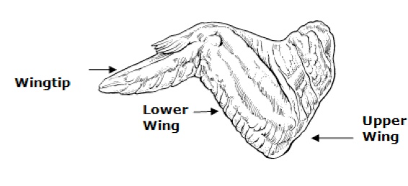

Pre-Lab Questions

1. What type of organs are the humerus, radius, and ulna?

2. To what body system do the organs listed in #1 belong?

3. What type of tissue composes the organs listed in #1?

SAFETY WARNING
Raw chicken is a source of bacteria. Do not let the raw chicken touch your clothing, personal belongings, lab handouts, or pen/pencil. We will wipe down the tables with disinfectant when we are finished, and you will need to thoroughly wash your hands and dissection materials with soap and water.

Procedure

1. Observe the chicken wing on the dissection tray.

Would the chicken wing you received be on the right or left side of the chicken?

2. Observe the skin that covers the outside of the wing.

What evidence do you see that the skin was covered with feathers?

3. Carefully remove the skin with the scissors, avoiding damaging the structures beneath it. This will not be easy so go slowly and be patient! I recommend starting on the side of the wing with “less meat.” Observe the very thin, stretchy film/membrane that holds the skin to the muscles. This membrane is called the superficial fascia.

4. Find the adipose tissue, which is clumpy and yellow.

What are two functions of the adipose tissue?

1.

2.

5. Locate a blood vessel. Blood vessels are thin, brownish-red tubes that you can see on the surface of the muscles.

6. Locate a nerve. Nerves are thin, white, somewhat strong “string” that you’ll often find running next to blood vessels.

7. Carefully remove as much of the adipose tissue as possible without cutting other structures. This will allow you to get a better view of the muscles.

8. Pick up the wing by the shoulder joint (hold it at the joint – where the two bones meet). Gradually pull on the various muscles that are attached. See if you can find the muscles that bend the wing at the elbow joint and at the wrist joint.

9. Use your finger to separate the muscles from one another. Each muscle is its own bundle.

10. Locate the tendons. These are the skinny, tough, silvery-white tissue that connects the muscle to the bone.

11. Find the joints in the wing. At every joint there will be a layer of cartilage that is usually pearly-white in color. Feel the texture of the cartilage in the joints.

What type of cartilage are you looking at and feeling?

12. Locate a ligament. These are tough, white fibrous tissue that holds two bones
together.

What type of connective tissue makes up ligaments?

13. Carefully break a bone in half. Any soft, red material is bone marrow, which makes red blood cells.

Observation and Analysis Questions

14. Describe how the chicken wing is similar to a human arm. Discuss the various anatomy, tissues, functions, etc. that the chicken wing and human arm have in common (This should be more than a 1-sentence answer…).

15. Describe how the chicken wing is different than a human arm. Discuss the various anatomy, tissues, functions, etc. that differ between a chicken wing and a human arm (This should be more than a 1-sentence answer…).

