STATION 1

Connective – General Characteristics

Use the information provided to fill in the chart in your notes.

The most widespread, and the most varied of all the tissues is connective tissue. Existing in a variety of forms – ranging from tough cords to elastic sheets to fluid – connective tissue performs a variety of tasks. The overriding purposes of this seemingly diverse group of tissues are to connect the body together and to support, bind, or protect organs.
Components of Connective Tissue
The key component of connective tissue – called extracellular matrix – is what allows connective tissues to be so diverse. Extracellular matrix is the framework into which the cells of the tissue are embedded. The matrix consists of varying kinds and amounts of protein fibers and fluid; it’s the variation in composition that gives the tissue its characteristics. For example, the matrix of blood is fluid; it contains many cells but no fibers. In contrast, the matrix of bone contains few cells and many fibers, making it hard and brittle.
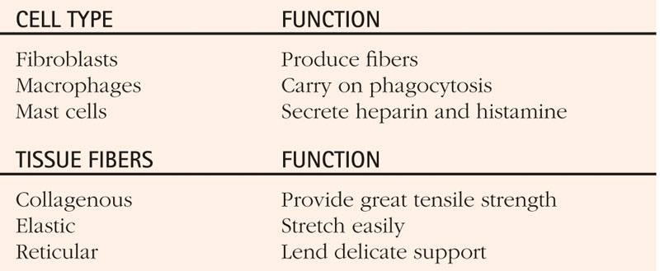

STATION 2
Connective Tissue Chart – Adipose

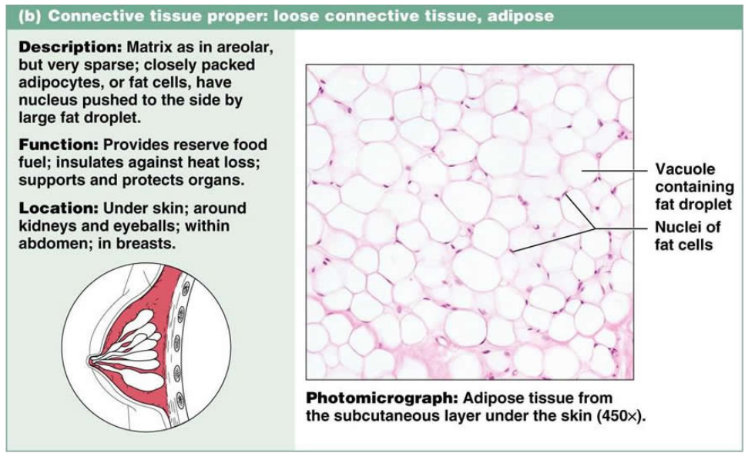
Description – closely packed adipocytes (adipo- = fat, -cyte = cell), nucleus is pushed off to the side

Functions – provides reserve food fuel, insulates against heat loss, supports and protects organs

Location – under the skin, surrounding the kidney and heart, around the eyeball

STATION 2
Connective Tissue Chart – Bone

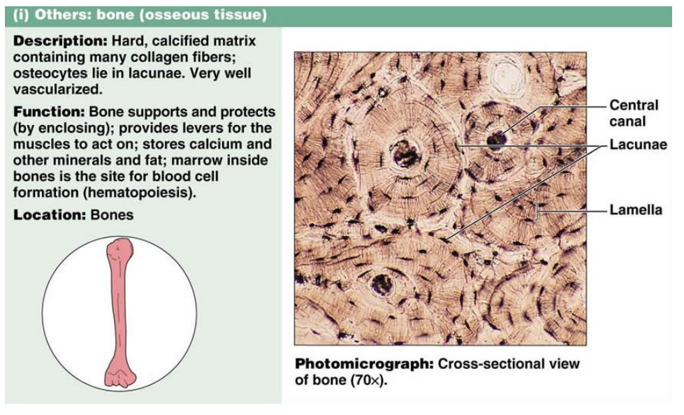
Description - made of a hard, calcified matrix, several collagenous fibers, osteocytes (oste- = bone, -cyte = cell)

Functions – supports and protects (encloses organs), provides levers and attachment points for muscles, calcium storage, bone marrow allows for blood cell formation

Location – bones of the skeletal system

STATION 2
Connective Tissue Chart – Blood

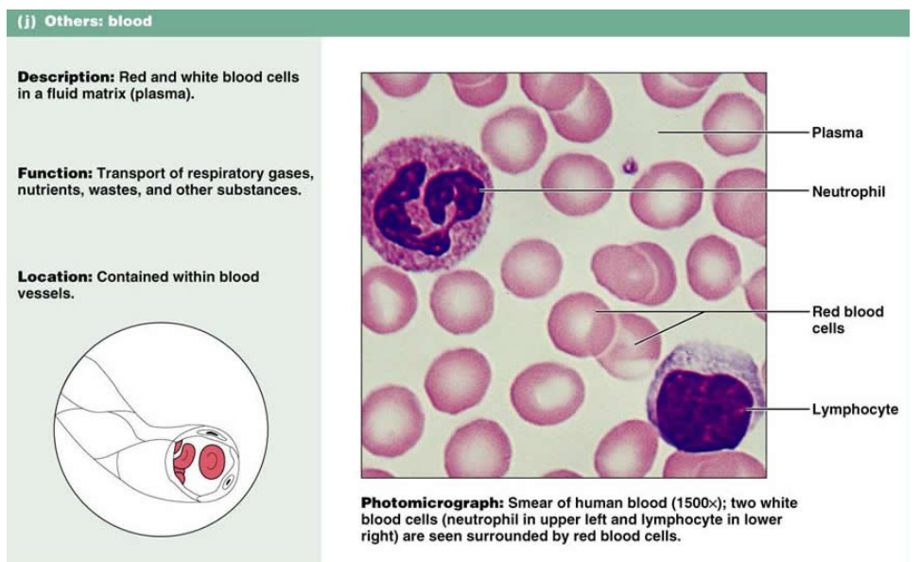

Description - made of a liquid matrix (plasma), and red and white blood cells

Functions – transportation of respiratory gases (oxygen and carbon dioxide), nutrients, and waste

Location – contained in the blood vessels and the heart

STATION 2
Connective Tissue Chart – Loose Connective

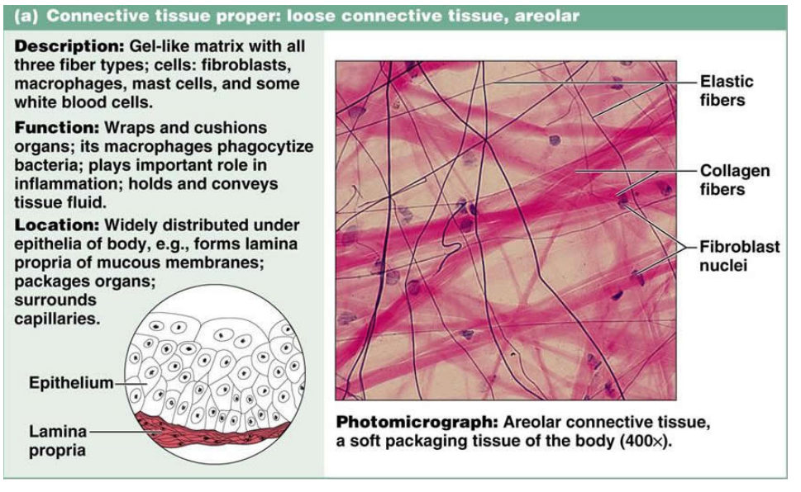
Description - made of a gel matrix, collagenous and elastic fibers, fibroblasts and macrophages

Functions – attaches skin to deep organs, wraps and cushions organs, fills spaces between muscles, under most epithelial layers (blood vessels nourish epithelial cells)

Location – beneath skin and epithelial tissue, between muscles and organs

STATION 2
Connective Tissue Chart – Dense Connective

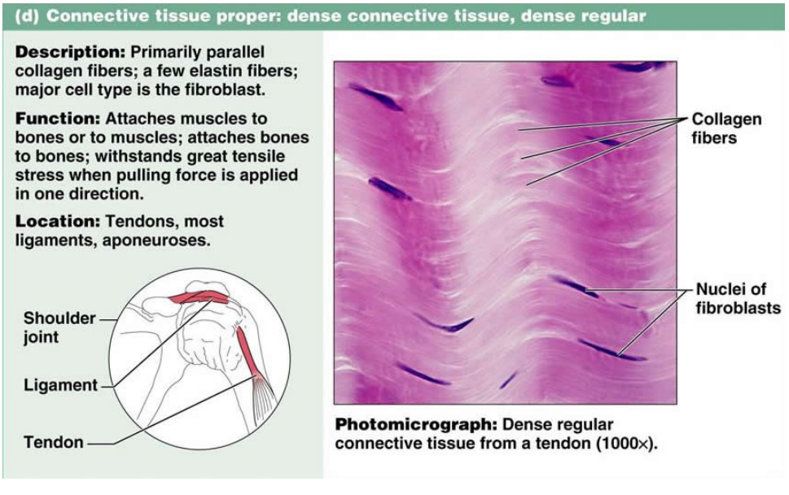

STATION 2
Connective Tissue Chart – Hyaline Cartilage

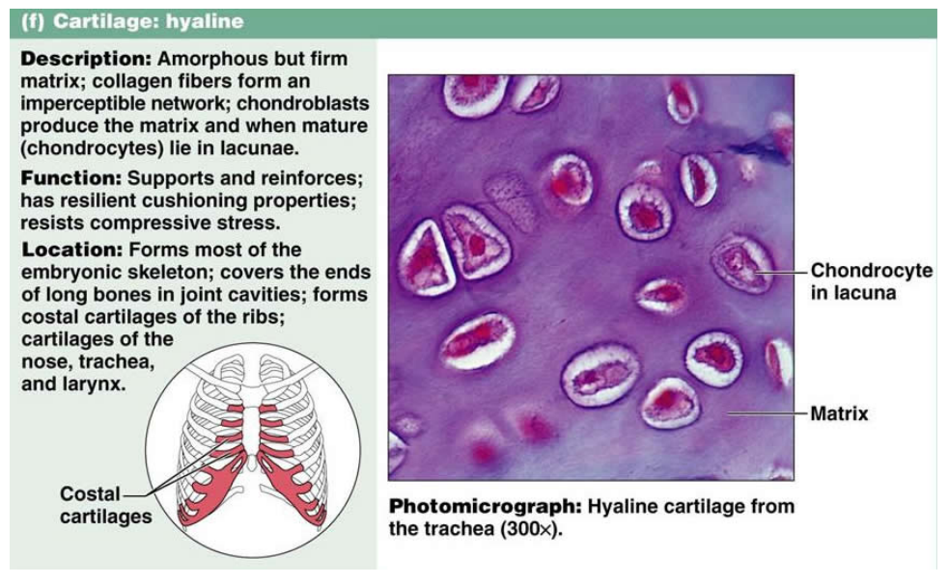
Description - made of a firm matrix with chondrocytes
(chondro- = cartilage, -cyte = cell)

Functions – support, protection (resists compression), provide framework

Location – ends of bones in joints, costal cartilage in ribs, nose, trachea

STATION 2
Connective Tissue Chart – Elastic Cartilage

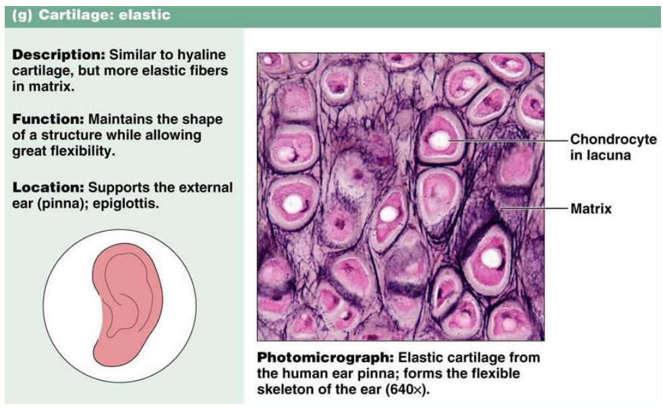

STATION 2
Connective Tissue Chart – Fibrocartilage

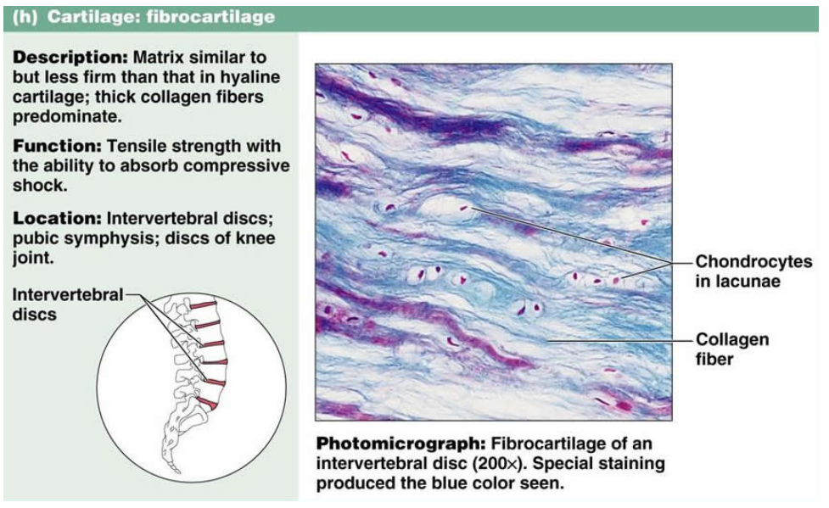
Description - Made of a firm matrix with chondrocytes
(chondro- = cartilage, -cyte = cell) and collagenous fibers

