Cow Eye Dissection
Procedures:
- Place the cow eye on the dissecting tray.
- Trim away any excess tissue surrounding the eyeball and observe the external features. Using your probe, identify the following structures:
  - Optic Nerve
  - Sclera
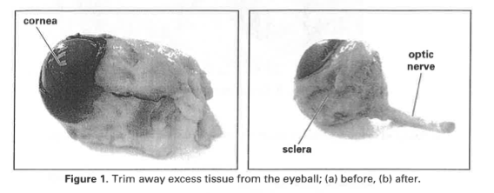
  - Cornea – should be clear, however the preserving process makes it look cloudy

- Hold the eyeball gently with your thumb and forefinger at the cornea and the optic nerve.
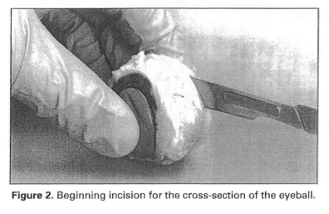
- Make a cross-section of the eye by making an incision slightly behind the middle of the eyeball through the sclera, as shown in the picture below. You may want to start with the scalpel and then finish with the scissors.
Avoid damage to the internal structures! Do not cut deeply into eyeball and do not squeeze too tightly.
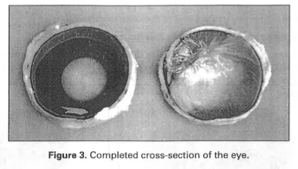
- Once you have made a cut around the eyeball, separate the eye into its two halves, as shown in the picture below.
- Remove the vitreous humor (the jelly-like substance) from the posterior chamber. You may need to tease it gently away from the lining of the eye.
- Remove the lens from the anterior section of the eyeball. Remove any extra vitreous humor from the lens.
- Pick up the lens with a pair of forceps and pat it dry with a paper towel.
- Place the lens on top of your lab and observe its ability to magnify.
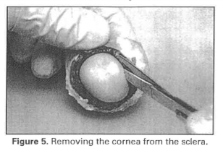
- Pick up the front half of the eyeball so that you are looking at the cornea. Cut the front of the eye around the outside of the cornea, removing the cornea from the sclera as shown in the picture below. You may want to use start the incision with a scalpel and then finish by using the scissors.
- Place the cornea on the dissecting tray. Cut the cornea in half and observe its thickness.
- In the anterior portion of the eyeball, insert the forceps through the opening created and carefully separate the edge of the iris from the inner surface of the eye. Try and keep the iris intact as you remove it.
- Note the hole in the iris. This is the pupil.
- Pick up the posterior portion of the eyeball and observe the following structures:
  - Retina (tan film lining the eye – it may have come off during the dissection)
  - Spot on the retina that transitions into the optic nerve (blind spot!)
- Turn the back half of the eyeball over and observe the optic nerve.
- Pinch the nerve with your forceps to see the separate fibers of the nerve.
- Turn the back half of the eyeball back over so you are looking at the retina again. Gently tease the retina away from the eyeball and remove it.
- Observe the dark, metallic tissue on the back of the eye. This is the choroid, a thin layer that lies between the retina and the sclera.
- Observe the iridescent portion of the choroid that appears blue/green. This is called the tapetum lucidum and is not found in humans. This helps many mammals with night vision.
- After you have observed all of the structures, dispose of the specimen according to your teacher’s instructions.
Make sure that you can identify all of the following structures of the eye:
- Lens
- Retina
- Iris
- Cornea
- Sclera
- Optic nerve
- Pupil
- Vitreous humor

