STATION 5
Epithelial Tissue Chart – Simple Squamous

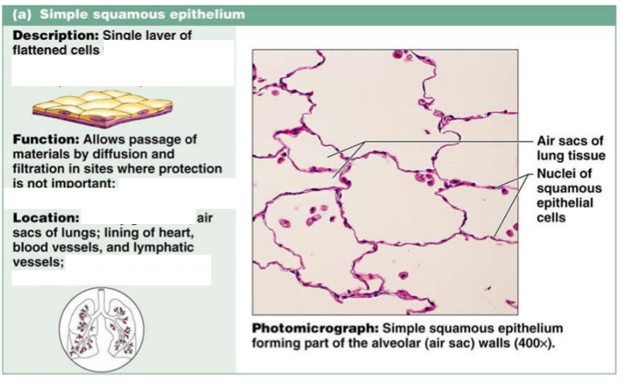

STATION 5
Epithelial Tissue Chart – Simple Cuboidal

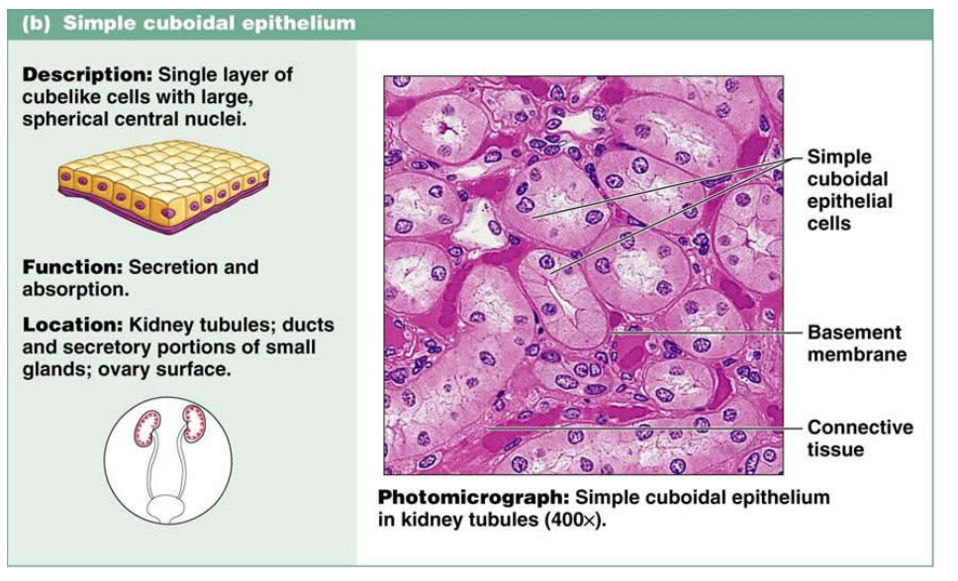

STATION 5
Epithelial Tissue Chart – Simple Columnar

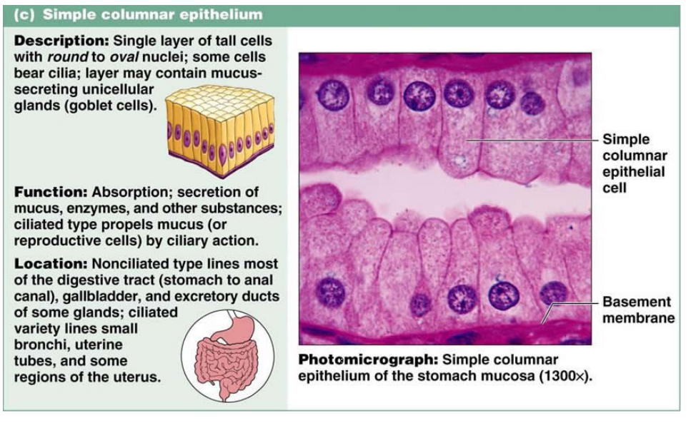

STATION 5
Epithelial Tissue Chart – Stratified Squamous
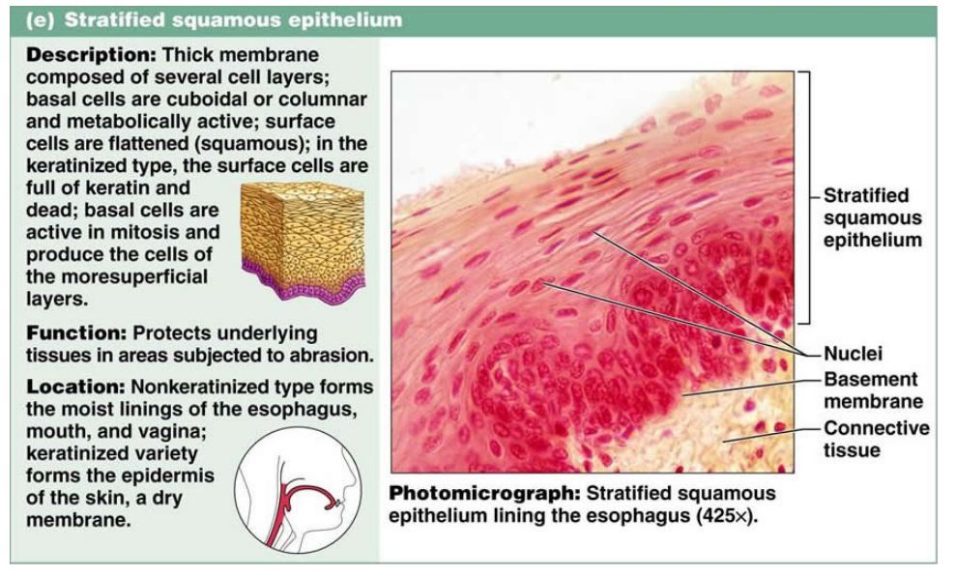

STATION 5
Epithelial Tissue Chart – Stratified Cuboidal
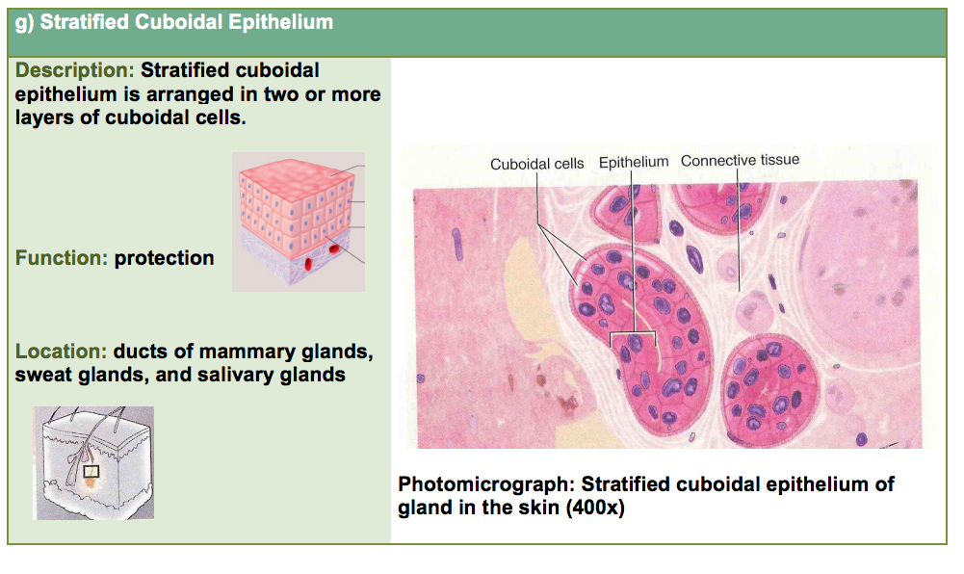

STATION 5
Epithelial Tissue Chart – Stratified Columnar

