STATION 1

Tissue Types

Read Section 5.1 in your book and list the four major tissue types in the body and their main functions.

STATION 2

Epithelial – General Characteristics

Read section 5.2 in your book and summarize each paragraph into a general characteristic of epithelial tissue. Fill in the chart accordingly and answer the question below the table.

STATION 3

Epithelial – Classification and Naming

Look at the diagrams provided (in your notes, or you may use the larger versions provided) and answer the questions in your notes.

Diagram for Questions #1 and #2.
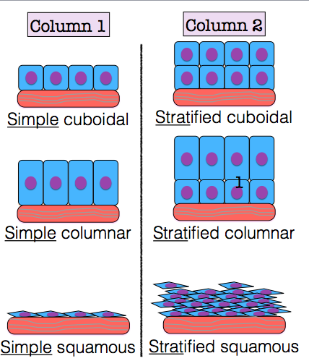
Diagram for Questions #3 -6

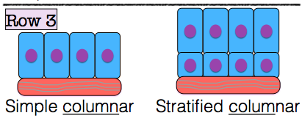
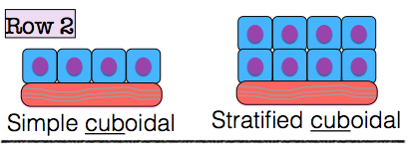
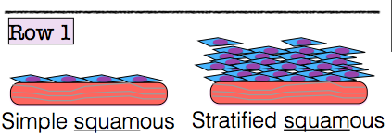

STATION 4

Epithelial Identification

Look at the diagrams provided (in your notes, or you may use the larger versions provided) and answer the questions in your notes.

Diagram for Question #1
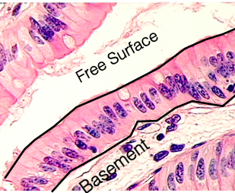
Diagram for Question #2

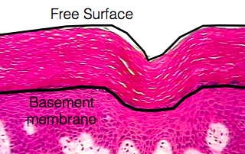
Diagram for Question #3
