Cardiovascular Lab

Pre-Lab
Use your notes and textbook to help you fill in the chart below.
 | Pressure in Atria  (High or Low) | Pressure in Ventricle  (High or Low) | Valves that are closed | Sound that we hear
Atrial Diastole/
Ventricular Systole
Atrial Systole/
Ventricular Diastole

- The maximum pressure achieved during ventricular contraction is called
_________________________ pressure.
- The lowest pressure that remains in the arterial system during ventricular
relaxation is called ______________________ pressure.
Procedure

- Obtain a sphygmomanometer and a stethoscope.
- Clean the earpieces and the diaphragm of the stethoscope with an alcohol wipe.
- Use the stethoscope and listen to your partner’s heartbeat. Listen to the following 4 places and place a checkmark in the circle when completed:
  - An inch below the clavicle, just to the right of the sternum
  - An inch below the clavicle, just to the left of the sternum
  - Just to the right of the xiphoid process
  - Just to the left of the xiphoid process

- Do you hear the Lubb Dupp?
  - What makes the Lubb?
  - What makes the Dupp?

Procedures – Heart Rate

Heart Rate
- The carotid pulse can be found on the neck about 1 cm inferior and slightly medial to the angle of the jaw. The radial pulse can be found on the lateral surface of the wrist, near the base of the thumb. Using either of these locations, take your index finger and find your partner’s pulse.
- Have the test subject sit. Measure their heart rate by counting the number of times you feel their pulse in 15 seconds (use the second hand on the wall clock to keep the time). Multiply that number by 4. Record your data in the first column of Table 1.
- Have the test subject lie down. After about one minute, take their heart rate (count for 15 seconds and multiply by 4) and record the data.
- Have the test subject stand. After about one minute, take their heart rate and record the data.
- Have the test subject do jumping jacks for 3 minutes. Immediately take their heart rate and record the data.
- Have the test subject sit. After 3-4 minutes, take their heart rate and record the data.
- Have the test subject sit. Find their pulse and monitor their heart rate. Have them hold their breath and quickly take their heart rate. Record your data.
  - If they turn blue and pass out, call over your teacher. He/She may not call 911 depending on who it is.
- Answer the questions on your data sheet.

Procedures – Blood Pressure

Blood Pressure – Part 1
- Have the test subject sit quietly with bare upper limb resting on a table at heart level. Have the subject remain as relaxed as possible.

- Locate the brachial artery at the antecubital space (inside of the elbow). Wrap the cuff of the sphygmomanometer around the arm so that its lower border is about 2. 5 cm above the bend of the elbow. Center the bladder of the cuff in line with the brachial artery. See the diagram to the right.

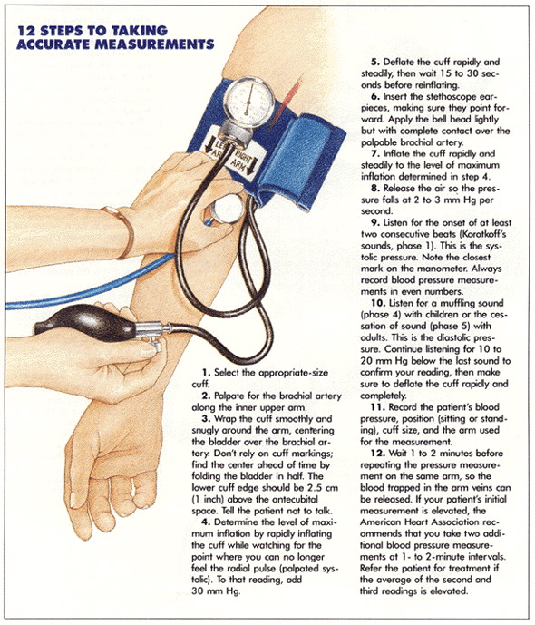

- Locate the radial pulse.
- Close the valve on the neck of the rubber bulb connected to the cuff and pump air from the bulb into the cuff. Inflate the cuff while watching the sphygmomanometer and note the pressure when the pulse disappears. This is a rough estimate of the systolic pressure.
- Immediately deflate the cuff. Record the pressure reading in Table 2.
- Tester puts on the stethoscope and positions the diaphragm over the brachial artery. Take the pressure reading from Step 4 and add 30 mmHg. Inflate the cuff to this number.
  - Example – Pressure from Step 4 = 110 mmHg, inflate the cuff to 140 mmHg.
- Slowly open the valve of the bulb until the pressure in the cuff drops at a rate of approximately 2-3 mmHg per second.
- Listen for sounds from the brachial artery. When the first loud tapping sound is heard, take note of the pressure reading. This is the systolic pressure.
- Continue to listen to the sounds while slowly releasing the pressure.
- When the last sound is heard, take note of the pressure reading. This is the diastolic pressure.
- Release all pressure from the cuff.
- Record the systolic and diastolic pressure in Table 2.
- Allow the test subject to sit for two minutes, then repeat the procedure on the same arm.
- Record the systolic and diastolic pressure for Trial 2 in Table 2.
- Allow the test subject to sit for two minutes, then repeat the procedure on the opposite arm two more times.

Blood Pressure – Part 2
- Measure the test subject’s blood pressure in each of the following conditions and record the data in Table 3:
  - 3-5 minutes after lying down
  - 3-5 minutes after standing quietly
  - Immediately after 3 minutes of moderate exercise (jumping jacks)
  - 3-5 minutes after exercise has ended

Data Sheet

Table 1 – Heart Rate

Sitting  Heart Rate | Lying Down  Heart Rate | Standing  Heart Rate | Immediately After Exercise  Heart Rate | 3-4 Minutes After Exercise Heart Rate | Holding Breath Heart Rate

- Was there a difference in heart rate between standing, sitting, and lying down? Why do you think this is?

- While the test subject was holding their breath, did their heart rate change?
- Can you think of any reason why a person’s heart rate might change as they hold their breath? Simply saying “yes” or “no” is not okay, explain…
- Do you think both the subject and the tester would have the same resting heart rate? Why?
- What might contribute to differences in people’s heart rate?

Table 2 – Blood Pressure at Rest
 | Blood Pressure  in Right Arm | Blood Pressure  in Left Arm
Trial 1
Trial 2
Average

Table 3 – Blood Pressure after Activity
Activity | Blood Pressure
3-5 minutes after lying down
3-5 minutes after standing
Immediately after exercise
3-5 minutes after exercise

- Was there a difference between the average blood pressures in the right arm and the left arm?
- Summarize the effects of body position and exercise on blood pressure.
- Summarize any correlations between heart rate and blood pressure from any of the experimental conditions (i.e. body position, exercise, etc.)

