Homeostasis Lab

Names:
_________________________________
_________________________________
_________________________________

Introduction
Living things need a relatively stable internal environment in order to function properly. Organ systems are interdependent, and failure to maintain homeostasis in one organ system causes other organ systems to work less efficiently. Homeostatic regulation is achieved when receptors, control centers, and effectors sustain physiological values near the set point. The body is in good health when physiological values stay close to their set points. Deviations from homeostasis result in diseases such as diabetes and hypertension.

Directions
1. Cut out the pieces for Part A, B, C, and D. Be sure to keep these pieces in distinct piles.
2. Turn to Part A on p. 2 and use the cut-out pieces for Part A to correctly diagram the homeostatic regulation that occurs. Glue these pieces on the diagram when you are satisfied with your responses.
3. Follow the same procedure for Parts B, C, and D. Be sure to answer questions you encounter along the way.

Part A - Regulation of Oven Temperature at 375°F

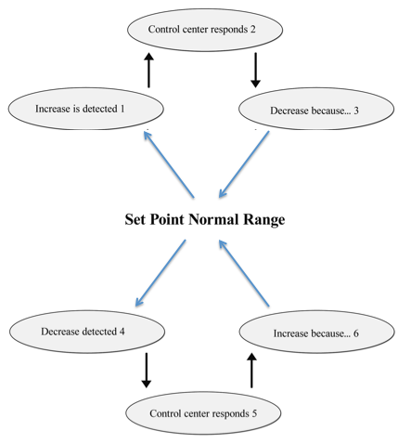
1. What is homeostasis?
_____________________________________________________________________________________
_____________________________________________________________________________________

Part B - Body Temperature Regulation
2. In the context of the example above, what is the role of the:
receptor: _____________________________________________________________________________
control center:_________________________________________________________________________
effector:______________________________________________________________________________

Part C - Blood Glucose Regulation

3. What would happen if your body couldn’t produce insulin?
_____________________________________________________________________________________
_____________________________________________________________________________________
_____________________________________________________________________________________

Part D - Blood Pressure Regulation

4. Do Parts A, B, C, and D demonstrate a positive or negative feedback system? ____________________
How do you know? _____________________________________________________________________
_____________________________________________________________________________________

Part A - Regulation of Oven Temperature at 375°F

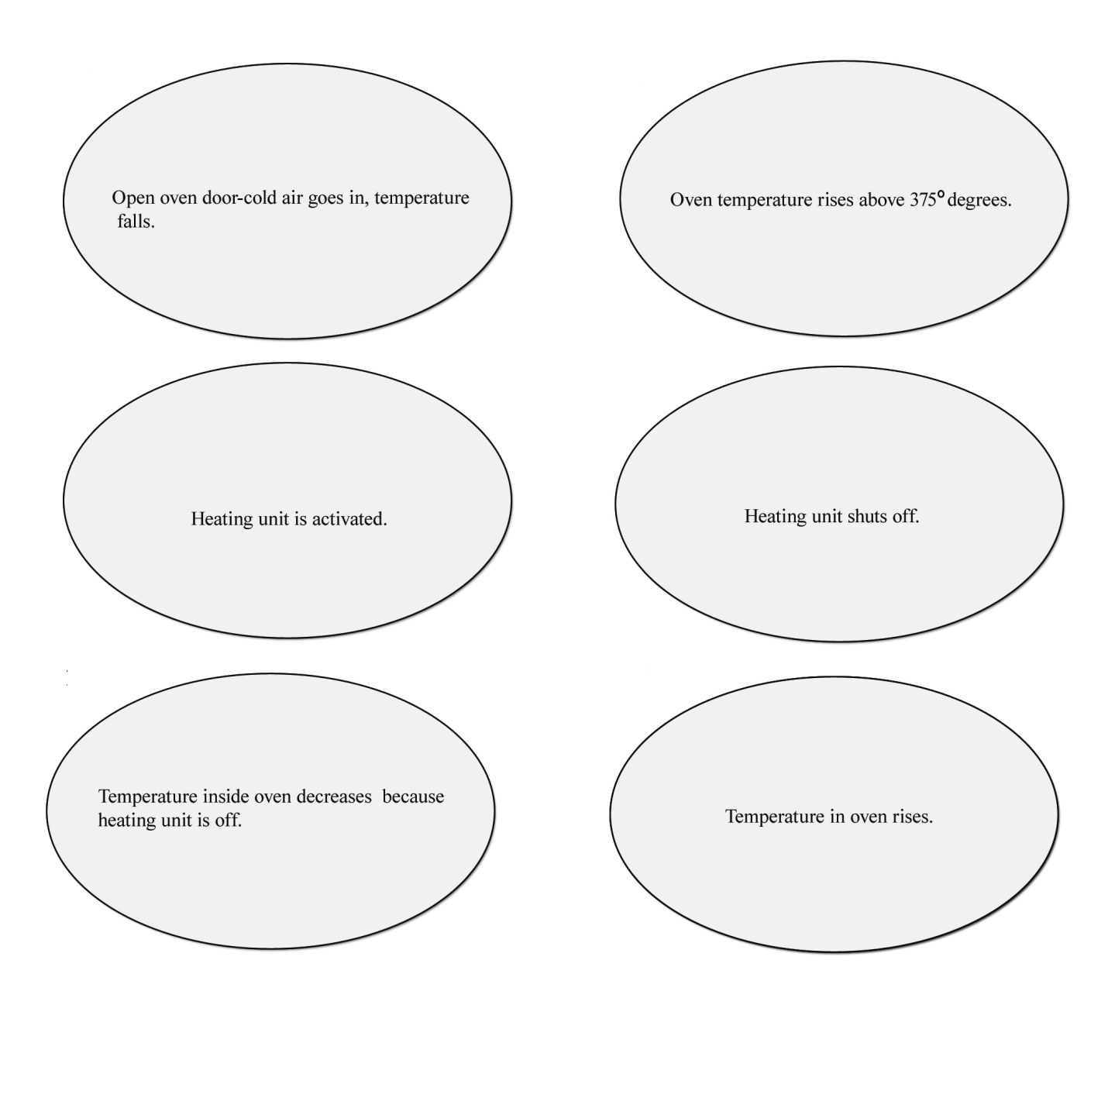

Part B - Body Temperature Regulation

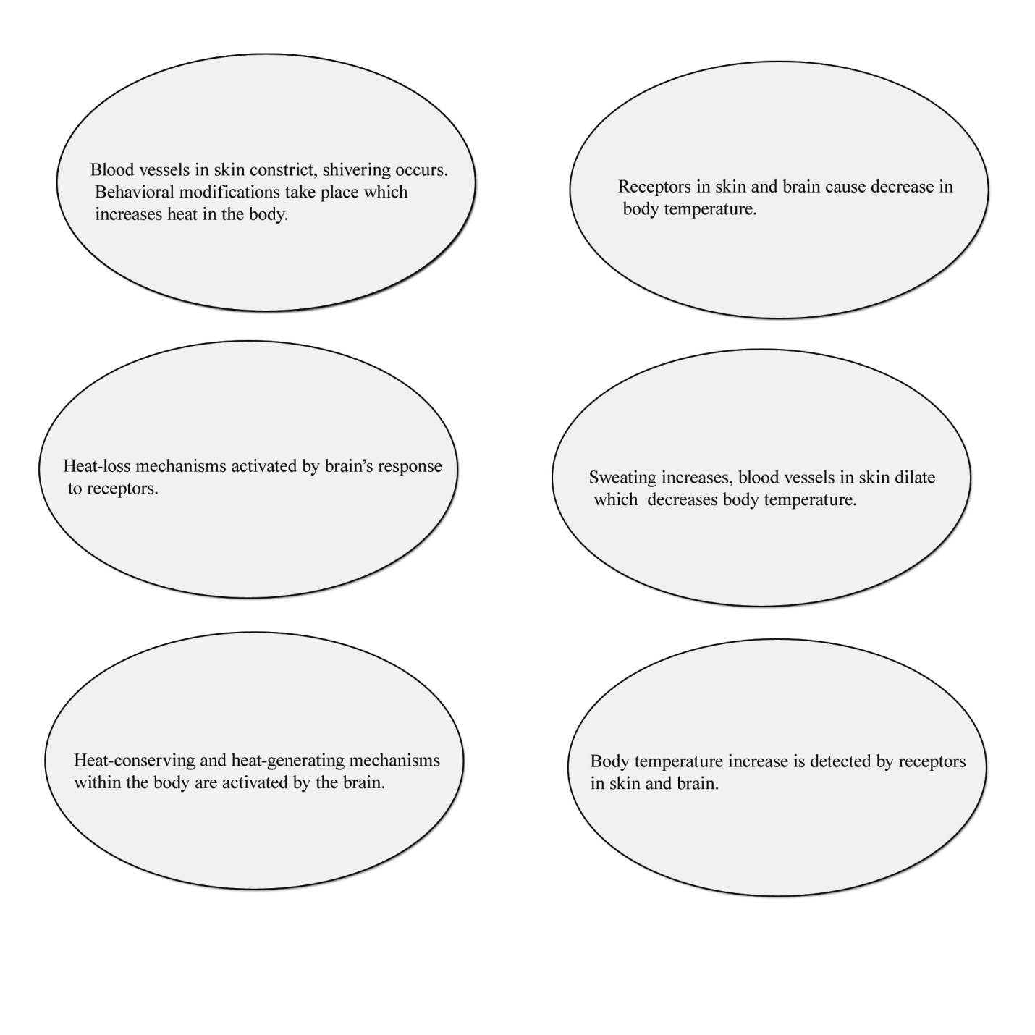

Part C - Blood Glucose Regulation

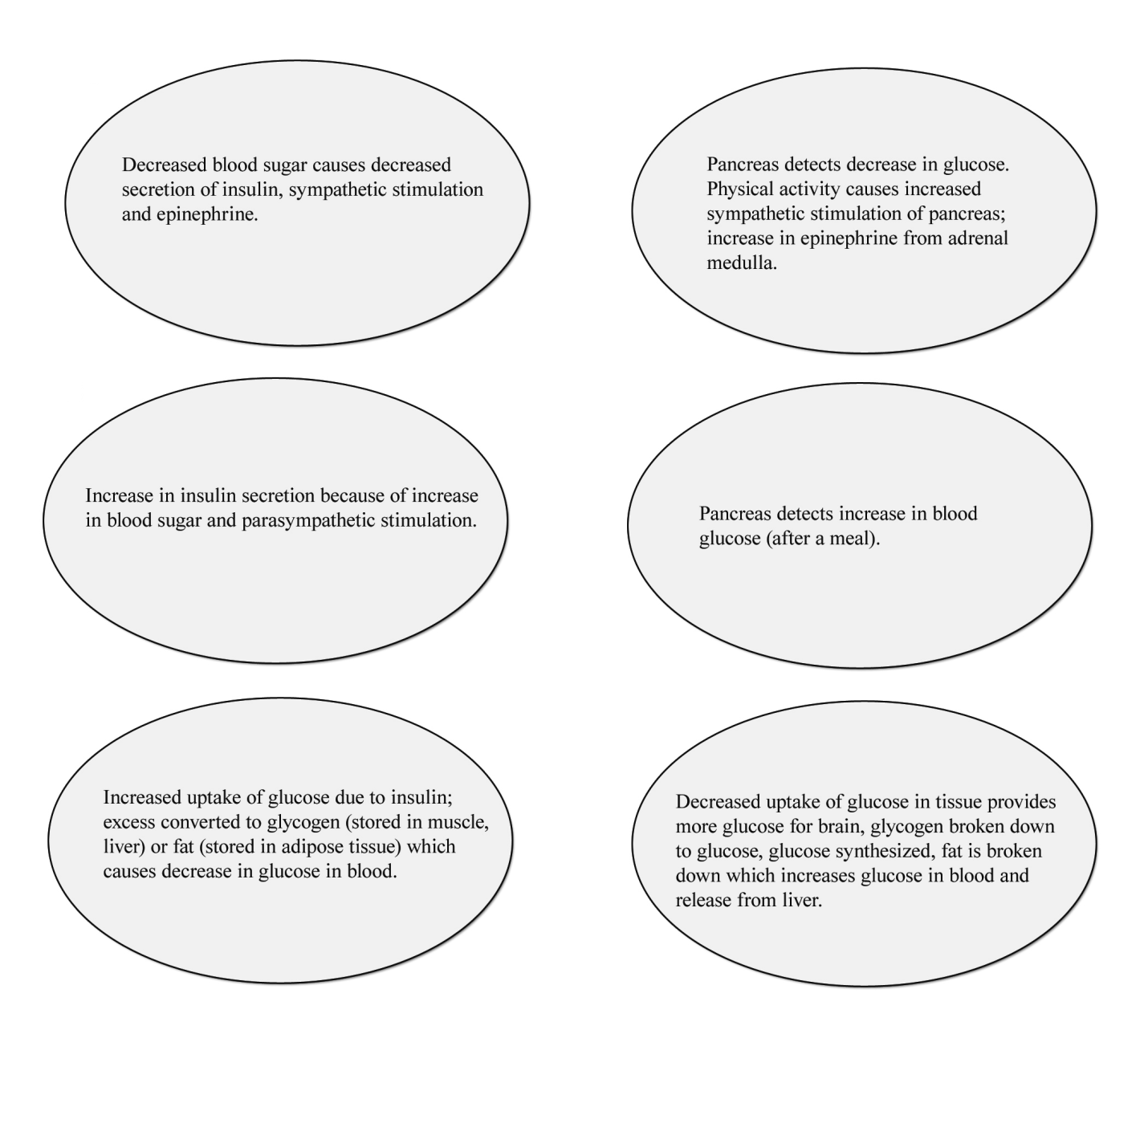

Part D - Blood Pressure Regulation

