Integumentary System
Station 1: Components and Functions
Read the information provided to identify the main components of the integumentary system. Then summarize its functions in the table below.
Parts of the Integumentary System

- __________________________________
- __________________________________
- __________________________________
- __________________________________
- _________________________________

Functions of the Integumentary System
1.
2.
3.
4.
5.

Layers of the Skin
Read the information provided to identify and describe the 2 layers of skin and the 1 layer underneath.
Layer | Tissue Type | Vascular? | Extra Info

Station 2: Structures of the Epidermis, Dermis, and Hypodermis
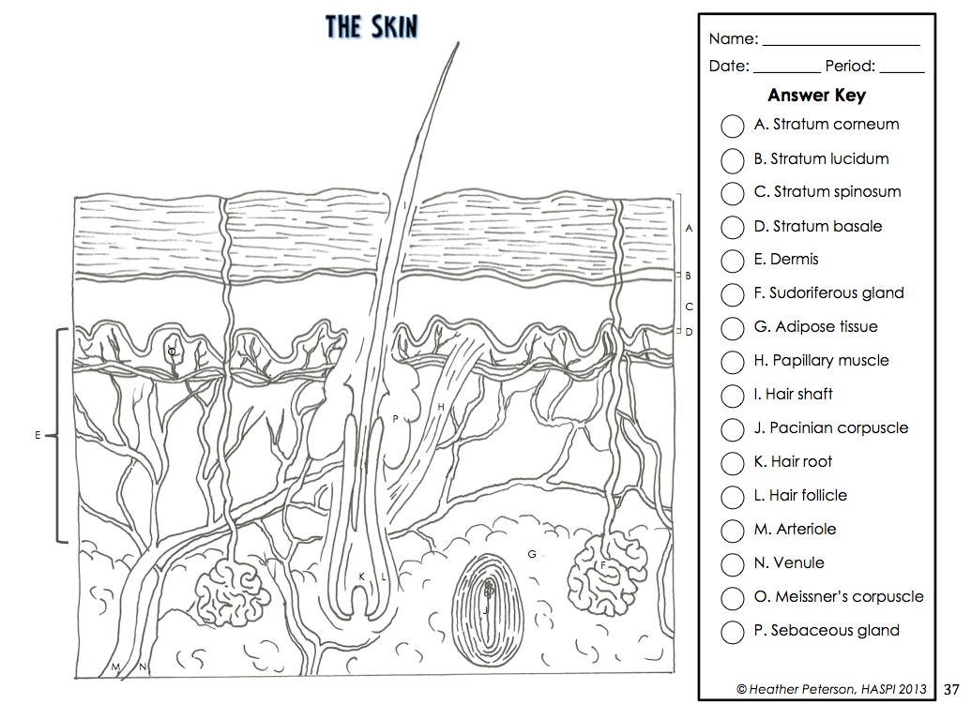
Using the key on the right and p. 114 in your text, color each structure in the diagram.
Deep
Superficial
According to the diagram, what are the 4 layers that make up the epidermis?
- ___________________________________
- ___________________________________
- ___________________________________
- ___________________________________
Eccrine Sweat Gland

Arrector pili muscle
Station 3: Layers of the Epidermis
Read the information provided to describe each of the 5 layers of the epidermis.
 | Layer | Description
Epidermis | Stratum corneum
 | Stratum lucidum
 | Stratum granulosum
 | Stratum spinsosum
 | Stratum basale

Skin Cell Turnover
The average person sheds more than 1 pound of skin every year and the outer layer – the stratum corneum – is completely replaced every month. In the space below, summarize how that happens.
- _________________________________________________________________________________________________
_________________________________________________________________________________________________
- _________________________________________________________________________________________________
_________________________________________________________________________________________________
- _________________________________________________________________________________________________
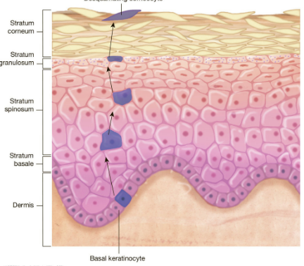
_________________________________________________________________________________________________

Station 4: Skin Color
Read the information provided to fill in the following page of notes.
Cell Type | Location | Function

Skin color

Determined by:
- ___________________________________________
- ___________________________________________
NOT determined by:
- ____________________________________________
Melanocytes and Sun Exposure

In the space below, summarize what happens when melanocytes are exposed to UV radiation
- _________________________________________________________________________________________________
- _________________________________________________________________________________________________
- _________________________________________________________________________________________________
- _________________________________________________________________________________________________
What happens if the UV radiation reaches the nucleus of the cell?

Condition | Skin Tone | Cause
Cyanosis

Jaundice
Albinism
Erythema
Pallor
Bruise (hematoma)
Station 5: Damage to the Skin
Damage Caused by Cuts

Superficial Cut – only effects the ________________________
Deep Cut – effects the ___________________ and __________________
- If you see _____________ you know you’ve cut into the dermis because the dermis has ______________________________ while the epidermis does not.
Damage Caused by Burns
Can be caused by:
- _________________________ 3. _________________________ 5. ________________________
- _________________________ 4. _________________________ 6. ________________________
Estimating % Body Affected
What percent of the patient shown below is affected by burns?
- Body is divided into ______ sections
- Each section represents _______ of the body
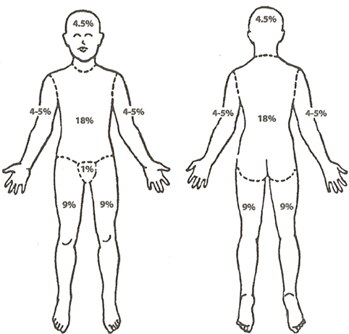
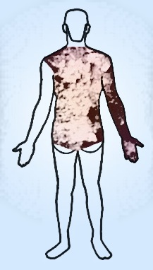
Types of Burns
Degree | Layer(s) of Skin Damaged | Signs and Symptoms | Extra Info
1st
2nd
3rd

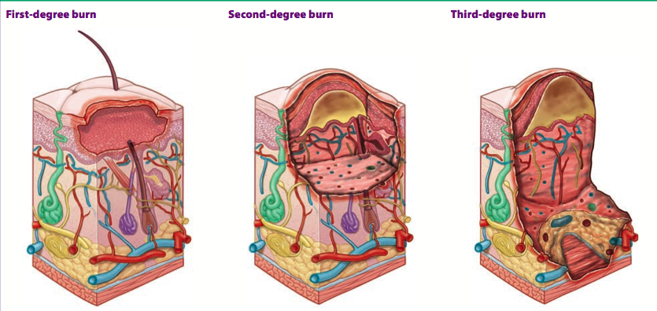
Sunscreen Lab
Since the number one risk factor for skin cancer is sun exposure, the use of sunscreen is the best prevention. Sunscreen is either made from chemical compounds that are able to absorb UV radiation, reflect UV radiation, or both. In addition, some sunscreens only block UV-B radiation while still allowing UV-A radiation to contact the skin. UV-A radiation will not cause sunburns, but can still increase the risk of skin cancer. Only broad-spectrum sunscreens actually block both UV-A and
UV-B radiation.

Sunscreens also have an SPF, or sun protection factor rating, that can range anywhere from
8 - 100+. The SPF rating refers to the amount of time it would take the sun to burn an individual with no sunscreen, compared to the time it would take to burn with the sunscreen. The SPF only refers to the ability of the sunscreen to block UV-B radiation. While there is some variation between SPF, many experts believe that the difference in the amount of protection over SPF 30 is very small, and also no sunscreen is 100% effective.

Objective
According to experts, there is little difference in the effectiveness of sunscreens over an SPF of 30. In this activity, you will use UV sensitive paper to determine whether there is a difference in the amount of UV radiation that passes through sunscreens of varying SPFs.

Materials
Transparency sheet Penny or dime Sunscreen 15 SPF
UV sensitive paper sheet Pencil or fine-tipped marker Sunscreen 30 SPF
Timer Water Sunscreen 50 SPF
Tape Cotton swabs (4) Sunscreen 100 SPF
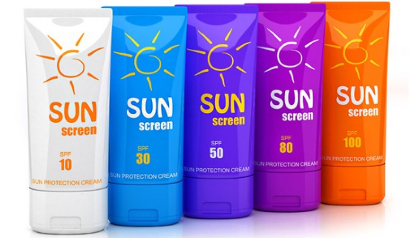
Directions                                                                                                                ✔when complete
Step 1 | IMPORTANT! The UV sensitive paper will react to any UV light so it is important to keep the UV sensitive paper covered, except during the experiment.
Step 2 | Obtain 4 Q-tips, a transparency sheet, a UV sensitive paper sheet, a black sheet, a pencil or marker, and a penny/dime. Make sure the UV sensitive paper is covered.
Step 3 | Using the pencil or marker and the penny as a guide, draw 5 circles on the transparency sheet. The pencil mark will be difficult to see, but an indent should be visible.
Step 4 | Label each of the 5 circles with the following: C, 15, 30, 50, and 100. The “C” stands for control and each number stands for the SPF that will be used.
Step 5 | The control circle will be left blank. Using a Q-tip collect a small amount of SPF 15 sunscreen and apply it to the circle labeled “15”. Make sure the circle is evenly covered. Discard the Q-tip.
Step 6 | Repeat step 5 for the SPF 30, 60, and 100 circles making sure to use a different Q-tip for each sunscreen.
Step 7 | Uncover the UV sensitive paper and place the transparency sheet over the blue side of the UV sensitive paper. Use a small amount of tape to tape the edges of the transparency sheet to the UV sensitive paper to hold it in place.
Step 8 | Have the timer ready and place the transparency + UV sensitive paper with the transparency side up in direct sunlight. Start the timer and leave the paper exposed for 5 minutes.
Step 9 | At the end of 5 minutes, remove the transparency + UV sensitive paper from the sunlight.
Step 10 | Remove the transparency sheet from the UV sensitive paper and run water over the UV sensitive paper for 30 seconds to 1 minute.
Step 11 | Let the UV sensitive paper dry on a paper towel.
Step 12 | Anywhere the paper was exposed to UV radiation will turn blue depending on the intensity UV radiation exposure. The whiter the area the less UV exposure. Record your results in Table 1.

Table 1. UV Sensitive Paper Observations - Record color change observations
Control | SPF 15 | SPF 30 | SPF 50 | SPF 100

Station 6: Skin Cancer

Type | Cells Affected | Signs and Symptoms | How Common? | How Dangerous?
Basal Cell Carcinoma
Squamous Cell Carcinoma
Melanoma

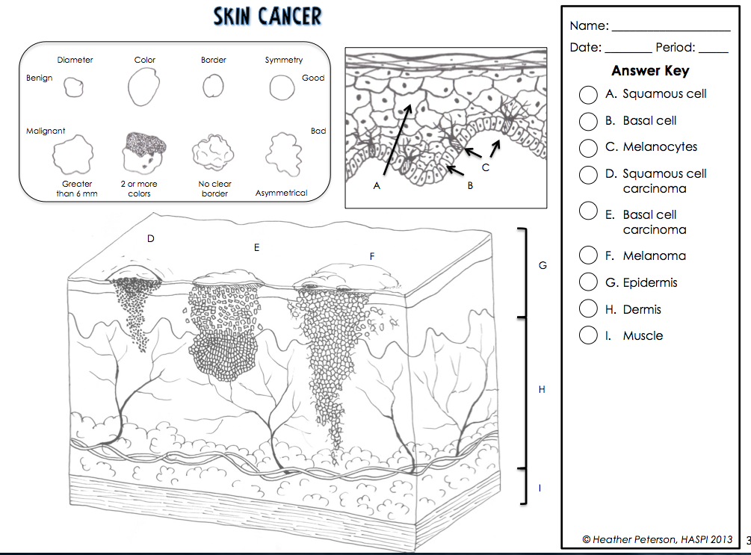
Using the key on the right, color each structure in the diagram.

Station 7: Hair, Nails, and Glands
Hair
Hair Location | Function
Eyelashes/Eyebrows
Nose Hair
Head Hair
Body Hair

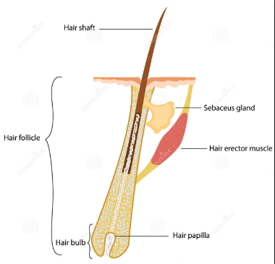
Use the diagram provided to label the structures in the picture below AND provide a brief description of each structure.

Hair Color and Texture

Hair Color | Melanin
Dark Hair
Blond Hair
Red Hair
Gray/White Hair

What determines the shape of hair?
What gives a person straight hair?
What gives a person curly hair?

Hair Growth and Loss
Summarize the process of hair growth:
- _____________________________________________________________
- _____________________________________________________________
- _____________________________________________________________
What is alopecia?
What are 5 causes of alopecia?

- _________________________
- _________________________
- _________________________
- _________________________
- _________________________

What two things are required for “male pattern baldness”?

___________________________ AND ___________________________
Nails

Nail Abnormalities | Indication
Cyanosis (blue-tinted)
Yellowish/thickened

Use the diagram provided to label the structures in the picture below AND provide a brief description of each structure
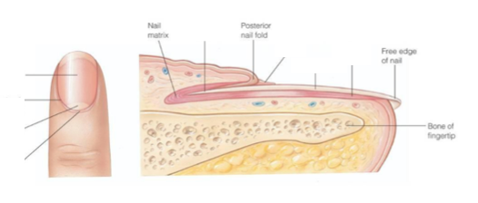

Glands
Type of Gland | Secretes | Function | Location
Eccrine
Apocrine
Sebaceous
Ceruminous
Sweat Gland Lab
There are more than 2 million pores that produce sweat on your skin. Sweat glands are very difficult to locate with the human eye, but this activity will allow you to identify the location of sweat glands on an area of your own skin.
Materials

- Cornstarch sheet
- Ruler
- Q-tips
- Iodine

Directions                                                                                                                          ✔when complete
Step 1 | Obtain a cornstarch sheet and place it on a paper towel. Do not touch with the iodine yet!
Step 2 | Use a Q-tip to spread iodine in an approximate 5 cm x 5 cm square on your palm. Discard the Q-tip in the trash and allow the iodine to dry completely.
Step 3 | Muscle contraction will create excess heat that will cause your body to release sweat in response. To do this you can either clench your hand into a fist and release repeatedly until your palms release sweat OR rub the ends of your hands together to create heat until your palms release sweat.
Step 4 | Check your palm to determine whether sweat has been released. As soon as there is evidence of sweat, press the cornstarch sheet firmly to your palm over the iodine.
Step 5 | The pores where sweat has been released will show up as dark spots on your cornstarch sheet. If no dark spots appear, repeat steps 3 and 4 until sweating does occur.
Step 6 | The color change occurs because cornstarch and iodine react to create the dark color, and only in the areas where sweat has made the iodine liquid will it stick to the cornstarch sheet.
Step 7 | Tape the cornstarch sheet with your results below.

Analysis Questions
- What caused sweat to be produced?

- Were the sweat pores on your palm evenly distributed? Explain why.

- Where do you think you would find the most sweat pores on your body?
Tape Your Results HERE:

Station 9: Diseases of the
Integumentary System Disorders
You and your group members will work together to produce a PowerPoint slide of an assigned disease of the Integumentary System. You will be given some reading material and laptops to conduct your research. Your group must then work to summarize the information to create your slide. You will then present your information to the class so they can fill in their notes.
Your slide should include the following information:
- Name of the disorder
- Cause of the disorder (genetic, shared contact, etc.)
- Signs and symptoms of the disorder
- Treatment of the disorder
- Appropriate picture of the disorder
- Any extra info that your group feels is important

Disorder | Cause | Symptoms | Treatment
Dermatitis

Tinea

Psoriasis

Urticaria

Cellulite

Acne

Chicken Pox
Staph Infection

