Integumentary Study Guide

- Know the functions of the skin.
- Know the general characteristics of the epidermis, dermis, and hypodermis. What type of tissue will you find in each? Where is each located? Are they vascular or avascular?
- Know the function and location of the stratum corneum and stratum basale.
- What is keratin and why is it found in the stratum corneum?
- Where are melanocytes found?
- What determines skin color? What determines hair color?
- What is the role of melanin?
- Know the various skin conditions, the color the skin will appear as, and the cause.
i.e. Cyanosis – blue skin – deficiency of oxygen

- If you get a cut, how do you know if you damaged just the epidermis or the epidermis and dermis?
- Know the difference between the three types of burns – layer(s) of skin affected, signs and symptoms, and treatment.

- Know the difference between the three types of skin cancer – cells affected, signs and symptoms, how common, and how dangerous.
- Know the functions of hair.
- Know the parts of the nail.

- Know the differences between eccrine, apocrine, sebaceous, and cerumen glands. What does each one secrete? Where is each one found?
- Know the various types of skin disorders based on their cause, symptoms, and treatment.

- Be able to label the following on a cross section of skin:
  - Epidermis
  - Dermis
  - Adipose
  - Arrector pilli
  - Blood vessels (arteries and veins)
  - Hair shaft
  - Hair bulb/root
  - Hair follicle
  - Eccrine gland
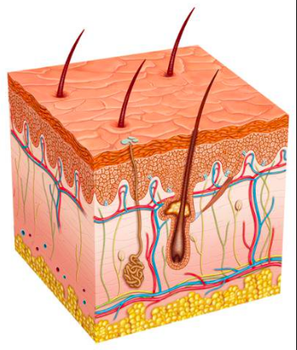
  - Sebaceous gland

