STATION 1

Anatomical Position
How many of you have seen anatomy diagrams/pictures and thought, “Boy, that body looks awfully stiff in that one position all the time”?
Which, okay, is true. But there’s a reason the bodies are always shown in that stance and look stiff as a board—it’s the position in which we study the body.
In the anatomical position, the body is upright, directly facing the observer, feet flat and directed forward. The upper limbs are at the body’s sides with the palms facing forward.
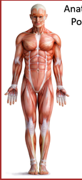
Like so:

You’ve probably seen all sorts of pictures of the body in your A&P textbooks that look like this. This stance should be very familiar to you. If not, it will be by the time you’re finished taking A&P!

STATION 1
Axial vs. Appendicular Skeleton

The skeleton can be thought of as 2 main divisions:

The Axial Skeleton, as the name implies, consists of those parts near the skeletal axis
- The skull
- The facial bones
- The vertebral column
- The ribs and sternum

The Appendicular Skeleton, as the name implies, consists of the parts of the appendages
- Upper limbs – scapula, humerus, radius, ulna, carpal bones, hand bones
- Lower limbs – pelvis, femur, tibia, fibula, tarsal (ankle) bones, foot bones

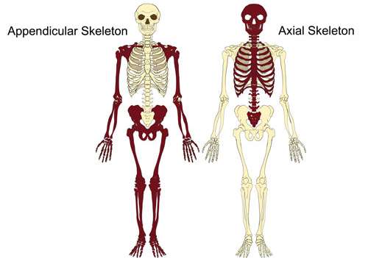

STATION 2

Body Cavities

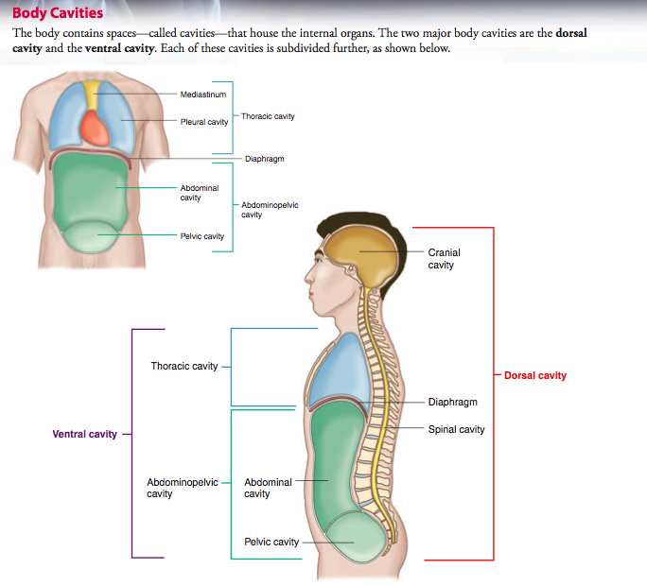
Use the information and diagram below to label the diagram in your notes.

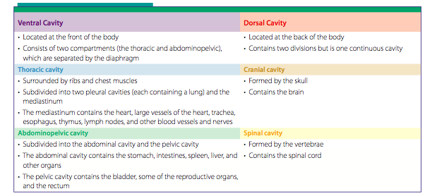

STATION 3

Terms of Relative Position

Read section 1.7 in your text, focusing on the section titled, “Relative Positions.” Use the information from the text and the diagram below to label the diagram in your notes AND provide a brief definition of each term.
Terms to use (they are not in this order in your note packet):
- Superior
- Inferior
- Anterior
- Posterior
- Medial
- Lateral
- Proximal
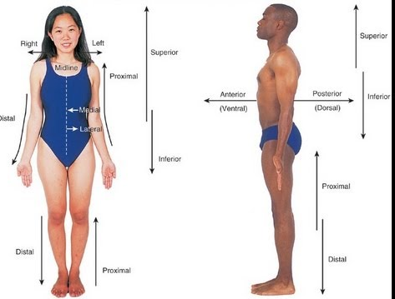
- Distal
- Superficial
- Deep

STATION 3

Body Planes
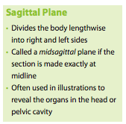
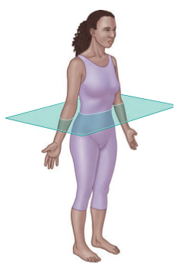
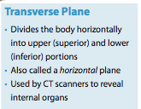
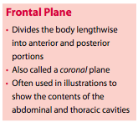
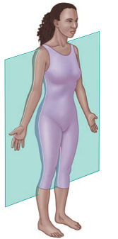
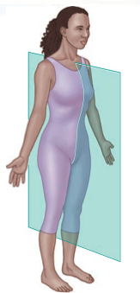
Use the information from the text and the diagrams below to label the diagram in your notes AND provide a brief definition of each term.

STATION 4
Body Regions

Use the information on p. 16-17 to find the anatomical terms for each body region listed in your notes. Then color in the regions marked with an asterisk (*) on your diagram with colors indicated.

STATION 4
Body Regions

Use the information on p. 16-17 to find the anatomical terms for each body region listed in your notes. Then color in the regions marked with an asterisk (*) on your diagram with colors indicated.

STATION 4
Body Regions

Use the information on p. 16-17 to find the anatomical terms for each body region listed in your notes. Then color in the regions marked with an asterisk (*) on your diagram with colors indicated.

STATION 5
Body Systems

Using the cards provided, work with your partner and match each system with its appropriate Structures/Major Organs AND Functions. Once your teacher gives you the okay that all systems are correct, use the information on the cards to fill in your notes.

STATION 5
Body Systems

Using the cards provided, work with your partner and match each system with its appropriate Structures/Major Organs AND Functions. Once your teacher gives you the okay that all systems are correct, use the information on the cards to fill in your notes.

STATION 5
Body Systems

Using the cards provided, work with your partner and match each system with its appropriate Structures/Major Organs AND Functions. Once your teacher gives you the okay that all systems are correct, use the information on the cards to fill in your notes.

