The Nervous System
Consists of: (Station #1)

- _________________________
- _________________________
- _________________________

Functions of the Nervous System

____________________________ Function
- Uses sensory receptors and nerve endings to ___________________________
________________________________________________________________________________________________________________________

___________________________ Function
- Uses the sensory information received and relates it to past experiences, allowing us to make ________________________________________________________________________________

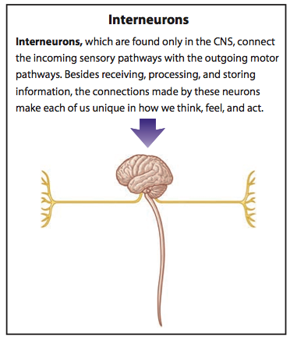

___________________________ Function
- Utilizes effectors (__________________ and _______________) to act on the decisions made by the Central Nervous System

Divisions of the Nervous System (Station #2)
_________________________________________________________ (CNS)
- Consists of
  - ________________________
  - ________________________
_________________________________________________________ (PNS)
- Nerves that connect CNS to the rest of the body
  - ______________________ nerves – capable of __________________________________________
  - ______________________ nerves - capable of __________________________________________
Divisions of the Peripheral Nervous System (PNS)

*Use the video provided at https://www.youtube.com/watch?v=zeo19WVQ47w to summarize the divisions of the PNS.

Two parts:

- ________________________ - carries information from ________________________ to ______________
- ________________________ - carries information from ____________ to __________________________
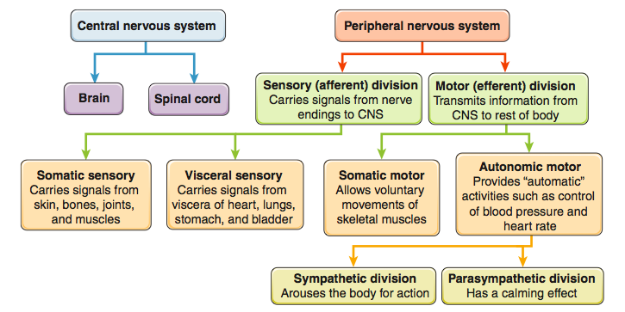
Nervous Tissue (Station #3)

Nervous tissue consists of two types of cells:

- __________________- _____________________________________________________________________________
_________________________________________________________________________________________________
- What is a nerve impulse? _________________________________________________________ _________________________________________________________________________________________
- ___________________________________ - cells that provide _________________________,
_________________________, ________________________, and __________________________ for neurons.
Neuroglial Cells
Name | Location | Function | Extra Info
Schwann Cells
Astrocytes
Oligodendrocytes
Microglial
Ependymal

Types of Neurons (Station #4)

Neurons Classified by Structure
Name | Description | Location | Sketch

Neurons Classified by Function
Name | Function | Location

Neuron Structure (Station #5)
- Label the following parts of the neuron –

- Cell body
- Nucleus
- Axon
- Dendrite
- Myelin sheath
- Node of Ranvier

- For each part you label, also provide a brief description of that structure’s function

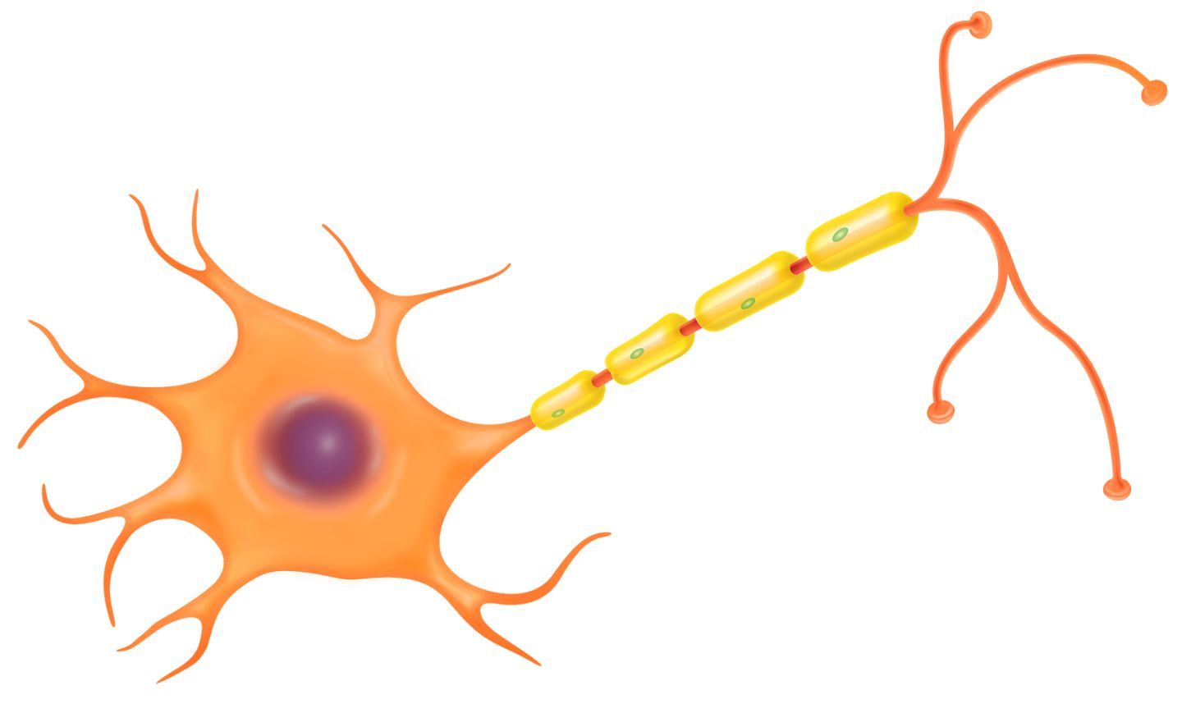
Myelination of Axons

Myelinated vs. Unmyelinated

- Not all nerve fibers are __________________________.
- Unmyelinated nerve fibers conduct ______________________________ more ________________.
  - Example: _____________________________________________________________________________
- Myelinated nerve fibers are used when __________________ is more important
  - Example: ____________________________________________________________________________
PNS vs. CNS
- In the PNS, the myelin sheath is formed by ________________________ cells.
  - The __________________________ cells wrap themselves around the _________________ and lay down multiple _________________________ of _________________________________.
  - The nucleus and cytoplasm are in the _____________________________________________ known as the ______________________________.
    - The neurilemma is essential for ____________________________________________
________________________________________________________________________________
- In the CNS, the myelin sheath is formed by _____________________________________________.
  - One ________________________________________ forms the myelin sheath for ________________________________________.
  - The nucleus is located _____________ from the myelin sheath and outward ___________________________ wrap around the nerve. As a result, there is _________ __________________________________.
    - With no neurilemma, injured neurons in the CNS can’t _________________.
    - Explains why paralysis from a spinal cord injury is ____________________.
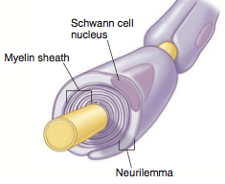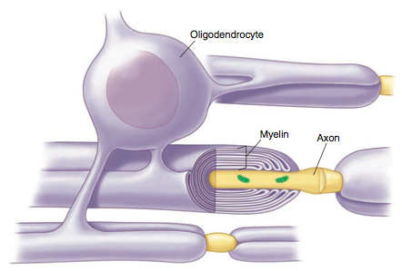
Nerve Impulse Transmission
Cell Membrane Potential
- _____________________________________ - Whenever ions with opposite charges are separated by a membrane, the potential exists for them to move toward one another
- ________________________ - A membrane that exhibits membrane potential has an excess of ________________________ ions (_________, ____________) on one side, and an excess of _____________________ ions (_________, ___________) on the other side
Resting Potential
- The _________________of a neuron is ______________________ relative to the __________________.
  - Inside: Has permanent negative ions and high _________ concentration
  - Outside: Has high __________ concentration
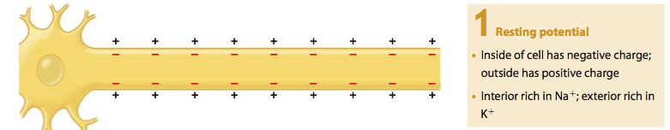
Depolarization
- Stimulation of a membrane can affect its resting potential
  - ___________________________________________, ____________________, _______________________
- When a stimulus comes along, ____________________________________, causing Na+ to _____________________________________________.
- The membrane potential then becomes ___________________________ and the membrane is ___________________________
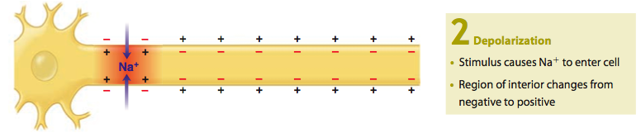
Action Potential
- If strong depolarization occurs, a _____________________________________ is achieved and
_____________________________________________________.
- When threshold is reached, an ____________________________________ (aka: __________________
______________________ ) is created.
- The ____________________________________ continues down the axon as one segment ________________________________________________________________________________________________.
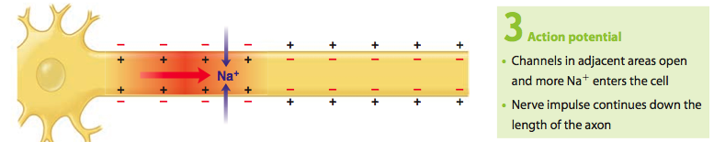
Repolarization
- The sudden increase in _________ triggers the opening of channels to allow ____________
_______________________________________________, thus ______________________________ the cell
  - Inside = __________________________________
  - Outside = _________________________________
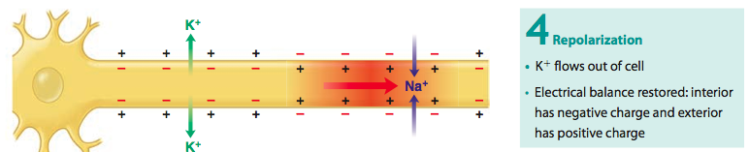
Refractory Period
- The ___________________________________________ works to return the ___________ to the outside and the _________ to the inside and thus returns the cell to its rest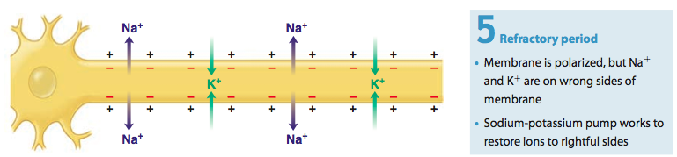
Impulse Conduction
- Unmyelinated fibers – conduct impulses over ____________________________________________
- Myelinated fibers – conduct impulses from _______________________________________________
  - Leap frogs its way down the neuron which is much faster!
All-or-None Response
- All-or-None Response - _____________________________________________________________________
  - If the threshold isn’t reached, the neuron doesn’t fire
- All impulses carried on an axon or the _____________________________________
  - A stronger impulse doesn’t produce a stronger response
Communication Between Neurons
- _____________________________________ usually travel through _________________________________
_______________________ before reaching their target _________________________________________
- Thus, the neurons must have some way of transferring the impulse from one neuron to the next.
The Synapse
- Synapse - _____________________________________________________________________________________
- Synaptic Cleft - _______________________________________________________________________________
- Presynaptic Neuron - ________________________________________________________________________
- Postsynaptic Neuron - _______________________________________________________________________
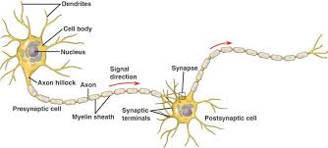
Synaptic Transmission
- Nerve impulse crosses the ___________________________________ to reach the
___________________________________________ using ___________________________________________

  - Neurotransmitters are stored in synaptic vesicles
- ___________________________________________ bind to _______________________________ on the
___________________________________________ and allows the impulse to continue
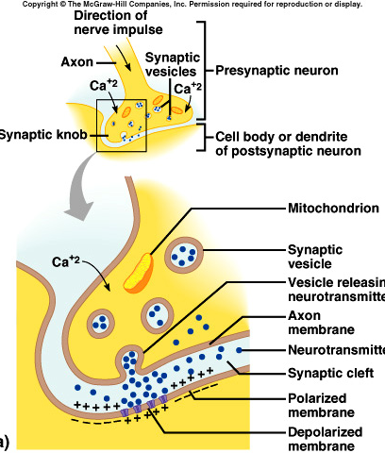

Types of Neurotransmitters
- Excitatory - ___________________________________________________________________________________
  - Acetylcholine – involved in ________________________________________________
  - Norepinephrine – involved in _______________, creates _____________________________
- Inhibitory - ___________________________________________________________________________________
  - Serotonin – involved in _____________________________________________________________

Reflexes
- Reflexes - _____________________________________________________________________________________
_________________________________________________________________________________________________
  - Two types
    - __________________________ - ____________________________________________________
    - __________________________ - ____________________________________________________
- Reflex arc
  - Includes:
    - _____________________________________
    - _____________________________________
    - _____________________________________
    - _____________________________________
    - _____________________________________

- Knee-jerk Reflex – helps maintain an upright posture
- Withdrawal Reflex – prevents or limits tissue damage

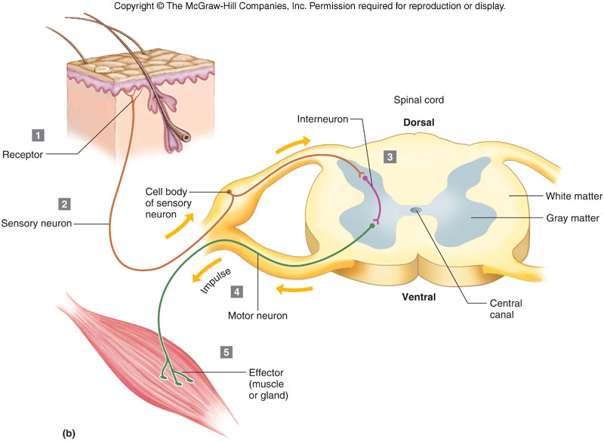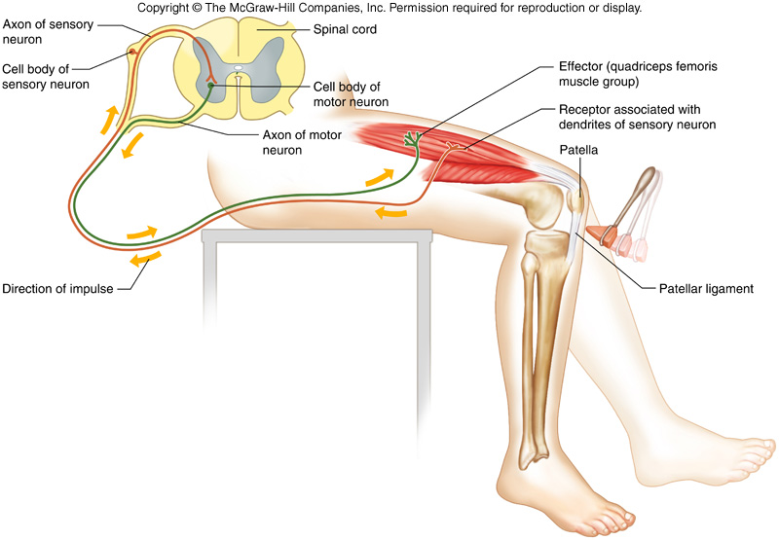

Central Nervous System
Protective Coverings
- Outer Coverings:
  - Brain - _____________________
  - Spinal cord - __________________________________

Meninges
Primary Structure
Structure | Location | Function | Extra Info
Meninges
Secondary Structures
Structure | Location | Function | Extra Info
Dura Mater
Arachnoid Mater
Pia Mater
Subarachnoid Space

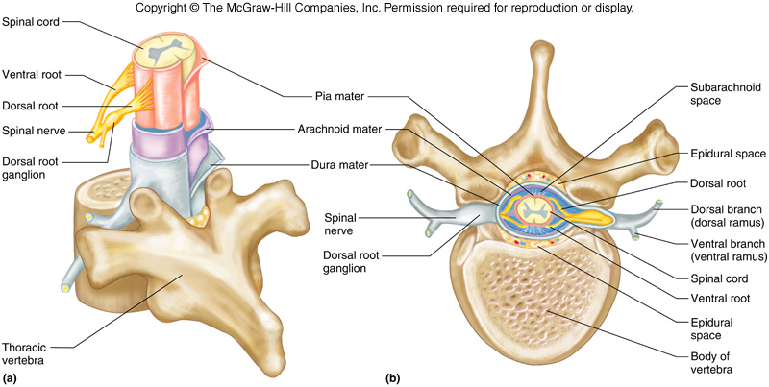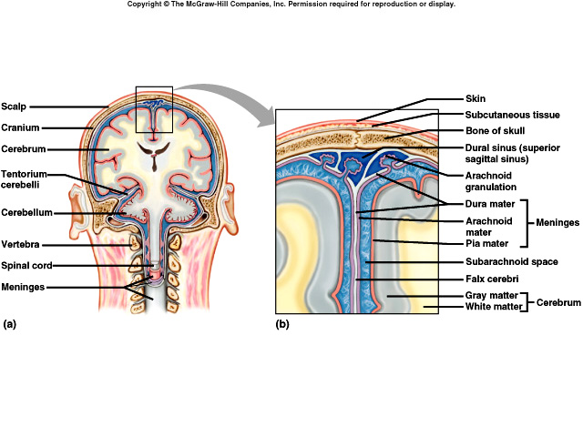
Spinal Cord
Primary Structure
Structure | Location | Function | Extra Info
Spinal Cord
Secondary Structures
Structure | Location | Function | Extra Info
Posterior Horn
Anterior Horn
Cervical Enlargement
Lumbar Enlargement
Spinal Nerves

Cross Section of Spinal Cord
- Spinal Nerves
  - Dorsal root - _____________________________________
  - Ventral root - ____________________________________
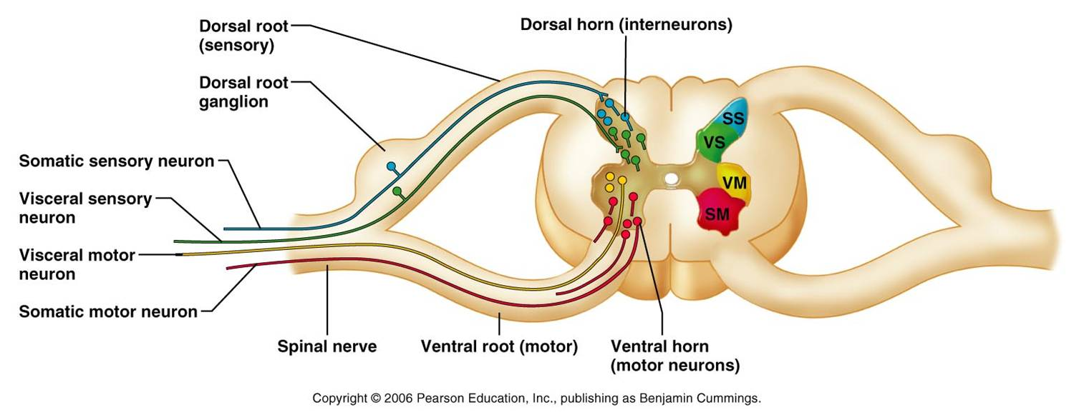
Brain

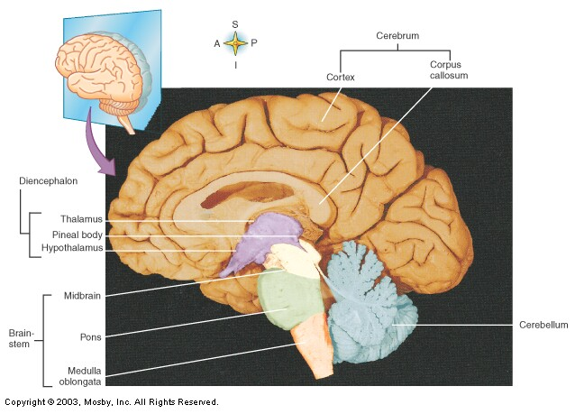
- Major Parts:
  - _____________________________
    - Medulla oblongata
    - Pons
    - Midbrain

  - _____________________________
  - _____________________________
  - ____________________________
    - Right hemisphere
    - Left hemisphere

- Functions of the brain:

  - ____________________________________
  - ____________________________________
  - ____________________________________
  - ____________________________________
  - ____________________________________
  - ____________________________________
  - ____________________________________
  - ___________________________________

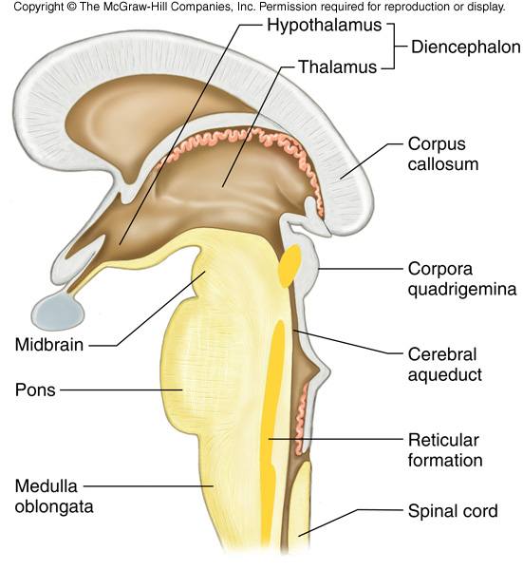
- Brain stem
  - Connects cerebrum to spinal cord
  - Consists of 3 parts
    - _____________________________
    - _____________________________
    - _____________________________

Brain Stem

Primary Structure
Structure | Location | Function | Extra Info
Brainstem
Secondary Structures
Structure | Location | Function | Extra Info
Medulla Oblongata
Pons
Midbrain

Cerebellum

Primary Structure
Structure | Location | Function | Extra Info
Cerebellum
Secondary Structures
Structure | Location | Function | Extra Info
Limbic System
Hippocampus
Amygdala
Diencephalon
Primary Structure
Structure | Location | Function | Extra Info
Diencephalon
Secondary Structures
Structure | Location | Function | Extra Info
Thalamus
Hypothalamus

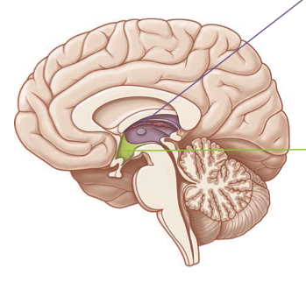
Cerebellum
Brainstem
Midbrain
Pons
Medulla Oblongata
Diencephalon
Hypothalamus
Thalamus
Cerebrum

Primary Structure
Structure | Location | Function | Extra Info
Cerebrum
Secondary Structures
Structure | Location | Function | Extra Info
Corpus callosum
Gyri/Sulci
Longitudinal fissure
Transverse fissure

Lobes of Cerebral Hemispheres

- _____________________________ - Anterior portion of each hemisphere
- _____________________________ - Posterior to the frontal lobe
- _____________________________ - Inferior to the frontal and parietal lobes
- _____________________________ - Posterior portion of each hemisphere

Structure | General Location  (Anterior/Poster  Superior/Inferior, etc.) | Function | What would happen if we didn’t have it/if it was impaired?
Frontal Lobe
Parietal Lobe
Temporal Lobe
Occipital Lobe

Structure | Location  (which lobe?) | Function | What would happen if we didn’t have it/if it was impaired?
Broca’s Area
Prefrontal Cortex
Motor Cortex
Sensory Cortex
Auditory
Cortex
Visual Cortex

Peripheral Nervous System

Peripheral Nervous System

- Consists of nerves that branch out from the CNS and connect it to other body parts
- Includes:
  - ___________________________ - arise from the __________________
  - ___________________________ - arise from the _____________________________

Somatic Nervous System

- Cranial and spinal nerves that connect to _______________ and _____________________________
- _______________________ activities
Autonomic Nervous System
- Nerve fibers that connect _________________ to ___________________ (heart, stomach, etc.)
- ________________________ activities
- Two divisions
  - ___________________________________ - prepares body for fight or flight situations
    - Examples:
  - ___________________________________ - prepares body for resting and digesting
    - Examples:
Nerve Fiber Classification
- _________________________ (afferent) Nerves - conduct impulses to brain or spinal cord
- _________________________ (efferent) Nerves – conduct impulses to muscles or glands
- _________________________ Nerves – contain both sensory and motor nerve fibers

  - Most nerves
Cranial Nerves

Number | Name | Sensory/  Motor/Mixed | Function
Spinal Nerves

- All _______________________ nerves
- ________ pairs
  - 8 cervical nerves
  - 12 thoracic nerves
  - 5 lumbar nerves
  - 5 sacral nerves
  - 1 coccygeal nerve

Plexuses

- __________________________ - complex networks formed from spinal nerves

Cervical Plexus
- Lies deep in the __________________
- Supply muscles and skin of the neck

Brachial Plexuses

- Spinal nerves of ____________________
- Lies deep within ___________________
- Nerves:
  - Musculocutaneous
  - Ulnar
  - Median
  - Radial
  - Axillary

Lumbosacral Plexuses

- Spinal nerves of ___________________
- Extend from _________________________________
- Nerves:
  - Obturator
  - Femoral
  - Sciatic
