**Introduction to Human Anatomy and Physiology**

|  |  |  |
| --- | --- | --- |
|  | **Definition** | **Example** |
| **Anatomy** |  |  |
| **Physiology** |  |  |

**Function First, Form Follows (FFFF)**

* What do you think this means? Write your thoughts below.  
  ________________________________________________________________________________________________________________________________________________  
  ________________________________________________________________________
* What did the Greeks say it means?

________________________________________________________________________

________________________________________________________________________

________________________________________________________________________

**Practice/Pre-Lab**

* 1. Think of any type of tool (cooking, construction, etc.).
  2. Each tool is designed a specific way in order to perform a specific task.
     + Identify a specific function of that tool
     + Identify the specific part of that tool that allows it to perform that function

|  |  |  |
| --- | --- | --- |
| **Tool** | **Specific Function** | **Specific Part** |
| *Spatula* | *Can slide under pancakes* | *Flat surface* |
| *Screwdriver* | *Can be held easily* | *Slim handle* |
|  |  |  |
|  |  |  |
|  |  |  |
|  |  |  |

**Characteristics of Life**

\**Read Section 1.3 and 1.4 in your textbook and use the information to fill in this page of notes.*

**Just Remember – ____________________________!**

* 1. _________________- increase in size without change in shape
  2. _________________- new organisms or new cells
  3. _________________- gettingoxygen, removing of CO2  (not strictly breathing)
  4. _________________- reaction to change, inside OR outside the body
  5. _________________- movement of “stuff” through cell membranes **into** fluids
  6. _________________- movement of “stuff” **within** body fluids - one place to another
  7. _________________- removal of wastes from metabolic reactions
  8. _________________- change of position of body part or internal organ
  9. _________________- changing nutrients into chemically different forms
  10. _________________- breakdown of food into simpler forms

**Requirements of Living Things**

Life depends on the availability – QUALITY and QUANTITY - of the following:

|  |  |
| --- | --- |
| **Substance** | **What it does for the body** |
| 1*. Water* | *Metabolic reactions, transport of substances, temperature regulation* |
| 2. |  |
| 3. |  |
| 4. |  |
| 5. |  |

**Homeostasis   
  
Homeostasis -** _______________________________________________________________

* ________________________________ – process in which the presence of a stimulus initiates a response within the body

_____________________________

_____________________________

____________________________

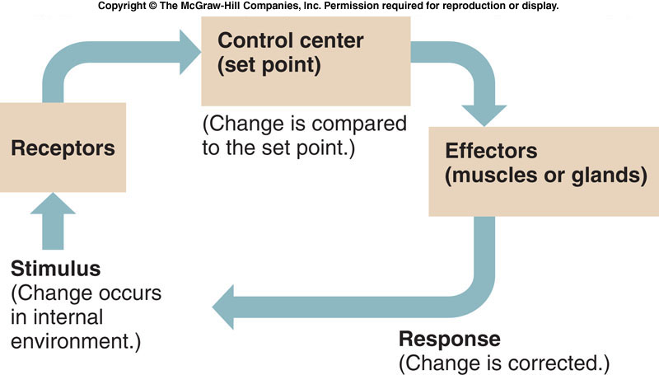

_________________

_________________

_________________

_________________

_________________

_________________

_________________

_________________

_________________

_________________

**Negative Feedback Mechanism** - _________________________________________________

______________________________________________________________________________

__________________________________________________________________

* Majority the body's homeostatic controls are ________________________________

*Example: The classroom thermostat is set at 68° F. Draw a diagram that indicates what happens when the temperature of the room* ***increases*** *and label the necessary components.*

*Include: Control Center, Set Point, Stimulus, Receptor, Effector*

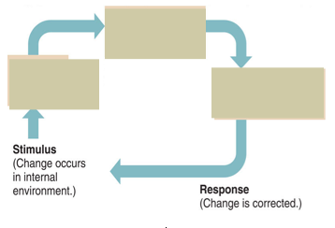

*Example: The classroom thermostat is set at 68° F. Draw a diagram that indicates what happens when the temperature of the room* ***decreases*** *and label the necessary components.*

*Include: Control Center, Set Point, Stimulus, Receptor, Effector*



Other Negative Feedback Examples:

1. _______________________________ 3. _______________________________
2. ________________________________ 4. _______________________________

**Positive Feedback Mechanism -__**________________________________________________

_____________________________________________________________________________

***Examples:***

* + 1. Nursing – baby sucking releases oxytocin = increased milk production until nursing stops
    2. Birth – oxytocin is released = increased speed of contractions until the baby is born
    3. Blood clotting – platelets cling to injured site and release chemicals to bring more platelets until the bleeding has stopped



**Stimulus** (Change occurs in internal environment)

**Response** (Change is encouraged to continue)

**Levels of Organization**

|  |  |  |
| --- | --- | --- |
| **Level** | **Definition** | **Example** |
| 1*. Organelle* | *Used to carry out a specific function in the cell* | *Mitochondria, Nucleus, Ribosome* |
| 2. |  |  |
| 3. |  |  |
| 4. |  |  |
| 5. |  |  |
| 6. |  |  |

Pneumonic Device: ___________________!

**STATION #1**

**Axial vs. Appendicular** – *Using the diagrams and readings provided:*

* *Color the Axial Portion of your supermodel skeletons* ***YELLOW***
* *Color the Appendicular Portion of your supermodel skeletons* ***RED***

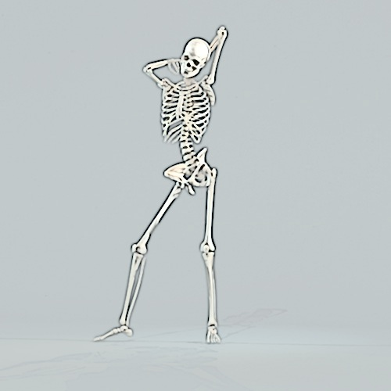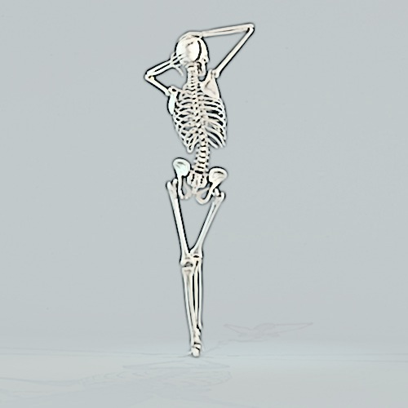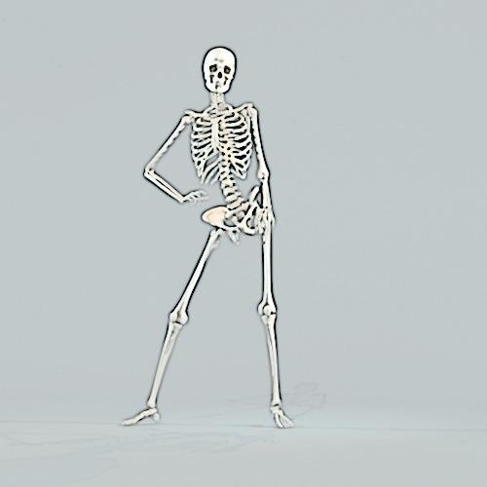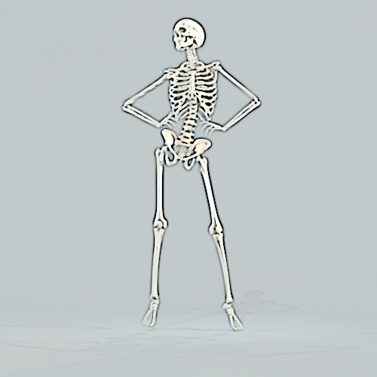

**Anatomical Position**

Definition: ____________________________________________________________________

*\*In the space below, draw a picture of a person (stick or otherwise) in anatomical position.*

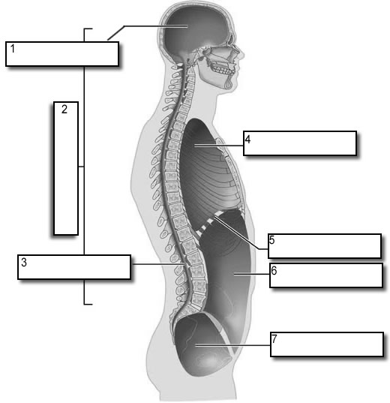**STATION #2**

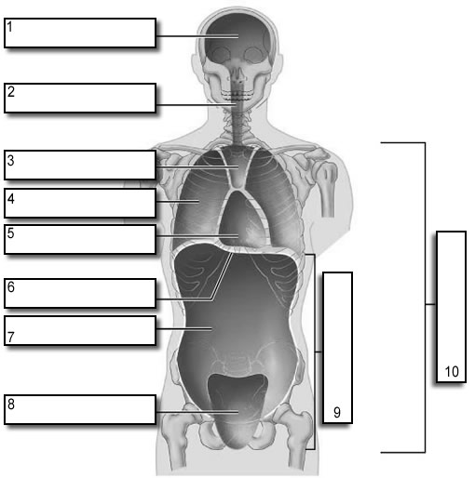

Diaphragm

Diaphragm

**Body Cavities** – *Using the diagrams provided, label the body cavities shown below.*

**STATION #3**

**Terms of Relative Position** – *Use the diagrams provided to label the terms of relative position AND provide a brief description/definition of each term.*

**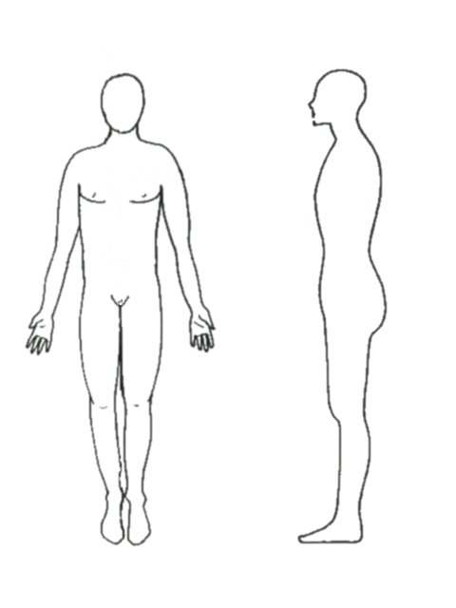***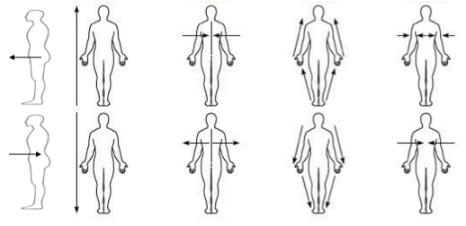*

**

**Body Planes** - *Use the diagrams provided to draw in the three different body planes AND provide a brief description/definition of each term.*

Transverse

Frontal/Coronal

Midsagittal

Sagittal

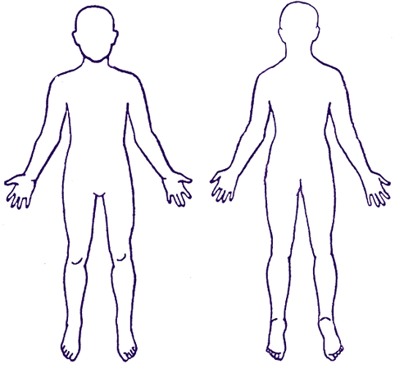****

**STATION #4**

**Body Regions** – *Use p. 16 and 17 in your textbook to find the anatomical terms for each body region listed below. Then color in the regions marked with an asterik (*) on your diagrams with the colors indicated.*

* ___________ - head

*___________ - forehead *(red)*

* ___________ - eye cavity
* ___________ - nose

*___________ - mouth *(orange)*

* ___________ - cheek
* ___________ - neck

*___________ - chin *(yellow)*

* ___________ - middle of chest
* ___________ - armpit

*___________ - arm *(green)*

* ___________ - ribs
* ___________ - abdomen
* ___________ - navel

* ___________ - forearm *(blue)*

* ___________ - wrist *(purple)*

* ___________ - finger
* ___________ - knee
* ___________ - foot

* ___________ - back of head *(blue)*

* ___________ - point of shoulder

* ___________ - spinal column *(green)*

* ___________ - back

* ___________ - lumbar back *(purple)*

* ___________ - buttocks

* ___________ - thigh *(red)*

* ___________ - back of knee

* ___________ - sole of foot *(yellow)*



|  |  |  |
| --- | --- | --- |
| **System Name** | **Major Organs** | **Functions** |
| 1. Integumentary |  |  |
| 2. Skeletal |  |  |
| 3. Muscular |  |  |
| 4. Nervous |  |  |
| 5. Endocrine |  |  |
| 6. Cardiovascular |  |  |

**STATION #5**

**Body Systems** – *Using the cards provided, work with your partner and match each system with its appropriate Structures/Major Organs AND Functions. Once your teacher gives you the okay that all systems are correct, use the information on the cards to fill in your notes.*

|  |  |  |
| --- | --- | --- |
| **System Name** | **Major Organs** | **Functions** |
| 7. Lymphatic |  |  |
| 8. Respiratory |  |  |
| 9. Digestive |  |  |
| 10. Urinary |  |  |
| 11. Reproductive  (male) |  |  |
| (female) |  |  |