Muscular System Notes
Station 1 – Function and Types of Muscular Tissue
Read the paragraph at the top of the information provided to describe the function(s) of muscle. Then provide a few examples.
Function: __________________________________________________________________________________________________
Examples:
- ______________________________________________________________________________________________________
- ______________________________________________________________________________________________________
- ______________________________________________________________________________________________________
- ______________________________________________________________________________________________________
- ______________________________________________________________________________________________________
This station is review from our histology unit. Fill in what you remember or use the information provided to help jog your memory.

Types of Muscular Tissue
Type | Location | Voluntary or Involuntary? | Appearance/Characteristics
Cardiac
Muscle
Smooth
Muscle
Skeletal
Muscle
Station 2 – Connections and Characteristics
What structures do muscles attach to?

- __________________________
- __________________________
- ___________________________________________________

How do muscles attach to other structures?

- ________________________ - ______________________________________________________________________
- ________________________ - ______________________________________________________________________

Characteristics of Muscle Tissue

Muscle Fiber Arrangement (Label and draw the arrangements below)

_______________ _______________ ________________ _________________ ________________

Station 3 – Skeletal Muscle Structure
Read the information provided on the diagram to label each structure found in skeletal muscle AND provide a brief description of each.
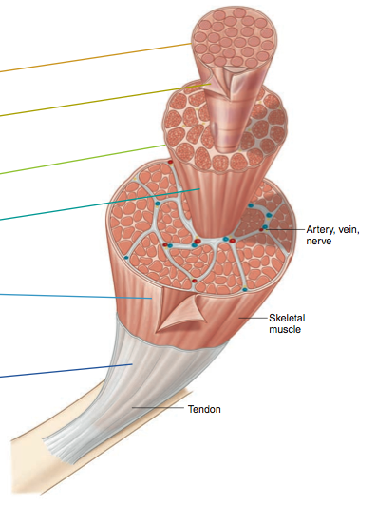

Once you have each structure labeled with its description, send one person up to Ms. Steffen to:
- check off the answers
- pick up a box of supplies with an instruction sheet on what to do next.

Station 4 – Muscle Fiber Structure
Now let’s zoom in on one single muscle cell…

What is a muscle cell called? _________________________________________________
Read the information provided on the diagram to label each structure found in a single muscle fiber AND provide a brief description of each.
Terms to use: Actin, Myosin, Myofibril, Myofilaments, Sarcolemma, Sarcoplasm, Sarcoplasmic reticulum, Thick filaments, Thin filaments, Transverse tubules

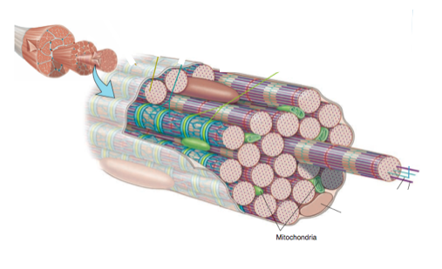

Once you have each structure labeled with its description, send one person up to Ms. Steffen to:
- check off the answers
- pick up a box of supplies with an instruction sheet on what to do next.
Station 5 – Actin and Myosin
Use the information provided to answer the questions below.
- Describe a myosin molecule. Include all of its components.
____________________________________________________________________________________________________________________________________________________________________________________________________________
- Draw a picture of a myosin molecule AND label its parts.
- Draw a picture of a myosin filament AND label its parts.
- Describe an actin filament. Include all of its components.
____________________________________________________________________________________________________________________________________________________________________________________________________________
- Draw a picture of an actin filament AND label its parts.
- Label the following diagram using: Myosin, Myosin head/Crossbridges, Actin, Troponin, Tropomyosin
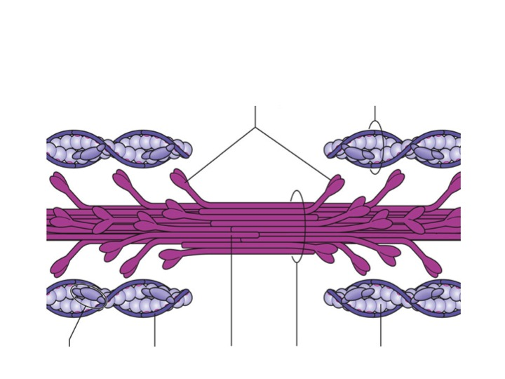

Station 6 - Myofibril Structure and Sliding Filament Theory

Now let’s zoom in even further and take a look at one single myofibril…

Read the information provided on the diagram to label each structure found in a myofibril AND provide a brief description of each.
Terms to use ON EACH DIAGRAM: Actin, Myosin, Myofibril, Sarcomere, Z-line

When a muscle contracts, what part of the muscle shortens?

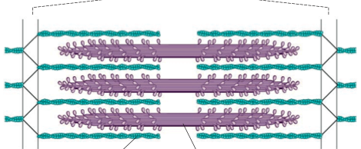
Is this diagram showing a relaxed or contracted muscle?

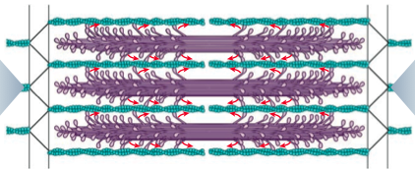
Is this diagram showing a relaxed or contracted muscle?

Summarize the Sliding Filament Theory below.
____________________________________________________________________________________________________________
____________________________________________________________________________________________________________
____________________________________________________________________________________________________________
____________________________________________________________________________________________________________
Station 7 – Neuromuscular Junction
Read the section in your textbook on p. 175, “Neuromuscular Junction,” to answer the questions below.

- Define the following terms:
- Motor Neuron - ___________________________________________________________________________________
- Neuromuscular Junction - _______________________________________________________________________
- Synaptic Cleft - ____________________________________________________________________________________
- Neurotransmitter - _______________________________________________________________________________

- What is the role of the neuromuscular junction? Why is it needed in order for a muscle to contract?
__________________________________________________________________________________________________________
__________________________________________________________________________________________________________
__________________________________________________________________________________________________________
__________________________________________________________________________________________________________

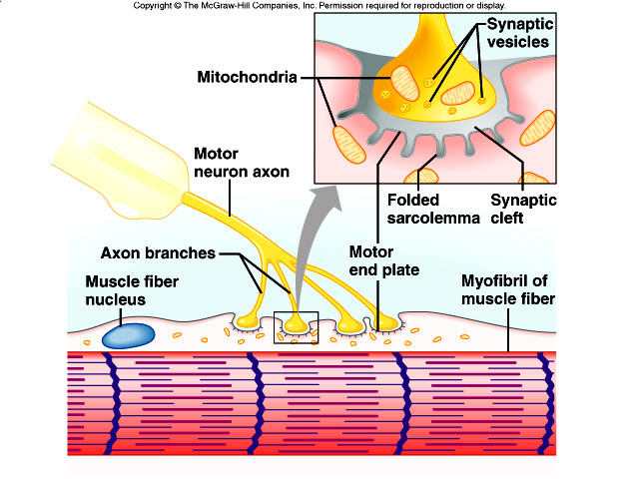

Station 8 - Steps of Skeletal Muscle Contraction
Using the steps provided below, create a model that illustrates how a skeletal muscle contracts. Examples include using various materials to represent each major component, creating a video presentation, drawing a detailed sketch (of the entire process OR of each step), etc. Show your completed model to Ms. Steffen when you are finished.
- Nerve impulse travels down motor neuron to the neuromuscular junction, causing ACh to be released from synaptic vesicles
- ACh crosses the synaptic cleft and binds to Ach receptors on the motor end plate which generates a muscle impulse
- Muscle impulse travels down the T-tubule (through the muscle fiber) and eventually reaches the sarcoplasmic reticulum, causing calcium ions to be released.
- Calcium ions bind to troponin and change its shape, the position of tropomyosin is altered, allowing binding sites to be exposed
- Myosin heads bind to the actin and form crossbridge, pulling the actin filament across the myosin filament and causing the sarcomere to shorten
- New ATP binds to myosin, which cause actin and myosin to break apart
- ATP splits into ADP and Pi (phosphate), which provides energy for the myosin head to go back to original position

The following information is provided for you to know. You do not have to make a model.
Steps of Skeletal Muscle Relaxation

- Acetylcholinesterase – Decomposes Ach remaining in the synapse
- Muscle impulse stops
- Calcium moves back into sarcoplasmic reticulum
- Tropomyosin returns to original position and binding sites are blocked
- Myosin is prevented from binding to actin
- Muscle fiber relaxes

Station 9 – Energy Sources for Contraction
Energy molecule required for muscle contraction is ________________.
Where does ATP come from?
Source/Process | Molecule that is broken down | When that process is used | Effect on the body
Aerobic Respiration
(a.k.a. Cellular Respiration)
Utilization of Creatine Phosphate
Anaerobic Respiration

Muscle Fatigue
- The liver will attempt to convert ________________________________________________________________, however during strenuous activity, ________________________________________ is being created than the liver can keep up with.
- As a result, _________________________________________________________________________________________.
- When lactic acid accumulates in the muscle, the muscle loses its ability to contract, which is referred to as ________________________________,

Station 10 – Hodgepodge Things to Know

Using the information provided, define the following terms. Then, use the vocabulary to appropriately label the origin and insertion of the muscles shown below (HINT: figure out where the muscle is located and what part will move when the muscle contracts)
- Origin – _________________________________________________________________________________
- Insertion – _____________________________________________________________________________

(Anterior thigh – quadriceps)
(Calf – gastrocnemius)
(Upper arm – biceps and triceps)

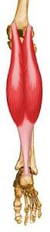
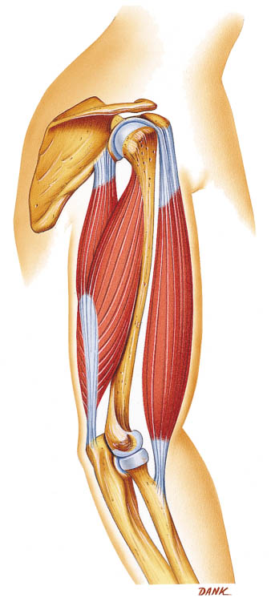

Using the information provided, define the following terms:

Muscles Working Together
- Agonist/Prime Mover - ____________________________________________________________________________
- Synergist - __________________________________________________________________________________________
- Antagonist - ________________________________________________________________________________________

Muscle Size
- Hypertrophy - ______________________________________________________________________________________
- Atrophy - ___________________________________________________________________________________________
(Station 10 cont’d)

Types of Muscle Fibers
Using the information provided, contrast the two types of muscle fibers.
 | Slow Twitch (Type 1) | Fast Twitch (Type 2)
Amt. of Mitochondria
Blood supply
Speed of Contraction
Time until fatigue
Type of athlete/sport

Types of Muscle Contractions

Using the information, contrast the two types of muscle contractions.

 | Isometric | Isotonic
What’s happening to the tension?
What’s happening to the muscle length?
Picture

