The Nervous System
Station 1 – Main Structures and Functions
Use the diagram to fill out the first section of your notes. Then read Section 9.2 in your text (p. 207) to list and summarize the 3 functions of the nervous system. Make sure to match the function with description/image provided and fill in the remaining parts of the descriptions.
The Nervous System consists of:

- _________________________
- _________________________
- _________________________ (________________________ & ______________________)

Functions of the Nervous System
Function | Description | Picture
 | Uses sensory receptors and nerve endings to:
 | Uses the sensory information received and relates it to past experiences, allowing us to make: | 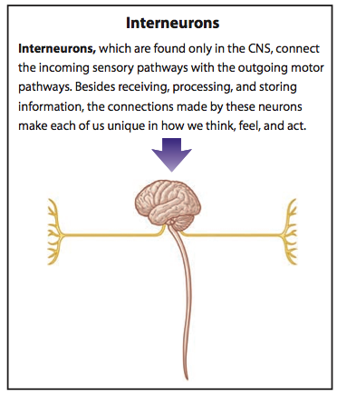
 | Utilizes effectors (__________________ and ___________________) to act on the decisions made by the Central Nervous System

Station 2 – Divisions of the Nervous System
As Ms. Steffen goes through the notes on the board, follow along and fill in the information below.
Main Divisions of the Nervous System
Division | Abbreviated as | Consists of
Divisions of the Peripheral Nervous System (PNS)

- ________________________ - ____________________________________________________ to CNS
- ________________________ - ____________________________________________________ from CNS
- ______________________ - carries information to _______________________________
- ______________________ - carries information to ___________________________________________
____________________________________________________________________
- _________________________________ - fight or flight response - preps body for action
- _________________________________ - rest and digest – slows things down
In the space below, create a flowchart that diagrams the divisions of the Nervous System.
Station 3 - Types of Neurons

Read the section titled, “Classification of Neurons” in your textbook (p. 211-212) and use the information to fill out the two charts in your notes.
Neurons Classified by Structure
Name | Description | Location | Sketch

Neurons Classified by Function
Name | Function | Location

Station 4 - Neuron Structure
Read the information provided on the diagram to label the parts of a neuron AND provide a brief description of its function. Make sure to label the following parts:

Cell body
Nucleus
- Axon
- Dendrite
- Myelin sheath
- Node of Ranvier

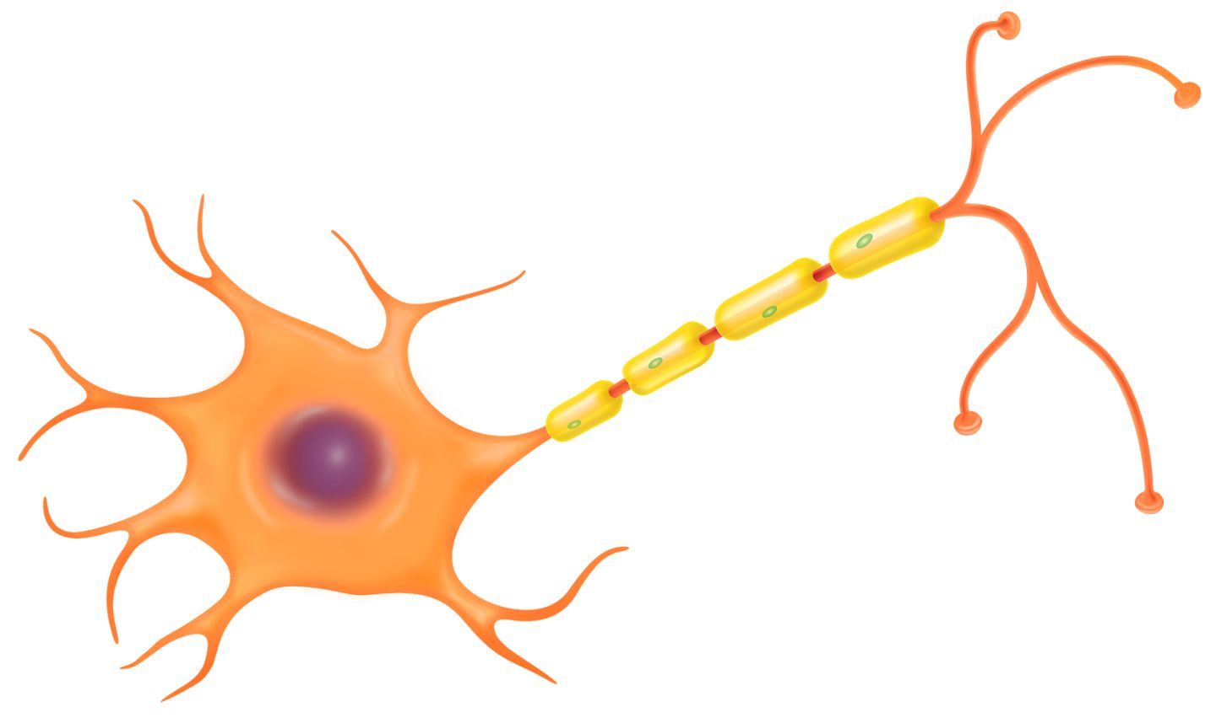
When everyone in your group has completed their notes, send one person up to Ms. Steffen to:
- check off the answers
- pick up the supplies and the instruction sheet for what to do next

Station 5 - Nervous Tissue and Neuroglial Cells
Use the diagrams and information provided to fill in the following section of notes and the table below.
Nervous Tissue
Nervous tissue consists of two types of cells:

- __________________- _____________________________________________________________________________
_________________________________________________________________________________________________
- What is a nerve impulse? _________________________________________________________ _________________________________________________________________________________________
- ___________________________________ - cells that provide _________________________,
_________________________, ________________________, and __________________________ for neurons.
Types of Neuroglial Cells
Name | Location | Function | Extra Info
Schwann Cells
Astrocytes
Oligodendrocytes
Microglial
Ependymal
Station 6 - Myelination of Axons

Use the reading provided to fill in your notes below. When you are finished, see Ms. Steffen to get your patient/case study and laptop.

Myelinated vs. Unmyelinated

- Not all nerve fibers are __________________________.
- Unmyelinated nerve fibers conduct ______________________________ more ________________.
  - Example: _____________________________________________________________________________
- Myelinated nerve fibers are used when __________________ is more important
  - Example: ____________________________________________________________________________
PNS vs. CNS
- In the PNS, the myelin sheath is formed by ________________________ cells.
  - The __________________________ cells wrap themselves around the _________________ and lay down multiple _________________________ of _________________________________.
  - The nucleus and cytoplasm are in the _____________________________________________ known as the ______________________________.
    - The neurilemma is essential for ____________________________________________
________________________________________________________________________________
- In the CNS, the myelin sheath is formed by _____________________________________________.
  - One ________________________________________ forms the myelin sheath for ________________________________________.
  - The nucleus is located _____________ from the myelin sheath and outward ___________________________ wrap around the nerve. As a result, there is _________ __________________________________.
    - With no neurilemma, injured neurons in the CNS can’t _________________.
    - Explains why paralysis from a spinal cord injury is ____________________.
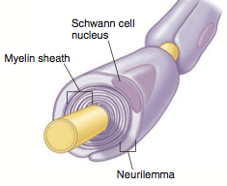
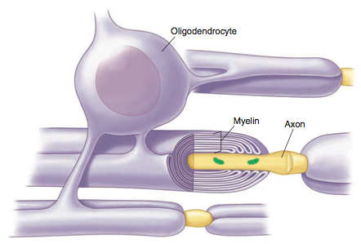
Station 7 - Nerve Impulse Transmission
As Ms. Steffen goes through the notes on the board, follow along and fill in the information below.
Cell Membrane Potential
- _____________________________________ - Whenever ions with opposite charges are separated by a membrane, the potential exists for them to move toward one another
- ________________________ - A membrane that exhibits membrane potential has an excess of ________________________ ions (_________, ____________) on one side, and an excess of _____________________ ions (_________, ___________) on the other side
1. Resting Potential
- The _________________of a neuron is ______________________ relative to the __________________.
  - Inside: Has permanent negative ions and high _________ concentration
  - Outside: Has high __________ concentration
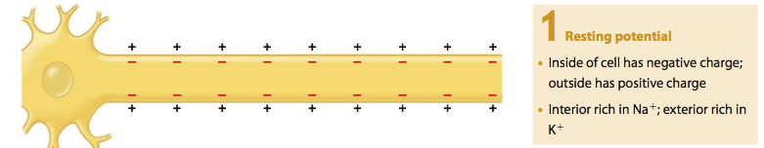
2. Depolarization
- Stimulation of a membrane can affect its resting potential
  - ___________________________________________, ____________________, _______________________
- When a stimulus comes along, ____________________________________, causing Na+ to _____________________________________________.
- The membrane potential then becomes ___________________________ and the membrane is ___________________________
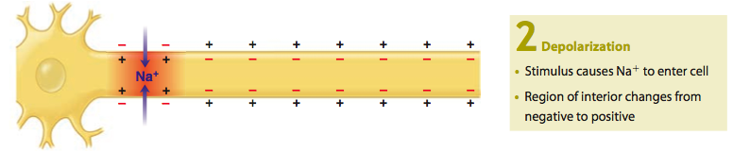

3. Action Potential
- If strong depolarization occurs, a _____________________________________ is achieved and
_____________________________________________________.
- When threshold is reached, an ____________________________________ (aka: __________________
______________________ ) is created.
- The ____________________________________ continues down the axon as one segment ________________________________________________________________________________________________.
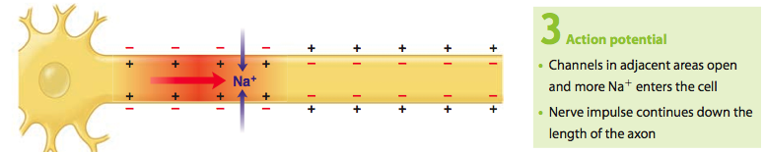
4. Repolarization
- The sudden increase in _________ triggers the opening of channels to allow ____________
_______________________________________________, thus ______________________________ the cell
  - Inside = __________________________________
  - Outside = _________________________________
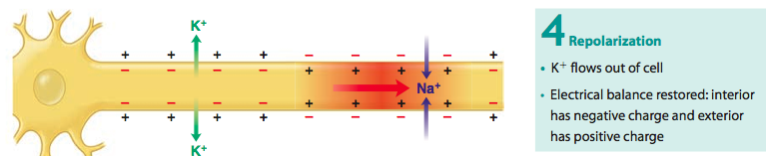
5. Refractory Period
- The ___________________________________________ works to return the ___________ to the outside and the _________ to the inside and thus returns the cell to its rest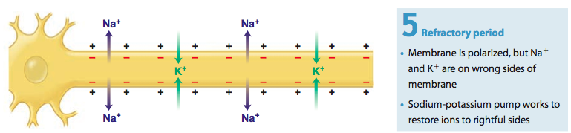
Impulse Conduction
- Unmyelinated fibers – conduct impulses over ____________________________________________
- Myelinated fibers – conduct impulses from _______________________________________________
  - Leap frogs its way down the neuron which is much faster!
All-or-None Response
- All-or-None Response - _____________________________________________________________________
  - If the threshold isn’t reached, the neuron doesn’t fire
- All impulses carried on an axon or the _____________________________________
  - A stronger impulse doesn’t produce a stronger response
Communication Between Neurons
- _____________________________________ usually travel through _________________________________
_______________________ before reaching their target _________________________________________
- Thus, the neurons must have some way of transferring the impulse from one neuron to the next.
The Synapse
- Synapse - _____________________________________________________________________________________
- Synaptic Cleft - _______________________________________________________________________________
- Presynaptic Neuron - ________________________________________________________________________
- Postsynaptic Neuron - _______________________________________________________________________
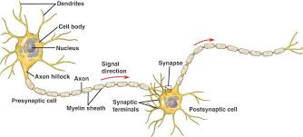
Synaptic Transmission
- Nerve impulse crosses the ___________________________________ to reach the
___________________________________________ using ___________________________________________

  - Neurotransmitters are stored in synaptic vesicles
- ___________________________________________ bind to _______________________________ on the
___________________________________________ and allows the impulse to continue
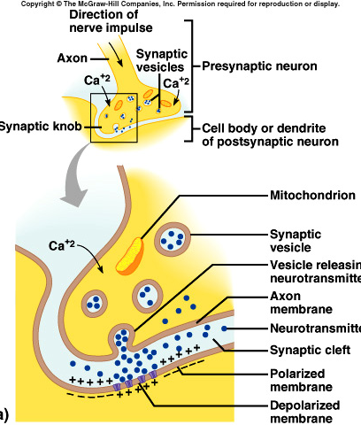

Types of Neurotransmitters
- Excitatory - ___________________________________________________________________________________
  - Acetylcholine – involved in ________________________________________________
  - Norepinephrine – involved in _______________, creates _____________________________
- Inhibitory - ___________________________________________________________________________________
  - Serotonin – involved in _____________________________________________________________

Station 8 – Reflexes and Reflex Lab
Read the introductory information in the Reflex Lab and then use the information to fill in your notes below.
Reflexes - _____________________________________________________________________________________
_________________________________________________________________________________________________
- Two types
  - __________________________ - ____________________________________________________
  - __________________________ - ____________________________________________________
    - Knee-jerk Reflex – helps maintain an upright posture
    - Withdrawal Reflex – prevents or limits tissue damage
Reflex arc
- Includes 5 parts:
  - _____________________________________
  - _____________________________________
  - _____________________________________
  - _____________________________________
  - _____________________________________

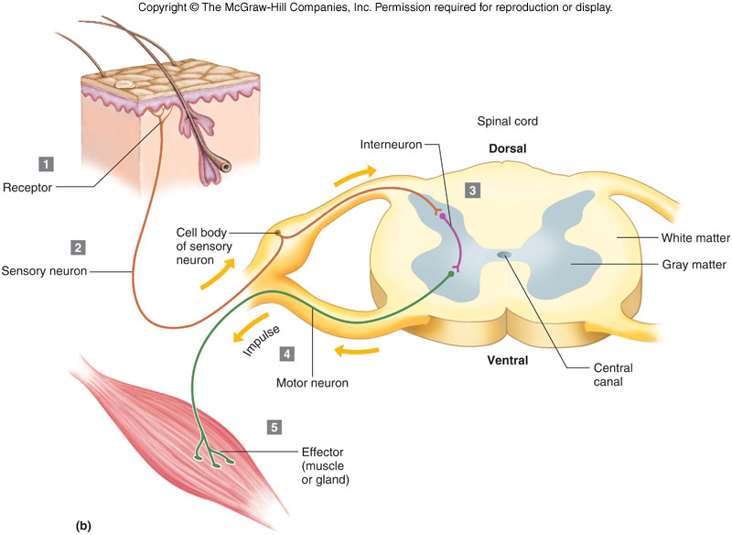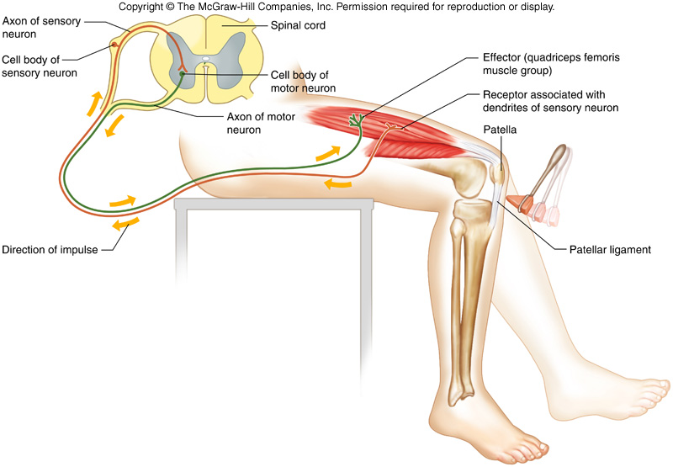

Station 9 – Structures of the Central Nervous System
You and your group members will work together to produce a PowerPoint slide highlighting a various structure within the Central Nervous System. You will be given two sets of material to read regarding the structure you have been assigned. Your group must then work to summarize the information to create your slide. You will then present your slide to the class.

Group 1 - Meninges
Primary Structure
Structure | Location | Function | Extra Info
Meninges
Secondary Structures
Structure | Location | Function | Extra Info
Dura Mater
Arachnoid Mater
Pia Mater
Subarachnoid Space

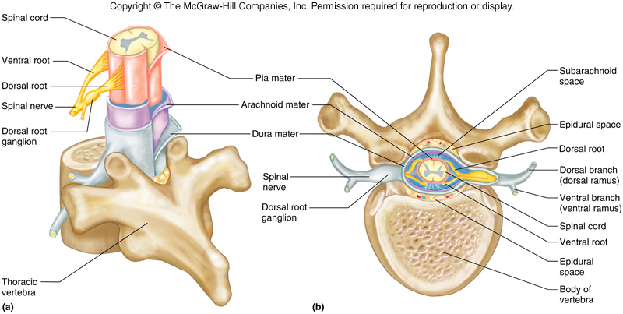
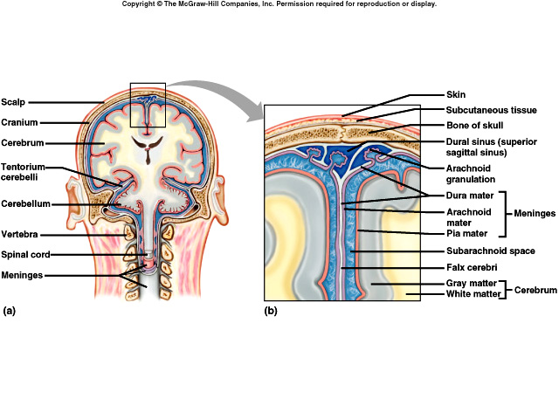

Group 2 - Spinal Cord
Primary Structure
Structure | Location | Function | Extra Info
Spinal Cord
Secondary Structures
Structure | Location | Function | Extra Info
Cervical Enlargement
Lumbar Enlargement
Spinal Nerves

Cross Section of Spinal Cord
- Spinal Nerves
  - Dorsal root - _____________________________________
  - Ventral root - ____________________________________
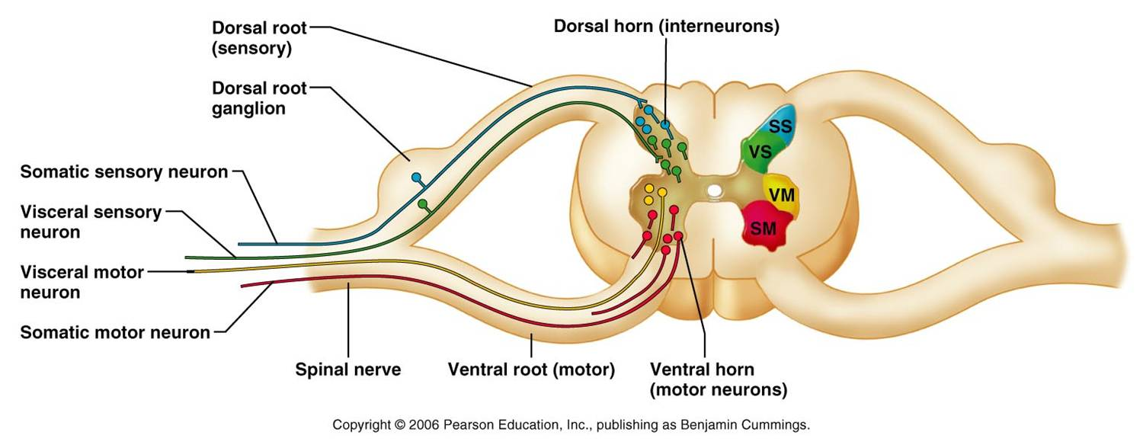

Group 3 - Brain Stem

Primary Structure
Structure | Location | Function | Extra Info
Brainstem
Secondary Structures
Structure | Location | Function | Extra Info
Medulla Oblongata
Pons
Midbrain

Group 4 - Cerebellum

Primary Structure
Structure | Location | Function | Extra Info
Cerebellum
Secondary Structures
Structure | Location | Function | Extra Info
Limbic System
Hippocampus
Amygdala
Group 5 - Diencephalon
Primary Structure
Structure | Location | Function | Extra Info
Diencephalon
Secondary Structures
Structure | Location | Function | Extra Info
Thalamus
Hypothalamus

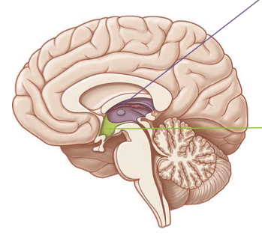
Cerebellum
Brainstem
Midbrain
Pons
Medulla Oblongata
Diencephalon
Hypothalamus
Thalamus
Group 6 - Cerebrum

Primary Structure
Structure | Location | Function | Extra Info
Cerebrum
Secondary Structures
Structure | Location | Function | Extra Info
Corpus callosum
Gyri/Sulci
Longitudinal fissure
Transverse fissure

Station 10 – Lobes of the Cerebrum
Go to the following website: https://www.opencolleges.edu.au/informed/learning-strategies/
and explore the brain! Use the information to fill in the chart below for the location and function of each lobe of the brain.

- _____________________________ - Anterior portion of each hemisphere
- _____________________________ - Posterior to the frontal lobe
- _____________________________ - Inferior to the frontal and parietal lobes
- _____________________________ - Posterior portion of each hemisphere

Structure | General Location  (Anterior/Poster  Superior/Inferior, etc.) | Function
Frontal Lobe
Parietal Lobe
Temporal Lobe
Occipital Lobe

Structure | Location  (which lobe?) | Function
Broca’s Area
Prefrontal Cortex
Motor Cortex
Sensory Cortex
Auditory
Cortex
Visual Cortex

Station 11 - Peripheral Nervous System

Consists of nerves that branch out from the CNS and connect it to other body parts
- Includes:
  - ___________________________ - arise from the __________________
  - ___________________________ - arise from the _____________________________
Sensory/Afferent Division – conducts impulses _______________________________________________.
Motor/Efferent Division – conducts impulses _________________________________________________.
- Somatic Nervous System
  - Cranial and spinal nerves that connect to _____________ and _______________________
  - _______________________ activities
- Autonomic Nervous System
  - Nerve fibers that connect ________________ to __________________ (heart, stomach, etc.)
  - ________________________ activities
    - Sympathetic Nervous System - prepares body for fight or flight
      - Examples:
    - Parasympathetic Nervous System - prepares body to rest and digest
      - Examples:
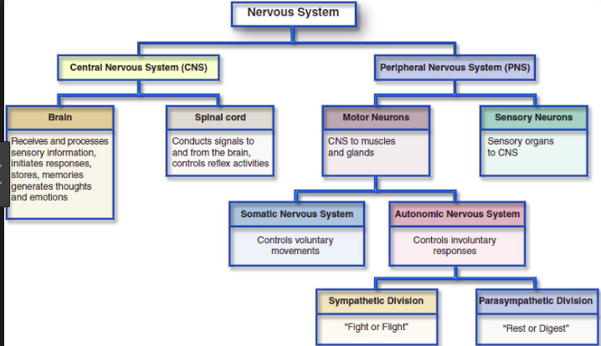
Station 12 - Cranial Nerves

Number | Name | Sensory/  Motor/Mixed | Function
Station 12 cont’d - Spinal Nerves

Spinal Nerves

- All _______________________ nerves
- ________ pairs
  - 8 cervical nerves
  - 12 thoracic nerves
  - 5 lumbar nerves
  - 5 sacral nerves
  - 1 coccygeal nerve

Plexuses

- __________________________ - complex networks formed from spinal nerves

Cervical Plexus
- Lies deep in the __________________
- Supply muscles and skin of the neck
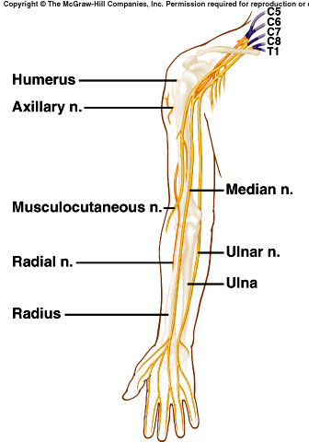

Brachial Plexuses

- Spinal nerves of ____________________
- Lies deep within ___________________
- Nerves:
  - Musculocutaneous
  - Ulnar
  - Median
  - Radial
  - Axillary

Lumbosacral Plexuses

- Spinal nerves of ___________________
- Extend from _________________________________
- Nerves:
  - Obturator, Femoral, Sciatic

