Skeletal System Notes

Station 1 – Functions and Types of Bone
Read the information provided to identify and summarize the functions of bone.
Functions of Bone
1.
2.
3.
4.
5.
6.
7.

Read the information provided to identify the different types of bones found in the skeletal system. Then give a brief description and an example of each.
Type of Bone | Description | Example
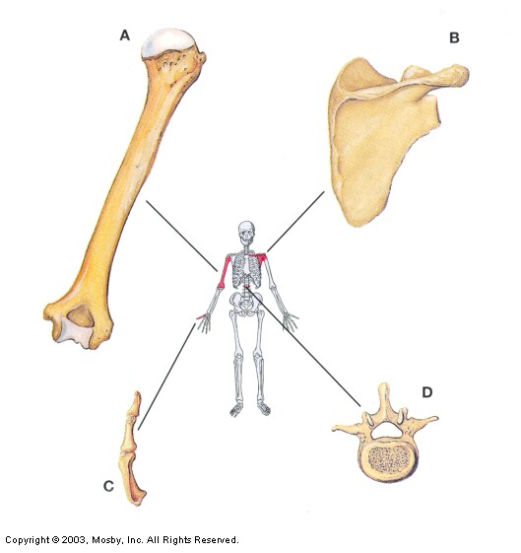

Station 2 – Parts of a Long Bone
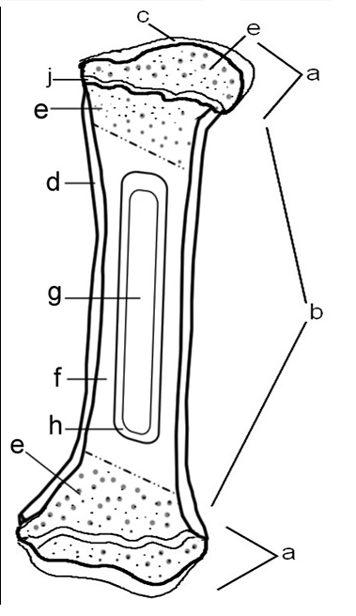
Part 1 - Color the diagram below according to the instructions provided. Then read the section on p. 128, “Parts of a Long Bone” to write a brief description for each structure.
- Epiphysis – (do not color)
i
- Diaphysis – (do not color)
- Articular Cartilage – (green)
- Periosteum – (blue)
- Spongy Bone – (red)
(contains red marrow)
- Compact Bone - (pink)
- Medullary Cavity – (yellow)
(contains yellow marrow)
- Endosteum - (orange)
- Epiphyseal Line – (purple)

Part 2 – When you have completed Part 1, check out a laptop from Ms. Steffen and go to the following Quizlet site: https://quizlet.com/48936200/07-long-bone-anatomy-flash-cards/.
Complete the Matching Activity, Flashcard Activity, and Test. Check off each task when it’s completed and then show your completed test score to Ms. Steffen when you are finished.
- Matching Activity
- Flashcard Activity
- Test Test Score: ____/8
Station 3 – Bone Tissue
Read the information provided to identify the types of bone cells and provide a brief description of their functions.

Type of Cell | Function

Read the information provided to summarize the characteristics of spongy and compact bone tissue.

Type of Tissue | Characteristics
Spongy Bone
Compact Bone

Questions:
- How is the form of spongy bone linked to its function?

- How is the “form” of compact bone linked to its function?

- Which type of bone tissue contains red bone marrow? _________________________

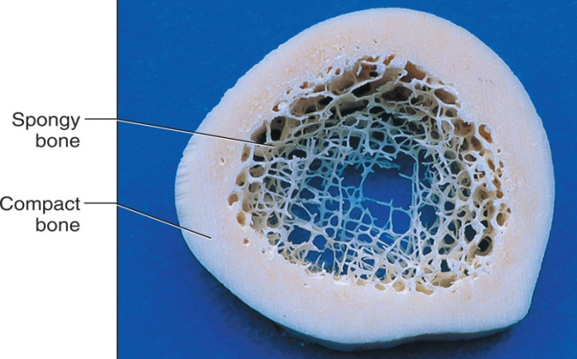
Color the diagram below according to the instructions provided. Then look at the diagram and readings provided to answer the questions below.
- Spongy Bone – (green) D. Haversian Canal – (yellow) G. Canaliculi – (purple)
- Volkman’s Canal – (orange) E. Compact Bone – (leave white) H. Osteocyte – (red)
- Osteocyte - (red) F. Periosteum - (blue) I. Lacuna – (pink)

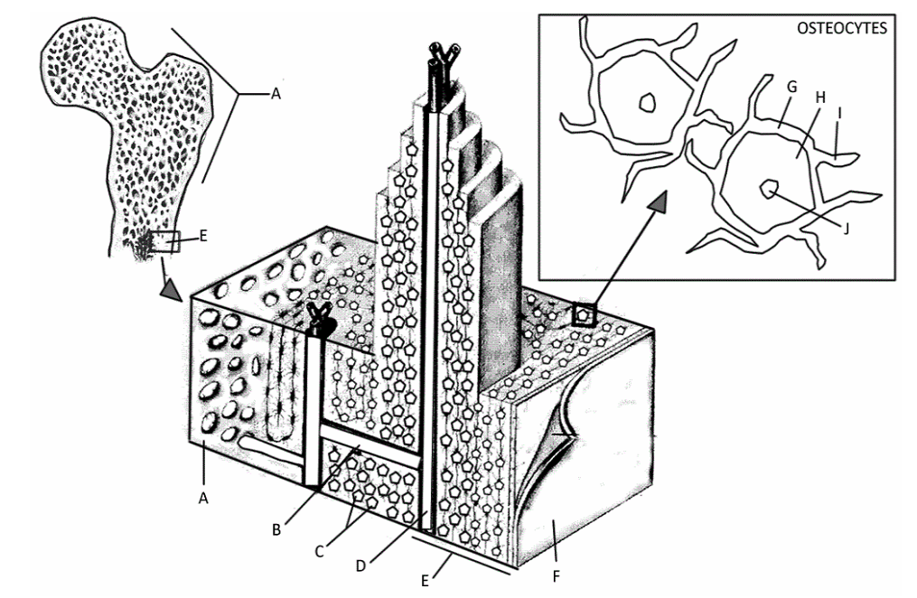

Questions:
- What structure connects osteocytes? ___________________________
- What canal is found in the center of the rings? _______________________________
- What is the purpose of that canal? ___________________________________________
________________________________________________________________________
- What are two differences between compact bone and spongy bone?

Station 4 – Bone Development and Growth
Use the diagram and readings to summarize the process of endochondral ossification.
Endochondral Ossification
- ________________________________________________________________________________________________________________________________________________
- ________________________________________________________________________________________________________________________________________________
- ________________________________________________________________________________________________________________________________________________
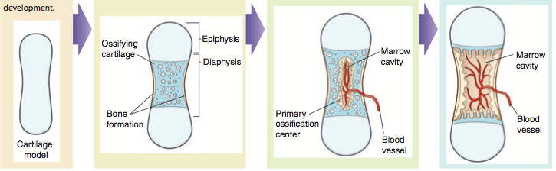
- ________________________________________________________________________________________________________________________________________________

Questions:
- Explain how you are taller now than you were when you were 3 years old. Include specific structures in your answer.

- Explain why Ms. Steffen has remained at a height of 5’7” for the last 10 years. Include specific structures in your answer.

Station 5 – Fractures
Watch the video provided and fill in the chart below. (https://www.youtube.com/watch?v=LCpneeLbWi8)
 | Type of Fracture | Description | Sketch
Incomplete Fractures | Hairline
 | Greenstick
Complete Fractures | Transverse
 | Oblique
 | Spiral
 | Comminuted

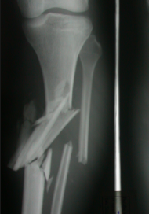
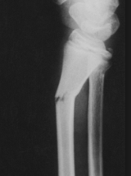
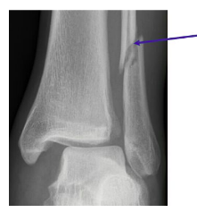
What types of fractures are shown in the X-rays below?
_________________ _______________ ________________

Station 6 – Types of Joints
Read the information provided to describe the various types of joints and fill in the chart below.
Type of Joint | How movable? | What connects the bones? | Example
Fibrous
Cartilaginous
Synovial
Synovial Joint Structures
Use the diagram provided to label each structure found in a synovial joint AND provide a brief description of each.
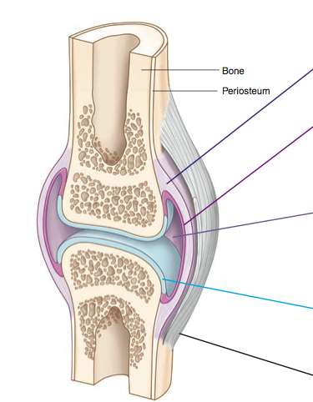

Question:
- What are bursae and where are they found?
Station 7 cont’d – Types of Synovial Joints Practice
Check out a laptop from Ms. Steffen and go to one of the following Quizlet sites:
https://quizlet.com/147468109/types-of-synovial-joints-flash-cards/
https://quizlet.com/194309770/types-of-synovial-joints-2-flash-cards/
https://quizlet.com/225243558/types-of-synovial-joints-flash-cards/
Complete the Flashcard Activity and Test for at least one set. Check off each task when it’s completed and then show your completed test score to Ms. Steffen

- Flashcard Activity
- Test Test Score: ______

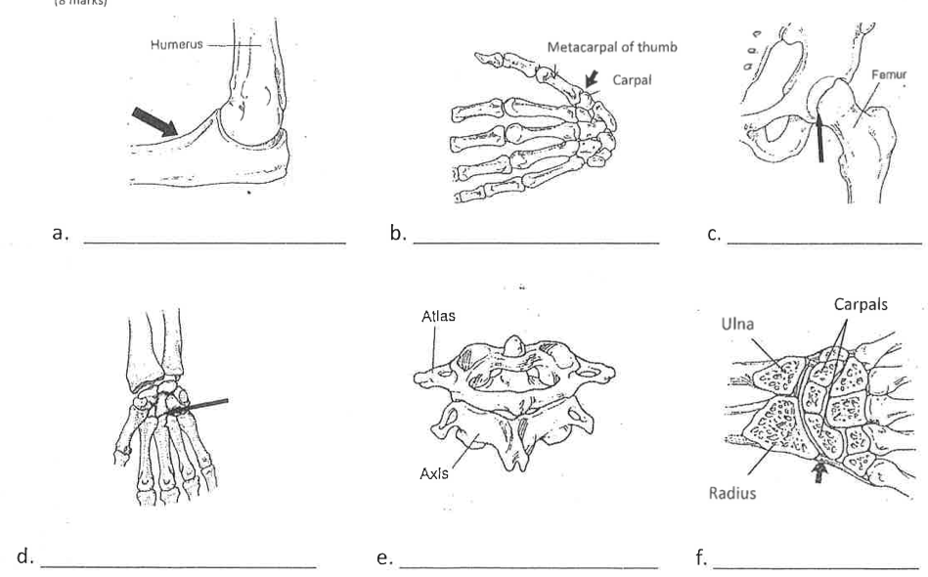
Label the pictures below with the type of synovial joint shown.

Station 8 – Joint Movements
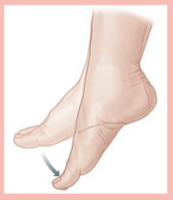
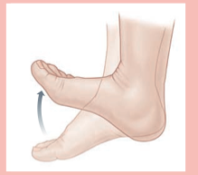
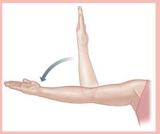
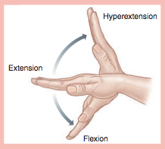
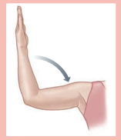
Using the definitions and diagrams provided in your book on p. 159-161, label each picture below with the type of joint movement shown AND provide a brief description.

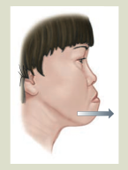
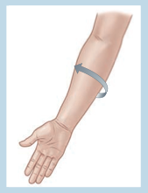
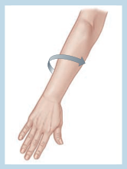

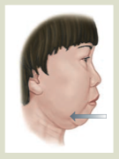
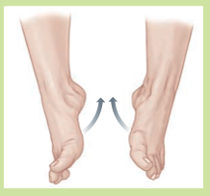
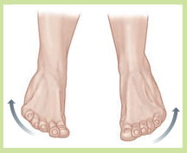

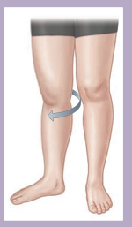
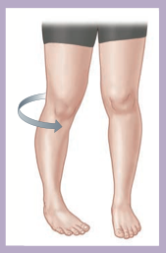

Station 8 cont’d – Joint Movements Practice
