Station 7 – Types of Synovial Joints

Read the information provided and summarize each type of synovial joint to fill in the chart below.

Type of Joint | Picture | Description | Movement | Example
Ball and Socket | 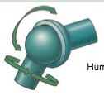
Hinge | 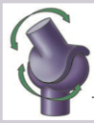
Pivot | 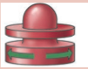
Gliding
Condyloid | 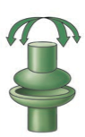
Saddle | 