Chapter 10: Senses
- ____________________________
  - ______________________ receptors associated with a sense of ______________,
_________________, __________________________, and _________________.
- __________________________
  - _____________________ receptors that provide the special senses of _________,
_________________, _____________________________, and ______________.
Sensory Receptors
- Most are ________________________________________________________________
______________________________________________________________________
- Some receptors combine with muscle and tissue to form sense organs
- Transmit information about the ___________, _____________________, and the ____________________ of each sensation
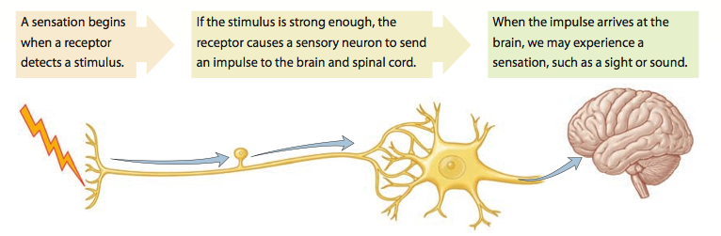

Sensations
- ________________
  - A feeling that occurs when the brain ___________________________________
- ________________
  - Process in which the brain ____________________________________________
  - Allows a person to __________________________________________________
Types of Sensory Receptors
Type of Receptor: | Respond to:

Sensory Adaptation
- Sensory Adaptation – ______________________________________________________
________________________________________________________________________
  - Example: _________________________________________________________
  - Once receptors have adapted, impulses can be triggered only if the stimulus strength _______________________.

Somatic Senses
- Senses associated with __________, ____________, __________, and ______________
- Types
  - ____________________________ (type of receptor: ______________________)
  - ____________________________ (type of receptor: ______________________)
  - ____________________________ (type of receptor: ______________________)
Pain
- Stimulated by ________________________________
- Signals a person to ________________________________________________________
- Adapt _________________ - may continue to send impulses to the CNS
  - Pain _____________________
Visceral Pain
- Pain receptors are the _______________________ in ______________ whose stimulation produces ______________
- Not well ______________ (___________ feeling of pain)
- May feel as if coming from _________________________________________________
  - Known as ______________ pain
Referred Pain

- Occurs due to sensory fibers from an ___________________ and those from an area of
______________ share a common nerve pathway to brain
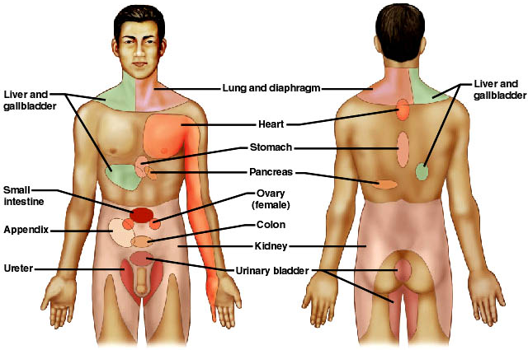
Pain Nerve Fibers
- ___________ pain fibers
  - ________________ nerve fibers- sends __________________________
  - Associated with _________________ but _________________________.
  - Typically more ____________________________.
  - Example: _________________________________________________
- __________ pain fibers
  - _______________ nerve fibers- sends ___________________________
  - Associated with ______________________________________________
  - More ___________________, but may be difficult to ________________
  - Example: _________________________________________________
Regulation of Pain
- _______________________ determines ______________, ______________
__________________ & ___________________ response to pain.
- ________________________________- NT’s that ____________ pain impulses
  - ___________________ & _________________
    - Suppress ___________ & _____________________
    - Acts like morphine which ___________ receptors on neuron membranes
  - _________________________
    - Stimulates other ____________ to release ___________________.
Touch and Pressure
Types of Mechanoreceptors
- _________________________________
  - Abundant in ____________________________
    - __________, ____________, _________, and ____________________
  - Detect fine ___________; distinguish between __________________ on the skin

- _________________________________
  - Common in _____________ tissue, _______________, and _________________
  - Detect heavy ______________ and ______________
Temperature
- ___________ receptors
  - Located in the ________________
  - Activated at temperatures ______________________
- __________ receptors
  - Located deep in the _________________
  - Activated at temperatures between ______________ and ______________
- ___________________________
  - Temperatures above ___________ = ____________________________
  - Temperatures below ___________ = ___________________________________
_________________________________________________________________

Special Senses
- Include _____________, ______________, ________________, ___________________ and _____________________.
  - cheeks and walls of pharynx
  - Each taste bud has ~_____________ taste receptors

Hearing
Results when _______________ creates ____________________ in the air (sound waves) that stimulate the _______________________ to send nerve impulses to the ___________________ of the cerebrum
- Ear – organ of hearing
- Three Sections
  - __________________
  - __________________
  - __________________
External Ear
- _________ (pinna) - collects sounds waves
- __________________________ - carries sound to ________________________________
- ___________________________________- opening to the _________________________
  - Lined with gland that produce secretions that mix with dead skin cells to form cerumen ( ________________ )
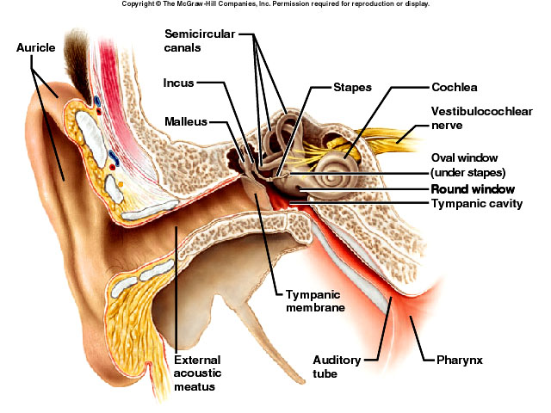
Middle Ear
- ________________ membrane
  - Vibrates in response to ______________________
- _________________________________
  - 3 smallest bones - ______________, _____________, and ________________
  - Vibrate in response to _____________________________________________
- __________________________________
  - Opening in wall of tympanic cavity
  - Stapes vibrates against it to move fluids in inner ear, which stimulates the hearing receptors
- __________________________________
  - Passageway for ___________________________________________________
  - Helps maintain equal pressure on both sides of tympanic membrane
    - “Popping of the ears”
  - Can also allow infection to spread from middle ear to your throat
Inner Ear
- Complex system of communicating chambers and tubes within the temporal bone
- Three Parts
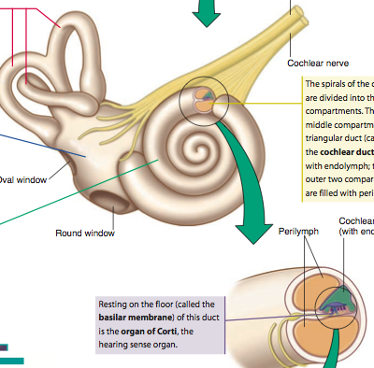
  - _________________
    - Contains structures for _____________
    - Organ of Corti
  - __________________
    - Contains structures for ______________
_________________________________
  - ____________________
    - Contains organs necessary for __________
__________________________________

Organ of Corti
- Contains the ______________________ (hair cells)
- Nerve fibers extend from the base of the hair and eventually from the cochlear nerve (aka vestibulocochlear nerve)
- Particular sound frequencies cause ___________________________________________
- Generates a nerve impulse
How We Hear Sound
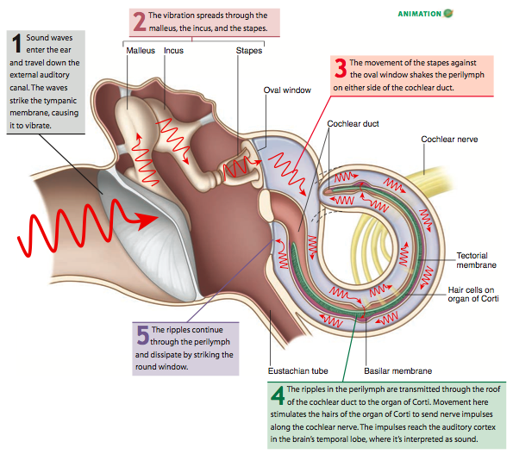

Balance and Equilibrium
Static Equilibrium
- Organ = __________________
- Sense ____________________ when body is not moving
- Sense of __________________ when moving in a straight line
- When the head bends forward, backward, or to one side, the receptors are stimulated
  - Initiates a nerve impulse
  - Brain initiates a _____________________ to muscles to ___________________.
- How it works
  - Patch of hair cells
  - Tips of hair cells are covered by a _________________________________
  - In the gelatin-like material are _______________________________ (otoliths)
  - When the head tilts, the ________________________________, stimulating the hair cells and consequently the vetibulocochlear nerve (CN VIII)
Dynamic Equilibrium
- Organ = _____________________
- Sense rotation and movement of head and body
- Rapid turns of the head or body stimulate the receptors
  - Initiates a nerve impulse
  - Brain initiates a ___________________ to muscles to ____________________.
- How it works
  - Canals are filled with ______________
  - At the end of each canal is a bulb-like structure (ampulla)
  - When the head _________________, the fluid in the ampulla lags behind
  - When the movement _____________, the fluid swirls past the cone and _______________ it in the process
  - This stimulates the hair cells and consequently the vestibulocochlear nerve

Taste
Results when __________________ come in contact with ___________________________ (chemoreceptors) in the _______________________ (taste buds)
- Taste Buds
  - ______________________
  - Located in papillae of tongue, roof of mouth, linings of cheeks and walls of pharynx
  - Each taste bud has ~_____________ taste receptors

- Taste Sensations
  - Four Primary Taste Sensations
    - _________ – stimulated by carbohydrates (sugar)
    - _________ – stimulated by acids (lemon)
    - _________ – stimulated by salts
    - _________ – stimulated by many organic compounds (caffeine)
  - Possible 5th - __________________ - meaty
  - Spicy foods activate pain receptors
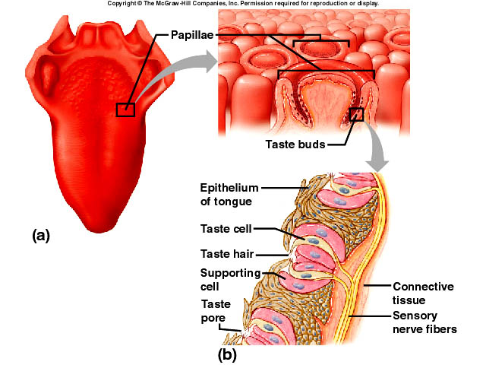
Smell
Results when __________________ come in contact with ___________________________ (chemoreceptors) in the _______________________ (olfactory bulbs)
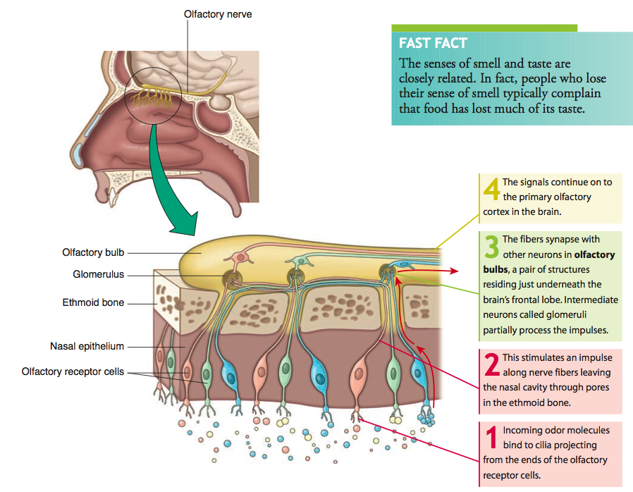
Olfactory Nerve Pathways
- Once olfactory receptors are stimulated, nerve impulses travel along the __________________ Nerve (CN I).
- Once the stimulus reaches the olfactory cortex in the cerebrum, it may continue on to other locations in the cerebrum and brainstem, including the limbic system
  - Explains why certain odors can _____________________________, ______________________________, or even a __________________________.
Olfactory Stimulation
- Olfactory organs located high in the nasal cavity above the usual pathway of inhaled air
  - Person may have to sniff and force air up to the receptor areas to smell a faint odor
- Olfactory receptors undergo sensory adaptation rapidly
  - Sense of smell drops by ______ within a __________ after stimulation (sensory adaptation)

Sight/Vision
Results when _______________ comes in contact with __________________________ (photoreceptors) in the eye
- Eye – organ containing visual receptors
  - Provides vision with the assistance of accessory organs
Accessory Structures
- Eyebrow – keeps out ___________________________
- Eyelid and Eyelashes – keeps out _________________
- Conjunctiva – secretes a mucous that _________________________________
  - Very vascular – when blood vessels are dilated = ____________________
- 6 Extrinsic Muscles - _________________________________
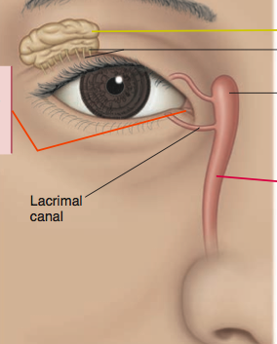
- ________________________________________
  - Lacrimal gland, which secretes ______________
  - Series of ducts that carry tears into the nasal cavity.

Structure of the Eye

- Mostly Hollow
- Spherical
- Wall has 3 layers
  - Outer layer - ________________
  - Middle layer - _______________
  - Inner layer - ________________
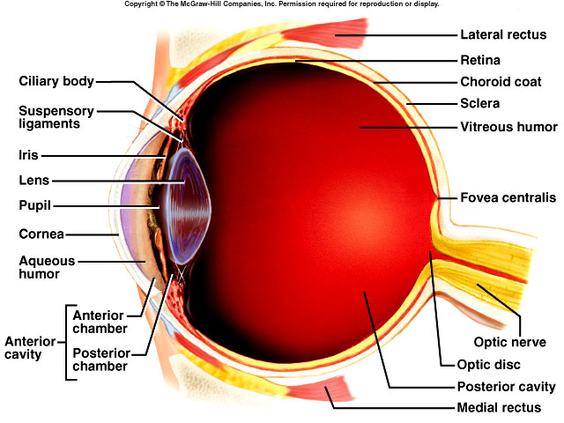

Outer Layer - Fibrous
- __________________
  - Dense connective tissue
  - _____________________________
  - _____________________________
- ____________________
  - Extension of sclera
  - Anterior part of the eye
  - ___________________________
  - Sits over the Iris
  - Admits ____________ into the eye
Middle Layer - Vascular
- Iris
  - Ring of colored ____________________
  - Adjust the __________________________ (hole in the iris) to control amount of light
- _________________
  - Highly vascular
  - Supplies ________________________ to _______________________
- Ciliary body
  - Thickened extension of ________________
  - Holds ___________________________
  - Secretes _________________________
- Lens
  - ______________________
  - Behind the iris
  - __________________________for near and far vision
Accommodation - Changing of lens shape to view objects
Inner Layer - Nervous
- Retina
  - Lines posterior 2/3 of the eye
  - Contains ___________________________ (photoreceptors)
    - _________ and _________________
  - Continuous with __________________
  - __________________ – produces sharpest vision
  - __________________ – blind spot; contains no visual receptors
Chambers and Fluids
- 2 main chambers
  - Anterior
    - ________________ of the lens
    - Filled with ____________________________ (water-like)
      - Provide nutrients
  - Posterior
    - ________________ the lens
    - Filled with ____________________________ (jelly-like)
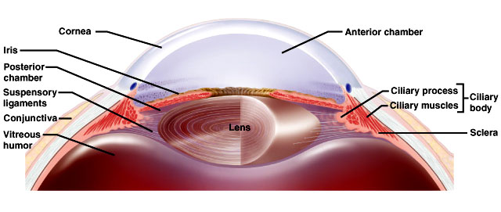
      - Maintains the shape of the eyeball and keeps it from collapsing

The Process of Vision
- In order for vision to occur:
- Light must enter the eye and _______________ on the retina to produce a tiny, upside-down image of the object being viewed
- The __________________________ in the retina must convert that image to ________________________________
- The impulses must be transmitted to the ___________ for ______________________
Light Refraction
- Refraction
  - ______________________________________
  - Occurs when light waves hit the curved surfaces of the cornea and the lens
  - Proper vision requires light rays from an object to fall on the ______________________ of _____________________
    - Convergence - _____________________________________________________
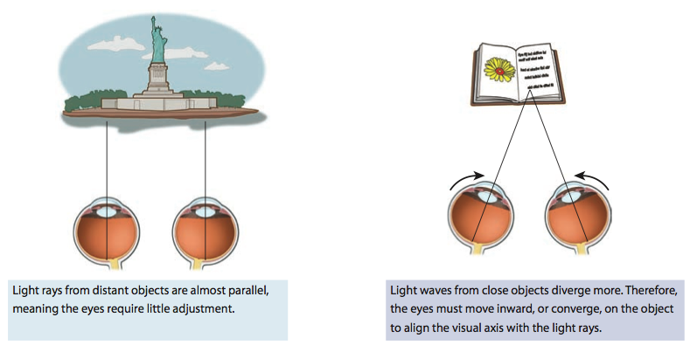
Clinical Application
- ________________ lenses correct nearsightedness
- ________________ lenses correct farsightedness

Action of Photoreceptors
- Photoreceptors ( __________ and ___________) in the retina ____________________________ and trigger the nerve impulse down the optic nerve to the brain
Visual Receptors
- _________
  - Located in the _____________ of the retina
  - Active in _______ light
  - Responsible for _____________________
  - Cannot distinguish ____________________
- ____________
  - Located in the _____________ of the retina
  - Active in _______ light
  - Responsible for _____________________
  - Responsible for ____________________

