Somatic and Special Senses

Station 1 – Vocab!
General Vocab
Word | Definition
Somatic Senses
Special Senses
Sensory Receptors
Sensation
Projection
Sensory Adaptation

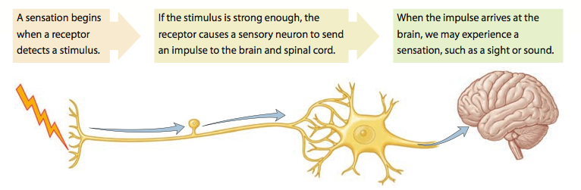
Types of Sensory Receptors
Type of Receptor | Responds to: | Picture
 |  | 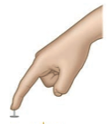
 |  | 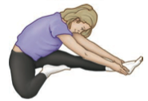

What type of receptor is responding when:
- You stub your toe? ___________________________________
- You’re eating a delicious cupcake? ___________________________________
- You step into a hot tub? ___________________________________
Station 2 – Somatic Senses

*Pain

Type of Receptor | Responds to: | Picture

Pain Receptors and Adaptation:
__________________________________________________________________________________________________________________________________________________________________________________________________________________
_________________________________________________________________________________________________________

Visceral Pain (Pain in the Organs):
- The only sensation that your organs produce is pain.
- Not well localized (broad feeling of pain)
- Could illicit referred pain sensations

Referred Pain
Definition
Why does it occur?
Example(s)
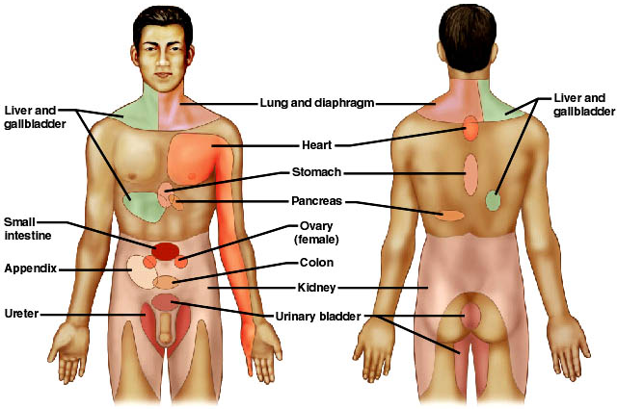

Types of Pain Fibers
Type of Fiber | Myelinated or No? | Type of Pain Sensation | Location of fibers/pain | Example

*Temperature
Type of Receptor | Responds to: | Picture

Types of Thermoreceptors - Warm Receptors vs. Cold Receptors

Type of Receptor | Location | Active Temperatures
 | __________________

*Touch

Type of Receptor | Responds to: | Picture

Types of Mechanoreceptors - Meissner’s Corpuscles vs. Pacinian Corpuscles

Type of Receptor | Location | Detection

Two-Point Discrimination Lab

Pre-Lab Questions
- Do you think that mechanoreceptors are distributed evenly across the body? Why or why not?
- Which areas on the human body are most sensitive to touch?
- If a person’s sensitivity to touch was below normal, what might this indicate to the neurologist?

Procedure

You and your partner will be taking turns performing the 2-point discrimination test on various parts of the body. Each partner will have each body part tested and should fill in their data table accordingly.
- Place the test subject’s left hand palm-up and motionless on the table. Have the test subject close his/her eyes and turn their head away. Instruct them to say “One” or “Two” depending on the number of points of contact felt on the area being tested.
- Start with the caliper closed at 0 mm.
- Gently touch the caliper to the test subject’s fingertip.
  - Make sure that the two points are applied simultaneously
- The test subject should indicate if they feel one or two points.
- Move the caliper out to 1 mm and repeat Steps 3 & 4.
- Continue moving the caliper out 1 mm until the test subject feels 2 points.
- The test subject should record the number in their data table.
- Switch roles.
- Using the left side of the body, repeat Steps #2-9 for the remaining body parts on your data table. |
Note: The measurer should occasionally test for reliability of the subject’s responses by randomly touching with just one point.
Body Part | 2-point Threshold |  | Body Part | 2-point Threshold
Scalp |  |  | Wrist
Forehead |  |  | Back of Hand
Cheek |  |  | Tip of Thumb
Back of Neck |  |  | Tip of Index Finger
Lower Back |  |  | Front of Knee
Upper Arm |  |  | Back of Knee
Elbow |  |  | Front of Lower Leg
Forearm |  |  | Back of Lower Leg

Station 3 – Taste

Type of Receptor | Responds to: | Picture

Taste:
__________________________________________________________________________________________________________________________________________________________________________________________________________________
Taste Buds:
- Location: ________________________________________________________
- # of chemoreceptors: ___________________________________________

4 Primary Taste Sensations
- _________________ - ______________________________________________________________________________
- _________________ - ______________________________________________________________________________
- _________________ - ______________________________________________________________________________
- _________________ - ______________________________________________________________________________
Possible 5th sensation:
- _________________ - ______________________________________________________________________________

What about spicy food?
__________________________________________________________________________________________________________________________________________________________________________________________________________________
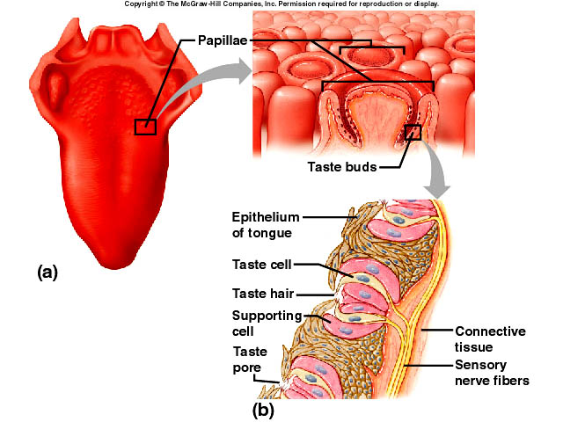
Station 4 – Smell

Type of Receptor | Responds to: | Picture

Smell:
__________________________________________________________________________________________________________________________________________________________________________________________________________________

Olfactory Nerve Pathways
- Once olfactory receptors are stimulated, nerve impulses travel along the:
  - __________________________________________
- Once the stimulus reaches the olfactory cortex in the cerebrum, it may continue on to other locations in the cerebrum and brainstem, including the limbic system.
  - Explains why: ________________________________________________________________________
_________________________________________________________________________________________
Olfactory Receptors and Adaptation:
__________________________________________________________________________________________________________________________________________________________________________________________________________________
_________________________________________________________________________________________________________
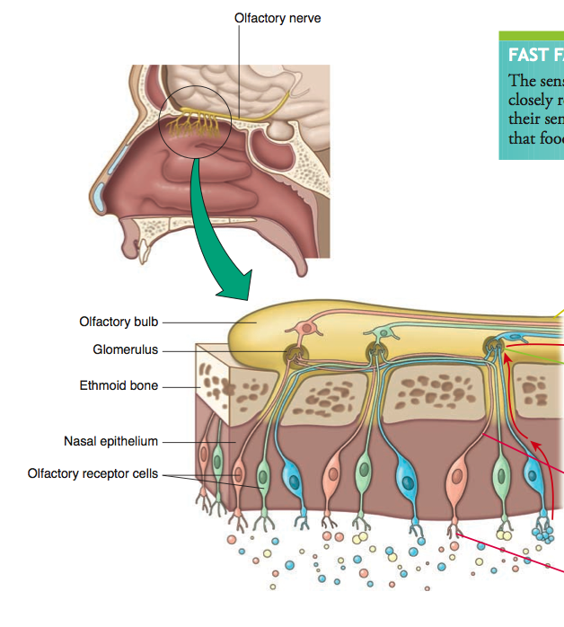

Station 5 – Hearing

Type of Receptor | Responds to: | Picture

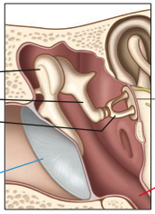
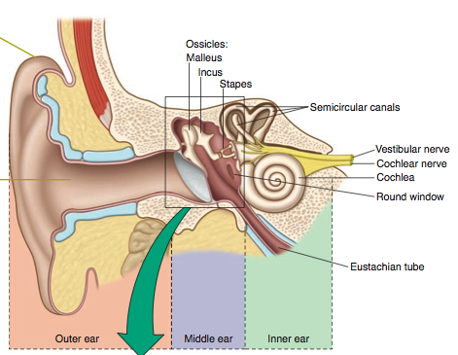
Lable each part of the ear AND give a brief explanation of its function.

Outer Ear

Middle Ear

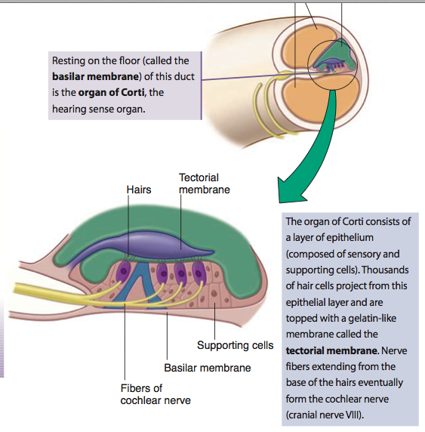
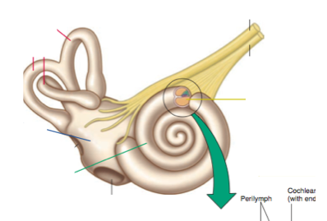
Inner Ear

Organ of Corti

How We Hear Sound

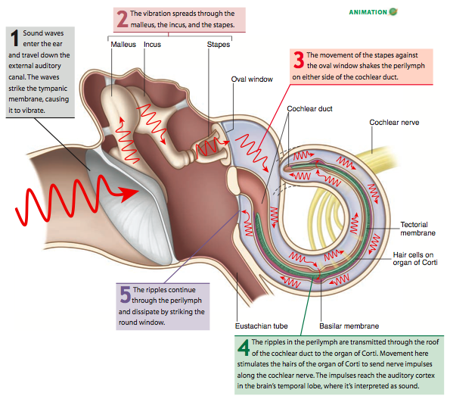

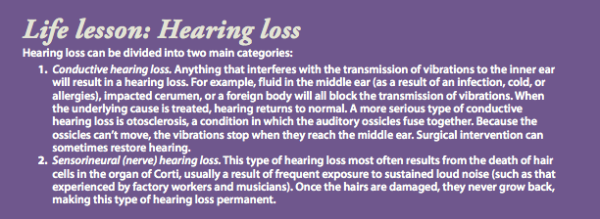
Station 6 – Balance and Equilibrium

Type of Receptor | Responds to: | Picture

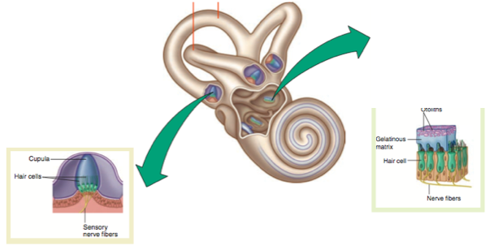

 | Dynamic Equilibrium | Static Equilibrium
Organ
Sensation
Picture | 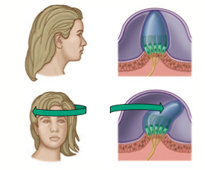 | 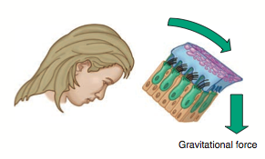
Station 7 – Vision

Type of Receptor | Responds to: | Picture

Accessory Structures of the Eye

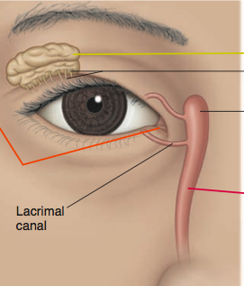
Label each accessory structure of the eye AND give a brief explanation of its function.

Structures of the Eye

Label each structure of the eye AND give a brief explanation of its function.

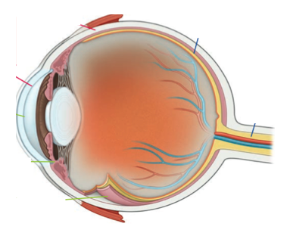
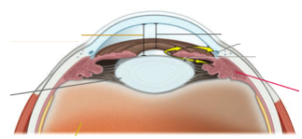
Forming an Image
- __________________________________________________________________________________________________________________________________________________________________________________________________
- __________________________________________________________________________________________________________________________________________________________________________________________________
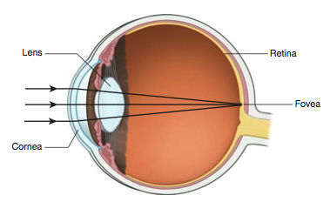
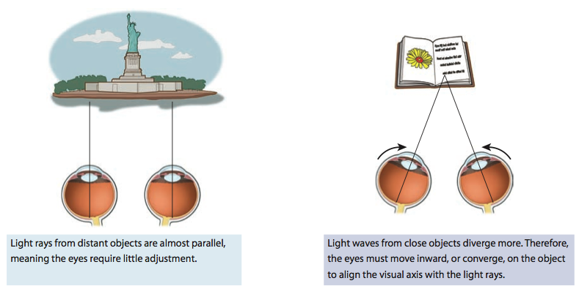

Refraction Convergence

Clinical Application
- ________________ lenses correct nearsightedness
- ________________ lenses correct farsightedness
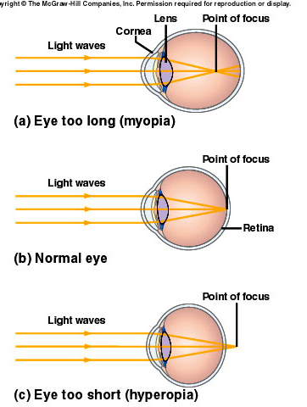
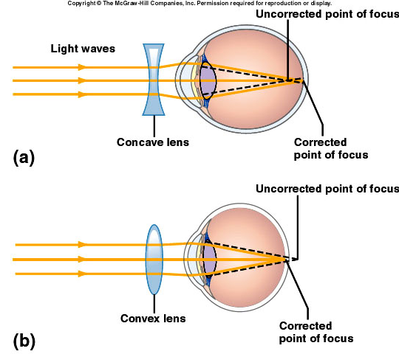
Type of Photoreceptors – Rods vs. Cones

 | Rods | Cones
Location
Active in:
Responsible for:
Color vision?

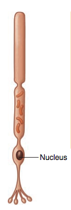
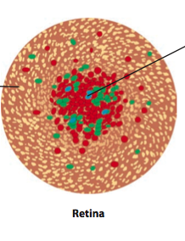
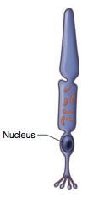

Rods Cones

