Sheep Brain Dissection
External:
- Carefully rinse your sheep brain in water to remove as much of the preserving fluid as possible.
- Write down 3 characteristics of your sheep brain. (how it feels, what color it is, etc.)
  - _________________________________________________________________________________________
  - _________________________________________________________________________________________
  - _________________________________________________________________________________________

- Set the brain down so the flatter side rests on the dissection pain.
- Notice the tough outer covering on the brain. These are the meninges. Use the scissor to cut across the meninges. Carefully pull back and remove the meninges while leaving the other structures intact. Be extra careful around the cerebellum.
- Can you see all three meninges? Yes No
- Try tearing the meninges in half. What do you notice?
__________________________________________________________________________________________________________________________________________________________________________________________________
- Using your probe, identify the following structures on your brain:
  - Left hemisphere
  - Right hemisphere
  - Longitudinal fissure
  - Frontal lobe
  - Occipital lobe
  - Parietal lobe
  - Temporal lobe
  - Cerebellum
  - Gyri
  - Sulci
- Compare the gyri of the cerebrum to those of the cerebellum. Note your observations below.
_________________________________________________________________________________________________
_________________________________________________________________________________________________
- Gently pull on the left and right hemispheres and expose the band of white fibers in the longitudinal fissure. This band is the corpus callosum.
- Turn the brain over so the spinal cord is superior. Using your probe, identify the following structures on your brain:
  - Medulla oblongata
  - Pons
  - Midbrain
  - Optic chiasma – the optic nerves cross and make an X
  - Olfactory bulbs – on the anterior portion, prominent, smooth and rounded

- Although some of the cranial nerves may be missing or are quite small, locate as many as possible using the picture below as a reference. Make note of which cranial nerves you were able to find below.
_________________________________________________________________________________________________
_________________________________________________________________________________________________
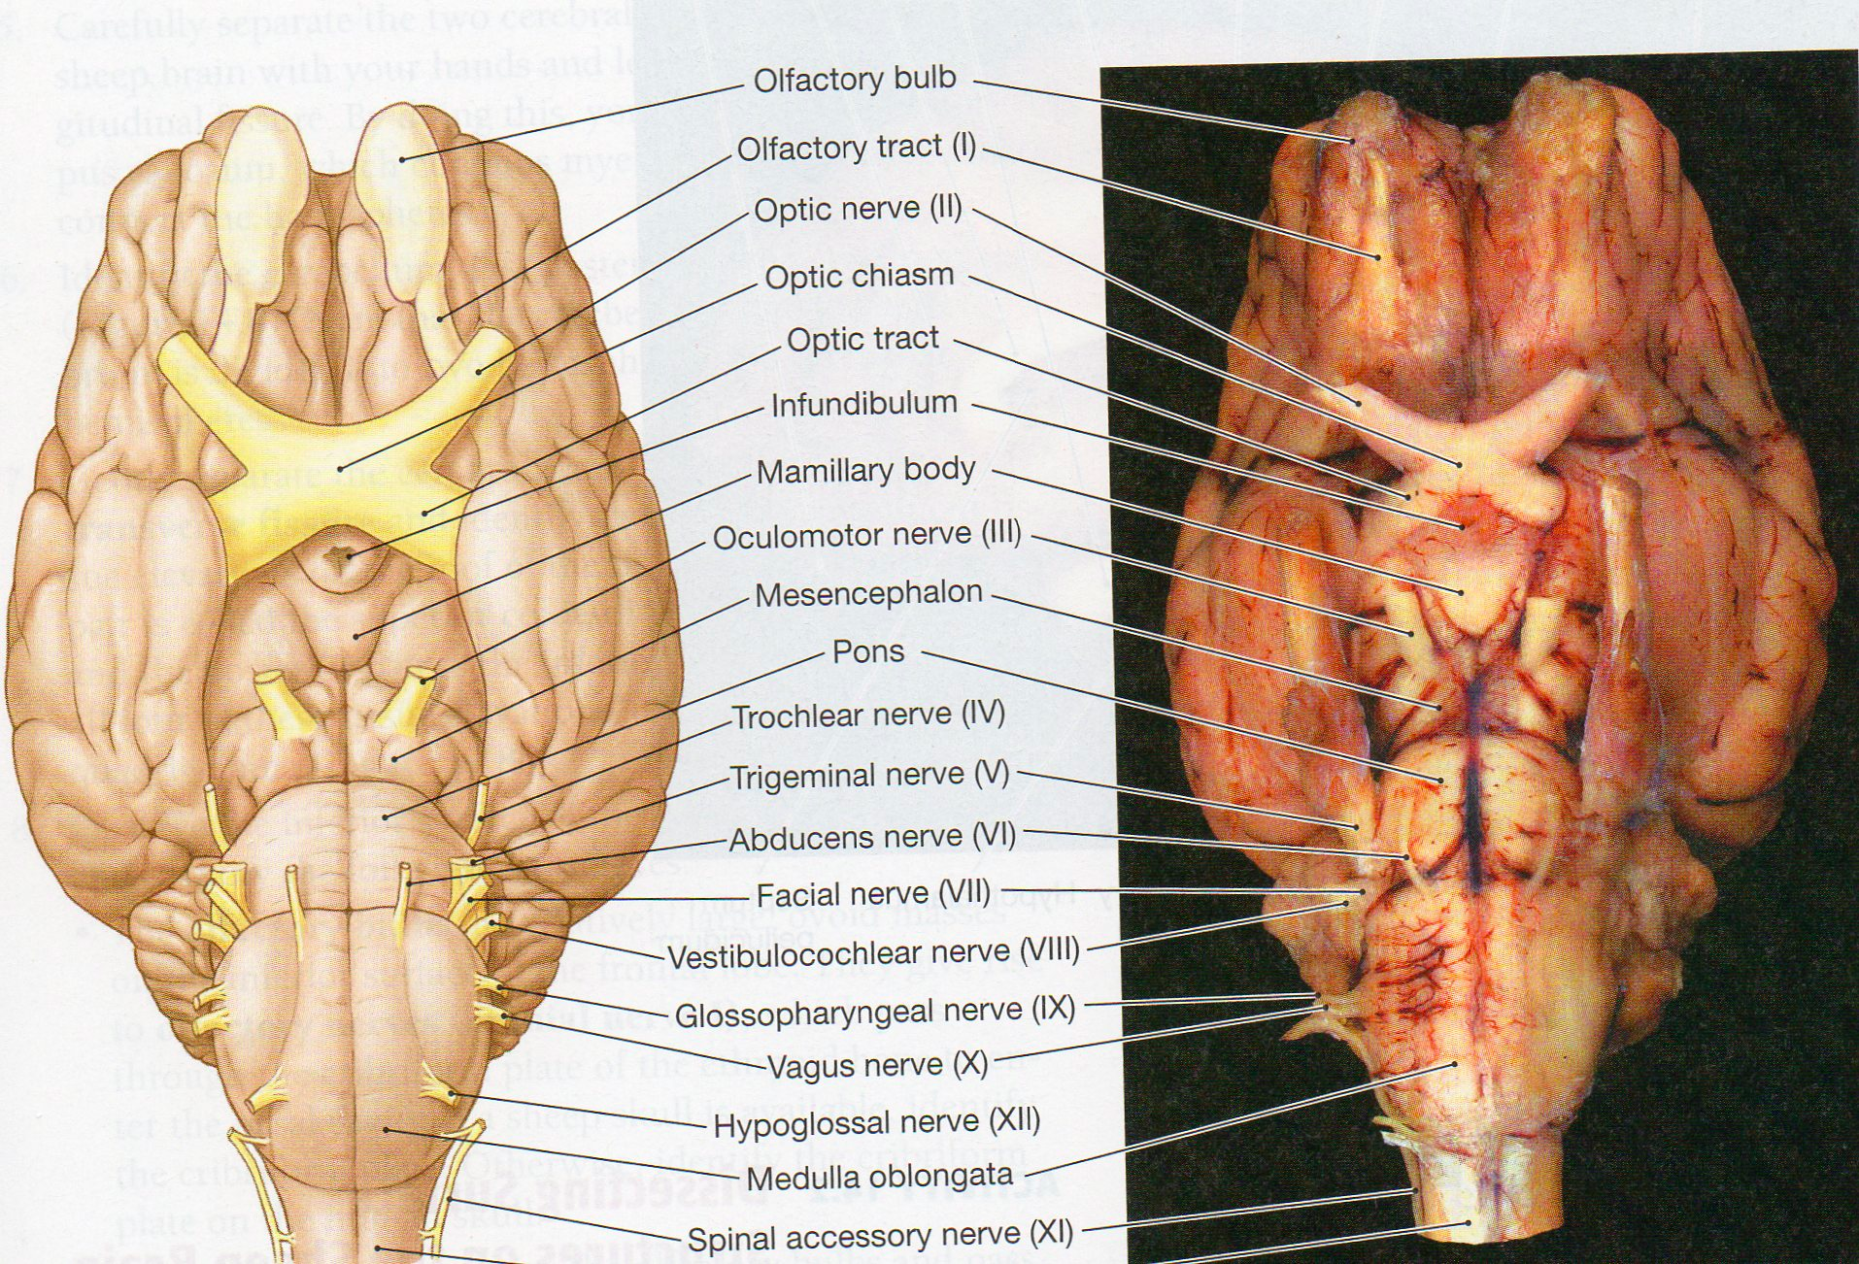
Internal:
- Use a scalpel to cut the brain along the longitudinal fissure, separating the left and right hemispheres. Slice through the brain starting at the cerebrum and going down through the cerebellum and brain stem.
- Each partner takes one hemisphere to observe the internal structures of the brain.
- Identify the following structures:
  - Corpus callosum
  - Thalamus (round structure in the center)
  - Hypothalamus (below thalamus and toward the front)
  - Midbrain
  - Pons
  - Medulla oblongata
- Slide your thumb along the outside (LATERAL) of the brain stem until it disappears under the cerebrum. Keep wiggling your thumb and dig it gently under the cortex until you can't push it in anymore.
- At the transverse fissure gently separate the cerebellum from the cerebrum.
- Observe the cerebellum and notice the difference between the white and gray matter. The white matter of the cerebellum is also known as the arbor vitae or “Tree of Life.”
- Use a scalpel to cut a cross section of the occipital lobe. Notice the difference between the white and gray matter. Compare/contrast the white and gray matter of the occipital lobe to the white and gray matter of the cerebellum below.
__________________________________________________________________________________________________________________________________________________________________________________________________

Turn over – One more question on the back!

- Below is a picture of a sheep brain and a human brain. Name 2 similarities and 2 differences.
Similar
  - _________________________________________________________________________________________
  - _________________________________________________________________________________________
Different
1. _________________________________________________________________________________________
2. _________________________________________________________________________________________

Sheep Brain Human Brain
