Histology
Station 1: Tissue Types
Read Section 5.1 in your book and list the four major tissue types in the body and their main functions.

Tissue Type | Main Function
1.
2.
3.
4.

Epithelial Tissue
Station 2: Epithelial General Characteristics
Read section 5.2 in your book and summarize each paragraph into a general characteristic of epithelial tissue.
General Characteristics
1.
2.
3.
4.
5.

Where in the body is epithelial tissue found?
_________________________________________________________________________________________________________
_________________________________________________________________________________________________________
Station 3: Epithelial Classification and Naming
Look at the diagrams provided and answer the following questions:

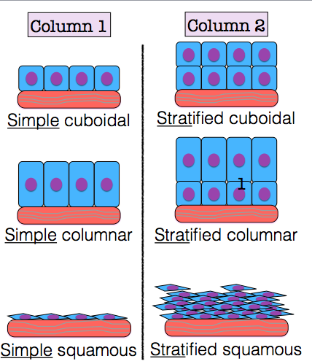
- What is the difference between the epithelial tissue in the first column and the epithelial tissue in the second column?
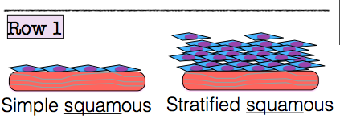
- What do you think the roots “simple” and “strat” mean?

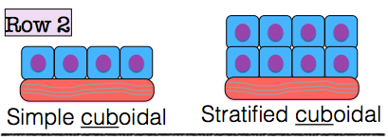
- Now that you know epithelial tissue is named based on the number of layers that it has, look at the rows of tissue to the right. In addition to being named for layers, what is second classification for how epithelial tissue is named?
- What shape are squamous cells?
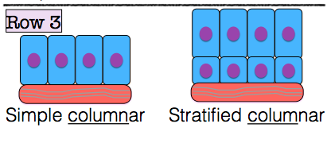
- What shape are cuboidal cells?
- What shape are columnar cells?

Station 4: Look at the diagrams provided and answer the following questions:

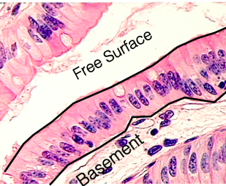
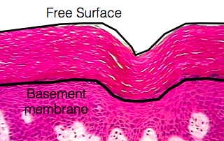
- Is the epithelial tissue to the right simple or stratified?

What shape are the cells?
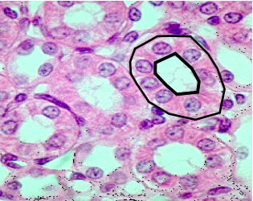
- Is the epithelial tissue to the right simple or stratified?
What shape are the cells?
- Is the epithelial tissue to the right simple or stratified?
What shape are the cells?

Station 5: Using the information provided, fill in the following chart for Epithelial Tissue
Epithelial Tissue Chart
Type | Layers/Shape | Function | Location | Sketch
Simple
Squamous
Simple
Cuboidal
Simple
Columnar
Stratified Squamous
Stratified
Cuboidal
Stratified Columnar

Station 6: Visit each microscope and view the slide of epithelial tissue provided. Sketch each view and identify each type of tissue.
Epithelial Tissues
Name of Tissue: ________________________  Magnification: _________  Function: _____________________________ | Name of Tissue: ________________________  Magnification: _________  Function: _____________________________
Name of Tissue: ________________________  Magnification: _________  Function: _____________________________ | Name of Tissue: ________________________  Magnification: _________  Function: _____________________________

Connective Tissue
Station 1: Read the information provided and fill in the following table regarding the various components of connective tissue

General Characteristics
Component |  | Main Function
Extracellular
Cell
Types
Fiber
Types

Despite the variety of tissue types that are included in the category “connective tissue,” what is the main function of connective tissue?
_________________________________________________________________________________________________________
_________________________________________________________________________________________________________

_________________________________________________________________________________________________________

_________________________________________________________________________________________________________

Station 2: Using the information provided, fill in the following chart for Connective Tissue
Connective Tissue Chart
Type | Made of | Function | Location | Sketch
Adipose
Bone
Blood
Loose Connective
Dense Connective
Hyaline Cartilage
Elastic Cartilage
Fibrocartilage

Station 3: Visit each microscope and view the slide of connective tissue provided. Sketch each view and identify each type of tissue.
Connective Tissues
Name of Tissue: ________________________  Magnification: _________  Function: _____________________________ | Name of Tissue: ________________________  Magnification: _________  Function: _____________________________
Name of Tissue: ________________________  Magnification: _________  Function: _____________________________ | Name of Tissue: ________________________  Magnification: _________  Function: _____________________________

Connective Tissues Cont’d
Name of Tissue: ________________________  Magnification: _________  Function: _____________________________ | Name of Tissue: ________________________  Magnification: _________  Function: _____________________________
Name of Tissue: ________________________
Magnification: _________
Function: _____________________________

Muscular Tissue
Station 1: Read the information provided and fill in the following table regarding the various components of muscular tissue

Muscular Tissue Chart
Type | Striated  or No? | # of Nuclei  (per cell) | Voluntary or Involuntary? | Location | Sketch
Skeletal
Muscle
Cardiac
Muscle
Smooth
Muscle

* Look at your sketches. How would you define “striated”?
_________________________________________________________________________________________________________

Station 2: Read the information provided and fill in the following table regarding nervous tissue.

Nervous Tissue Chart
Type | Made of |  | Function | Location | Sketch
Nervous | Type of Cells

Station 3: Visit each microscope and view the slide of muscular tissue provided. Sketch each view and identify each type of tissue.
Muscular Tissues
Name of Tissue: ________________________  Magnification: _________  Function: _____________________________ | Name of Tissue: ________________________  Magnification: _________  Function: _____________________________
Name of Tissue: ________________________
Magnification: _________
Function: _____________________________

